

**Our value: Self – belief and hard work will always earn you success**

**Worksheet no. (7)**

Passive Voice

Grade 6(A + B)

Name: Date: / /2023

Objectives: To identify the passive voice.

To practise using the passive voice.

**Only transitive verbs (verbs followed by an object) can be changed into the passive. While intransitive verbs (verbs not followed by an object) cannot be changed into the passive.

**What is an easy way to explain transitive verbs?**

A transitive verb is a verb that uses a direct object, which shows who or what receives the action in a sentence. In the example “she gives a gift,” **gives** is a **transitive verb** and a **gift** is the **direct object**.

S V Obj

-Peter feeds the cows. (feeds = transitive verb)

The cows are fed by Peter.

S Prepositional phrase

-They go to school every day. (go = intransitive verb)

This sentence cannot be changed.

**Passive Voice: Definition**

In the active voice, the subject of the sentence **DOES the action:**

* **John painted** the **house** last week.  
  **Doer (subject) / verb / object**

In the passive voice, the subject of the sentence **RECEIVES the action.**

* The **house was painted** last week.  
  **Receiver (object) / verb**

Notice that the **object** of the active sentence (house) became the **subject** of the passive sentence.

**Passive Voice: Present**

In the present, the passive voice uses the verbs **am**, **is** and **are** + past participle of the main verb.

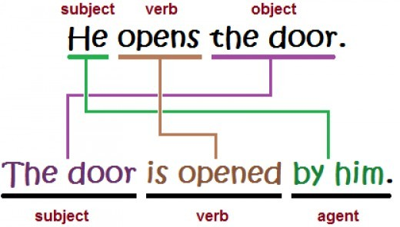

**Passive Voice: Past**

In the past, the passive voice uses the verbs **was** and **were** + past participle of the main verb.

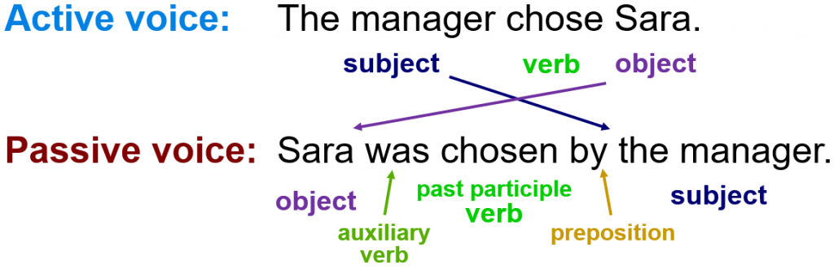

*** Don’t forget to change the pronouns in the passive:

I me

She her

He him

It it

You you

We us

They them

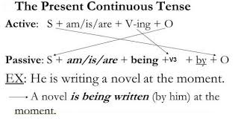

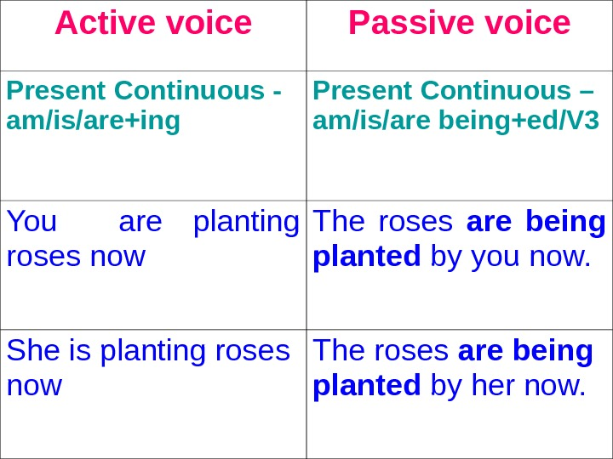

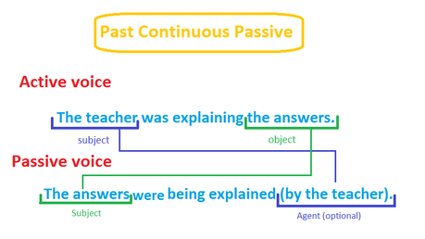

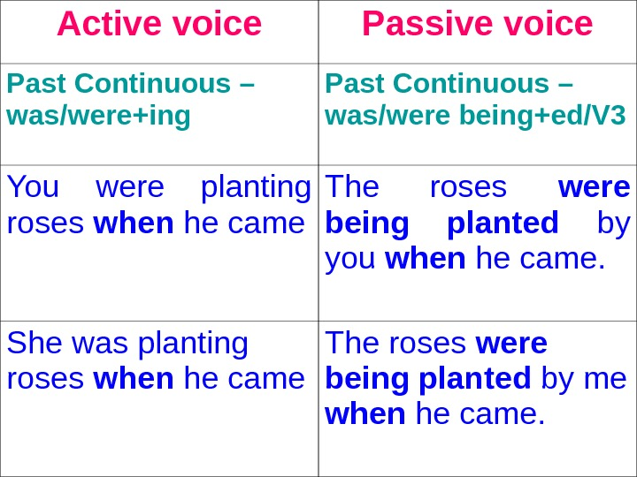

Rewrite the sentences in the passive voice.

1. John collects money.

Money is collected by John.

1. Anna opened the window.

The window was opened by Anna.

1. We set the table.

The table is / was set by us.

1. She pays a lot of money.

A lot of money is paid by her.

|  |  |
| --- | --- |
| 1. Somebody found the key.   The key was found. |  |
| 1. Somebody made a mistake.   A mistake was made. |  |
| 7. My father is washing the car.   1. The car is being washed by my father.   8. Farmer Joe is milking the cows.  The cows are being milked by farmer Joe.  9. She is taking a picture of him.  A picture of him is being taken by her.  10. I am writing a poem.  A poem is being written by me.   11. They were expecting a guest.  A guest was being expected by them.  12. The chef was cooking the meat.  The meat was being cooked by the chef.  13. The women were cleaning all the curtains.  All the curtains were being cleaned by the women.  14. They were watching the newest videos.  The newest videos were being watched by them. |  |