**The National Orthodox School / Shmaisani**

**Subject: Biology Worksheet : Food webs and Food chains**

**Name:**

**Date:** **Grade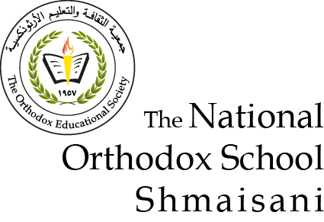 9 IB**

**Question one *:***

1. **Use the food web below to answer the following questions .**

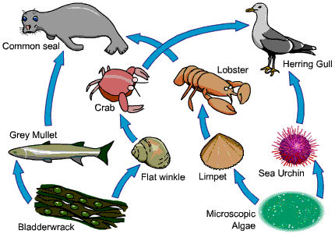

* Complete the food chain below from this food web :

bladderwrack 🡪 flat winkle 🡪 ……………………………. 🡪 …………………………

* Write the name of a : *( write only one name )*

1. Herbivore ………………….
2. Producer …………………………
3. Secondary Consumer ……………………………
4. An organism in the second trophic level ………………..
5. A top carnivore ………………………….

* What do the arrows in a food chain represent?

……………………………………………………………………….

1. The diagram shows some feeding relationships in a woodland area.

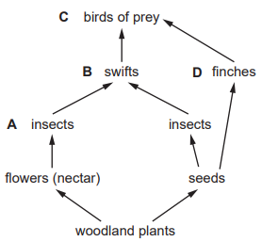

Which of the labelled animals are in competition with seed-eating insects for their food?

…………………………………..

1. 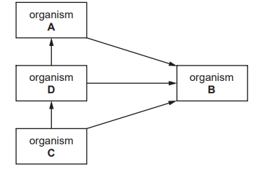The diagram shows a food web including a producer, consumers and a decomposer.

Which organism is the decomposer?

…………………………………….

1. 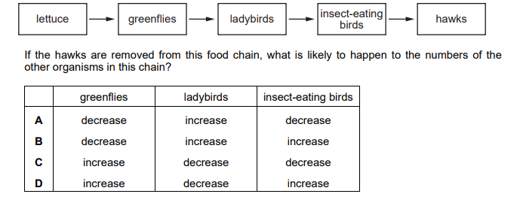The diagram shows a food chain.

**Choose the correct row from A,B,C and D .**



**Question 2 :**

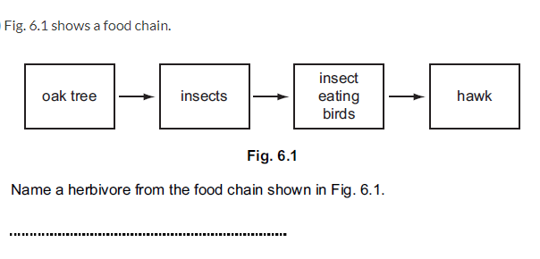

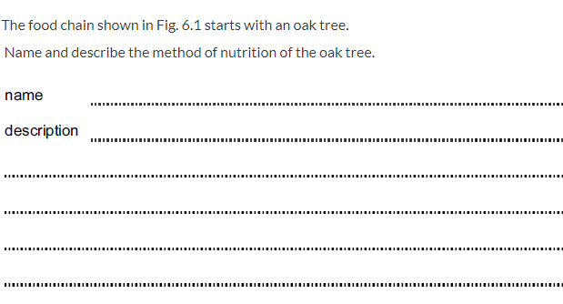

**Question 3 :**

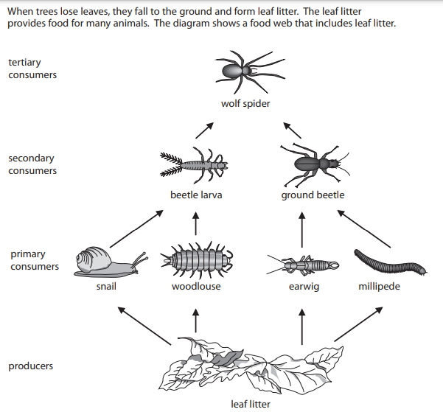

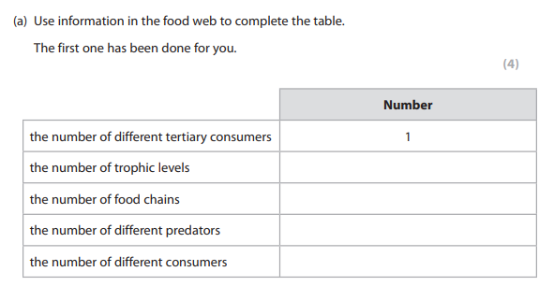

**Question 4 :**

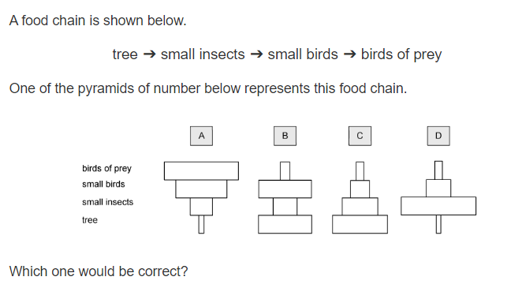

Explain your answer ………………………………………………………………………..

**Question 5 :**

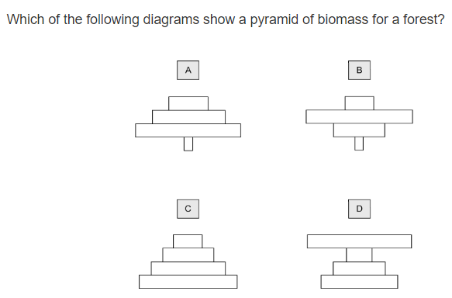

**Question 6 :**

