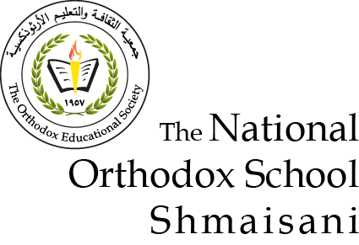**The National Orthodox School / Shmaisani**

**Subject: Biology Worksheet : Reproduction in plants**

**Name:**

**Date:** **Grade 9 IB**

**Question 1 : Circle the correct answer :**

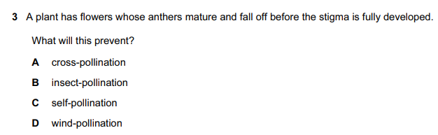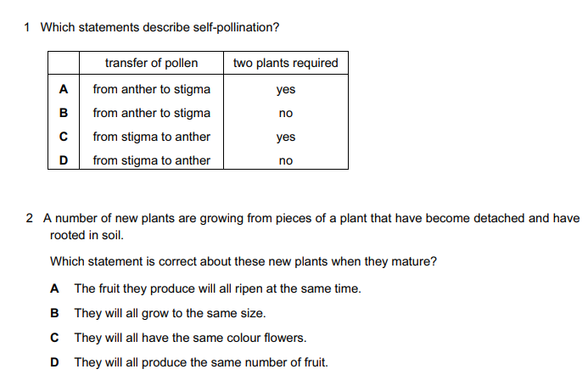

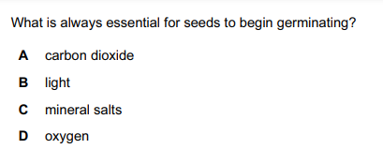

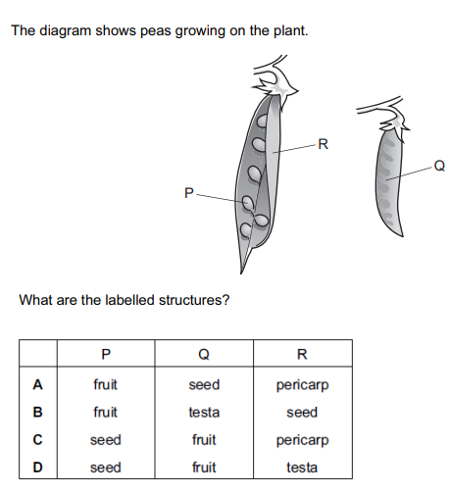

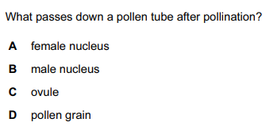

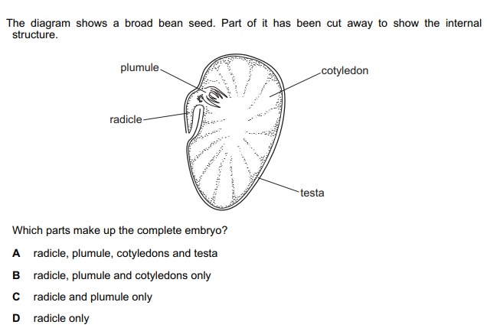

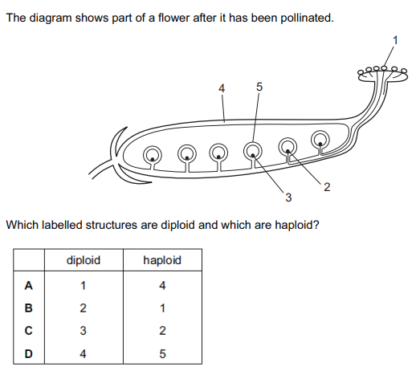

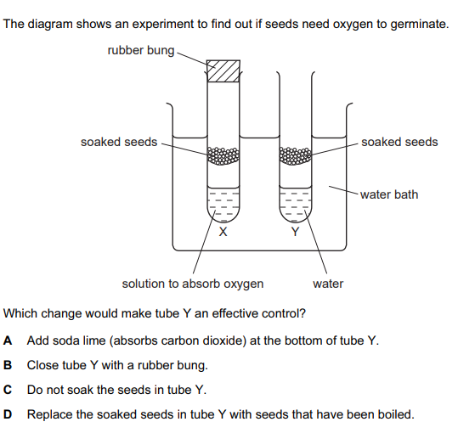

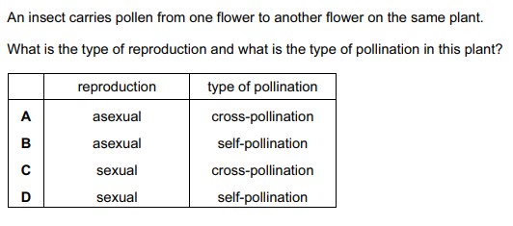

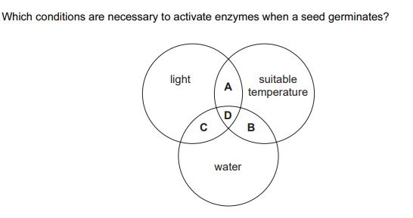

**Question 2 :**

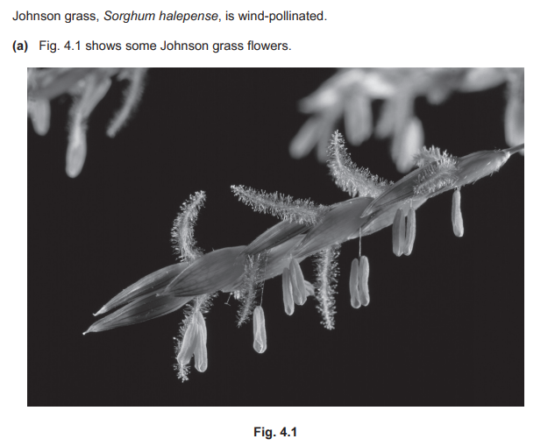

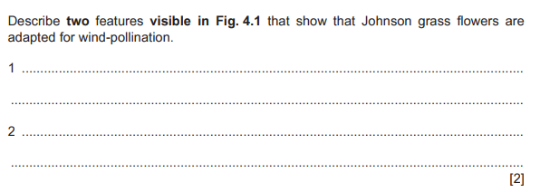



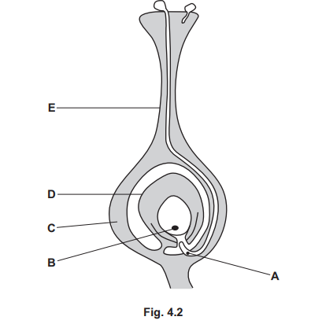

* Name part E : ……………
* Describe what will happen after pollination .

…………………………………………………………

………………………………………………………..

…………………………………………………………

…………………………………………………………

…………………………………………………………………………………………………………..

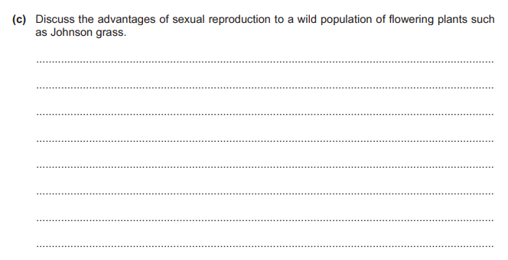

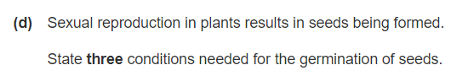 **……………………………………………………………………………………………………………**

**Question 3 :**

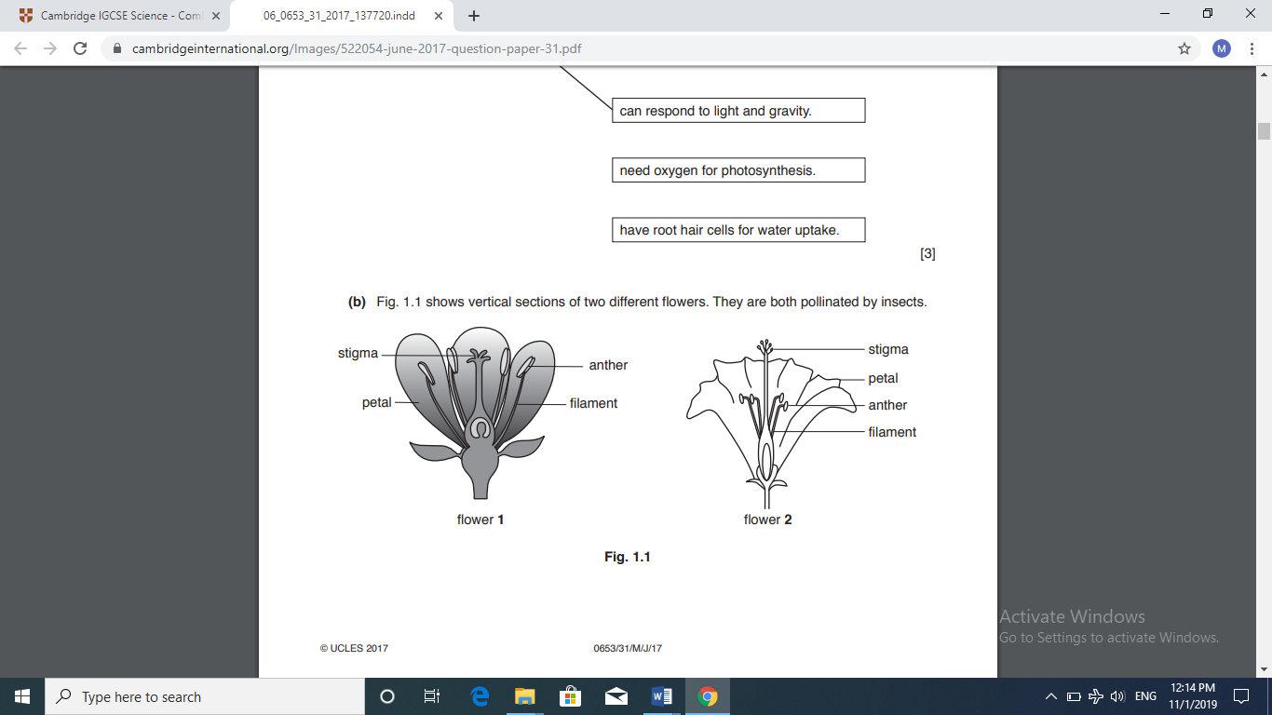**Diagram 2 shows vertical sections of two different flowers. They are both pollinated by insects.**

**Diagram 2**

* **Which flower would have less chance of self-pollination? …………...…………..**

**Explain your answer …………………………………………………………………………………**

**Question 4 :**

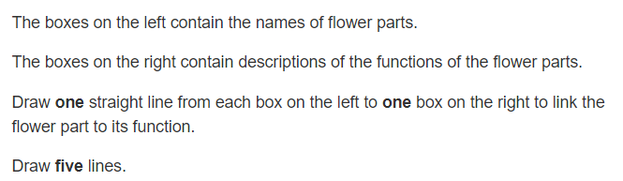

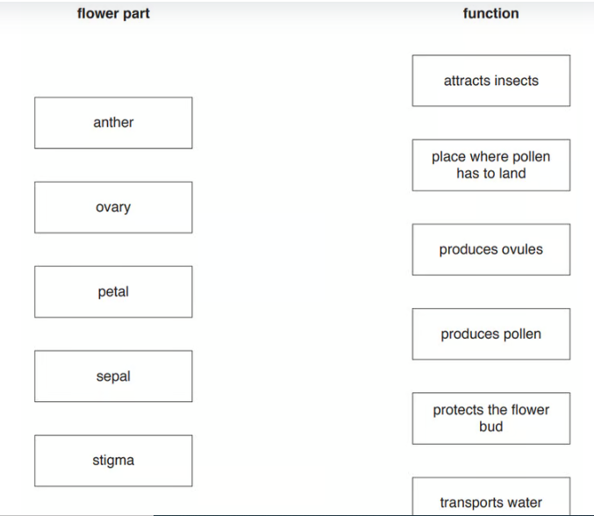

**Question 5 :**

Fig .2 shows two photomicrographs of pollen.

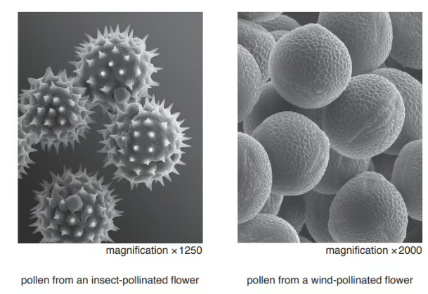

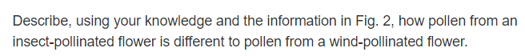

………………………………………………………………………………………………………………………………………………………………………………………………………………………………………………………………………………………………………………………………………………………………………………………………………………………………………………………………

**Question 6 :**

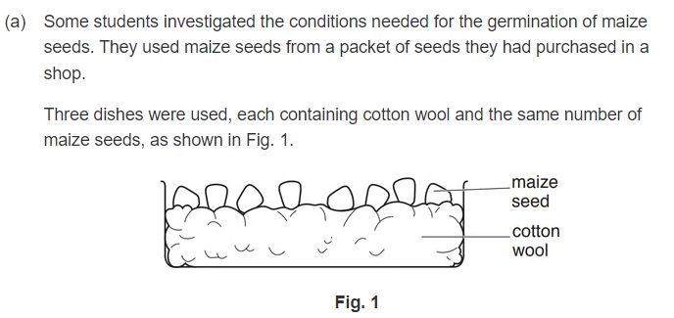

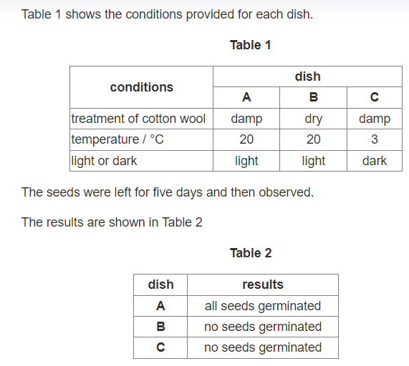

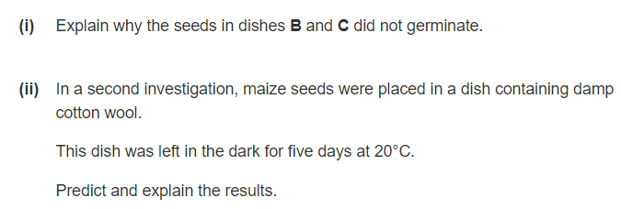

………………………………………………………………………………………………………………………………………………………………………………………………………………………………………………………………………………………………………………………………….

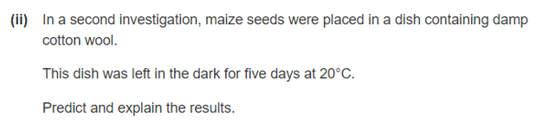

………………………………………………………………………………………………………………………………………………………………………………………………………………………………………………………………………………………………………………………………………………………………………………………………………………………………………………………………………………………………………………………………………………………………………………………………………………………………………………………………………..

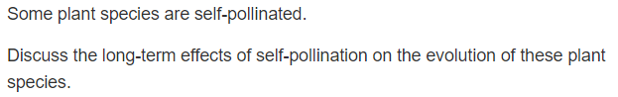**Question 7 :**

…………………………………………………………………………………………………………………………………………………………………………………………………………………………………………………………………………………………………………………………………..

<https://www.savemyexams.co.uk/igcse/biology/cie/23/topic-questions/16-reproduction/16-1-reproduction-in-plants-and-humans/-/theory-questions/hard/>