**Narrative Tenses**

**Unit 8**

(Past simple, past continuous, past perfect)

*Past Simple

I did my homework yesterday.

__________________________________

*Past Continuous

I was doing my homework yesterday at six o’clock.

_____________________________________



*Past Perfect

I had done my homework by six o’clock.

__________________________________



Past Simple



Regular

I worked in this office last year.



Irregular

I bought this office last year.

The past simple has the same form with all pronouns.

They/ He worked in this office last year.

She/We bought this office last year.

Verb ‘**to be**’ when used as a main verb, i.e., full verb:

**Positive/affirmative sentences**

| Person/pronoun | Positive | Interrogative form (question) |
| --- | --- | --- |
| I/he/she/it | He **was**. | **Was** he? |
| we/you/they | They **were**. | **Were** they? |

**Negative sentences**

| Person/pronoun | Negative | Short form | Interrogative form |
| --- | --- | --- | --- |
| I/he/she/it | I **was** **not**. | I **wasn’t**. | **Was** I ? |
| we/you/they | We **were** **not**. | We **weren’t**. | **Were** we ? |

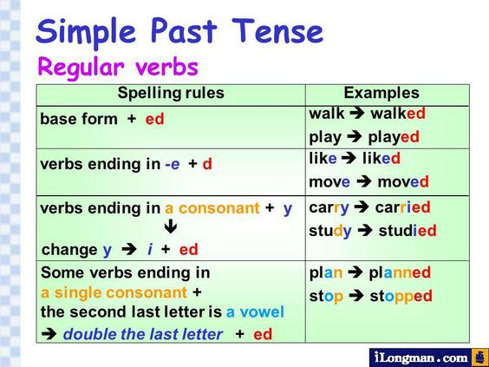



Negative

**She worked in a bank when I was young.

**She _____________ in a bank.



Questions

She bought house last year.



____________she _______________________?

**Form:**

**Affirmative:**

**S + V2 ………..**



**Negative:**

**S + did not + V1 (inf) …………**

**Question:**

**Did + S + V1 (inf) …………?**

**Keywords:**

last year, last month, last week, last Summer, last night…. etc.



a week ago, two days ago, a few months ago…etc.

yesterday, yesterday morning, yesterday evening etc.

In the past, once, in 1998, when I was a child, when I was 7 years old, before a week

**Correct the form of the verbs.**

1. The boy_______ home two weeks ago. **(leave)**



1. When I was ten years old, I___________ a computer. **(buy)**
2. The builder _____________ lunch an hour ago. (**not-eat**)



Uses:

1. **To talk about something that started and finished in the past.**

They **spent** their holidays in Switzerland last year.

1. **To talk about a sequence of actions that happened one after the other in the past.**



I slipped, fell and broke my leg.

1. **To describe a routine in the past. (past habit)**

People **travelled/used to** travel by carriages in those days.

1. **To talk about something that was true for an extended period of time in the past.** In this case, we use it with a time phrase.

We **lived** in this house when I was young.



Past continuous



Statement =S + was + v -ing

Question Was} + S + v -ing ?

were}

Negative: S + was not +v+ing



**Key words:**

**{while / when / as / At this time last week, this time last year ….etc. / at 5 o’clock yesterday morning ,at 8o’clock this morning / from 6 o’clock to 8 o’clock yesterday evening .............**}

Uses:

1. To talk about something which was happening at a definite time in the past.



I was cleaning the house at 6 o’clock yesterday.

1. To talk about something which was happening before and after another action in the past.



Long action was interrupted by a short action.

I was doing my homework when it started to rain.



1. To talk about two simultaneous actions (Parallel)actions that were happening at the same time in the past

I was doing my homework while/as my mother was preparing lunch.



1-The telephone rang while he……….a bath. (**have)**

2-It began to rain while I……….in the park. (**walk)**

3-While she………(**climb)** the ladder, she slipped off and …………….(**break).**

4-When he reached his office, the workers………………for him. **(wait)**

5-The police caught him while he…………. the car. **(open)**

Past perfect

Statement = S + had+ past participle

Question = Had + S + past participle ?



Negative S + had not + past participle



1. To talk about actions that happened before a specific moment in the past or another past action.



She **had** already **eaten** dinner ***by 8 o’clock.***



She **had** already **decided** what to cook when she **went** home.

2. For an action which finished in the past and whose result was visible in the past.



He **had injured** his legs in a car accident so he **used** a wheelchair.

3.For past feelings and the cause in the past perfect.



He **was** sad because he **had failed** the exam.

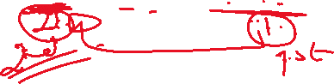

**Time expressions**

**after, before, when, by the time, by 1990**

Past simple

Past perfect

After

Because

Past perfect

Past simple

Before

When

By

So

1. After they …………..work, they went home. **(finish)**
2. My father … ……….. last year, he had worked for 25 years. **(retire)**
3. Ali …..…………..himself before he met us**. (prepare)**
4. When I reached home, I found that everyone………. …to sleep. **(go)**
5. I couldn't play because I …………..my leg. **(break)**
6. The teacher got angry at Ali because he.............to do his homework. **(forget)**
7. I went to bed after my friend_____________. **( phone)**

Past continuous **indicators**



**\*\*\*While/as**



1. (**While/as)+**past continuous, past continuous.

(**While /as**) he **was doing** his homework, his sister **was** **playing** with her dolls.

1. Past continuous +(**while/as)** + past continuous.

He **was doing** his homework (**as/while**) his sister **was** **playing** with her dolls.

1. Past simple +**(while/as)**+past continuous.

The bell **rang** **(as/while)** the teacher **was collecting** the test papers.

**\*\*\*When**

1. **When** +past simple, past continuous.

**When** he **came** home, I **was reading** a book.

1. Past continuous, **when** +past simple.

I **was reading** a book **when** he **came** home.

1. **When** +past simple, past simple. (narrating events)

**When** he **entered** the room, he **saw** the mouse on the table so he **screamed.**

1. **When** + simple past, past perfect / already

**When** he **arrived,** we **had already left.**

Past perfect indicators

**\*\*\*After**

1. **After** +past perfect , past simple.

After I **had had** lunch, I **did** the washing up.

1. Simple past +**after** +past perfect.

I **did** the washing up after I **had had** lunch.

**\*\*\*Before**

1. **Before** + past simple, past perfect.

Before I **went** to bed, I **had done** my homework.

1. Past perfect +**before** + past simple.

I **had done** my homework before I **went** to bed.

**\*\*\*By**

1. **By**+ simple past, past perfect, **by** 2013

**By** the time I **reached** the train station, the train **had left** so I had to take a taxi.

**By** 2013, she **had finished** her research.

1. Past perfect + **by**+ past simple

The train **had left** **by** the time I **reached** the station.

**\*\*\*When**

1. **When** + past simple, already + past perfect

**When** he **arrived**, the film had already started.

1. Already +past perfect + **when** +simple past.

The film **had already started** **when** I **arrived**.

**\*\*\*Because**

**Because** + past perfect, past simple .

1. Because he **hadn’t passed** the test, he **was** sad.
2. Past simple **because** + past perfect

Maher **felt** nervous because he **hadn’t swum** in the sea.