Module |  |  |  |  | 5 |  |  |  | Discourse
 |  |  |  |  |  |  |  |  |  |  |  |  | o | r | l | d
U | n | i | t |  | 9 |  |  | T |  | h | e |  | w

of

b

u

s

i

n

e

s

s 

Vocabulary

- Complete the collocations with the verbs in the box. One verb is not needed. The fi rst one is done for you.

ask cause do earn join make (x2) shake

1 make a mistake
2 | ask | questions
3 | shake | hands
4 | earn | respect
5 | join | a company
6 | Cause | offence
7 | make | small talk

- Complete the sentences with collocations from exercise 1. The first one is done for you.

1 Be very careful when you answer the

questions, and try not to make a mistake.
2 If you are polite, you won’t
cause offence or upset

anybody.

3 Before the serious discussion starts, we

always |  | make small talk |  |  |  | ; it’s
often about the weather!
4 Nasser has applied to |  |  |  |  | join
 |  |  |  | where his father
the | company
works.

5 In business, when you meet someone for the first time, it’s polite to
Shake hands.

6 After the talk, there will be a chance for

you to |  |  | Ask questions |  |  | about
anything you don’t understand.
7 By working hard, you will
 | earn |  |  | the | respect
of your boss.

- Complete the sentences with the correct form of the words in brackets. The first one is done for you.

1 Before you apply for a job, check that

you have the correct qualifications. (qualify)

2 The company is pleased with your work and is happy to give you a

recommendation (recommend)
3 Congratulations on a very
__successful__ business deal. (succeed)
4 We should always be ready to listen to
good ____advice_________. (advise)

5 My father often talks about what he did in his ____youth_________. (young)

6 It’s important to have an ___awareness_

of different countries’ customs. (aware)

- Complete the explanations with words from the box. One word is not needed.

compromise conflict negotiate patient prepared

previous track record

1 When you talk about business and try to do a deal, you negotiate ___.

2 When you are ready for something, you are ___ prepared __ for it.

3 When you can prove that you have experience, you have a track record
4 When two sides disagree and argue, there is __conflict_____

5 When each side changes their position a little so that they can agree, they have managed to _compromise______

6 When you stay calm and take your time, you are being patient______.

44


Grammar

- Complete the sentences with words from the box. The fi rst one is done for you.

had (x2) hadn’t if only wish

1 I couldn’t understand anything. If only I’d studied Chinese!

2 Ibrahim was right and I was wrong. I

wish I |  |  |  |  |  | listened to him.
3 I |  |  |  |  | I’d known more about the
company. If |  |  |  |  |  |  | I’d done some
research!

4 I am very hungry! I wish__________

before I went to the conference.
5 I regret the deal now. I wish we

___________ done it.

- Read the situations and complete the sentences. The first one is done for you.

1 Sultan forgot to do his Science homework.

If only he ____________to do it.
2 I regret going to bed late last night. I wish I
earlier.
3 Nahla could not find her way round
the city very easily. If only she
 |  |  |  |  |  |  |  | a map.
4 Oh no! I’ve forgotten my library book. I
left it at home.
I wish I |  |  |  |  |  |  |  |  | .
5 Our team didn’t play very well
 | yesterday.
 | If only they
better.
- Use the prompts and write sentences with I wish and If only. The fi rst one is done for you.

1 I didn’t bring a coat, and now I’m cold.

If only I’d brought a coat. I wish I’d brought a coat.
2 We didn’t up earlier, and now we’re late.
_______________________________
_______________________________
____3 I feel ill because I ate so many sweets.
__________________________________________________________________
4 Fadi keeps losing his wallet. He should
be more careful.

___________________________________ ____________________________________
5 Huda was too busy to visit us yesterday. She wasn’t able to come.
_________________________________ ____________________________________
6 I’ve broken my watch because I dropped it.
__________________________________________________________________
___________________
- Rewrite the sentences with the words in brackets.

1 Samia regrets being angry at
breakfast time. (if only)
If only ______________
2 If only I had concentrated properly in class today. This homework is really difficult. (wish)
I wish _________________________
3 Nader should have been more careful with his essay. He didn’t get a good mark. (wishes)
Nader wishes________________________ ________________________
4 I wish I had learnt English better when I was younger. (if only)
If only ___________________________


45



Reading

- Read the following web page and complete it with the missing sentences a–g. There is one sentence you do not need.

a Will you read it word by word, use notes or memorise it?

b Do you know when it was developed, and where it is produced?

c Instead, look round the room and make eye contact with your audience.

d For example, thank your hosts for allowing you to speak to them, and compliment their company.

e That’s why you need to be well-prepared!

f Why is your product superior to others and why does it have better value? g What makes your product perfect for them?
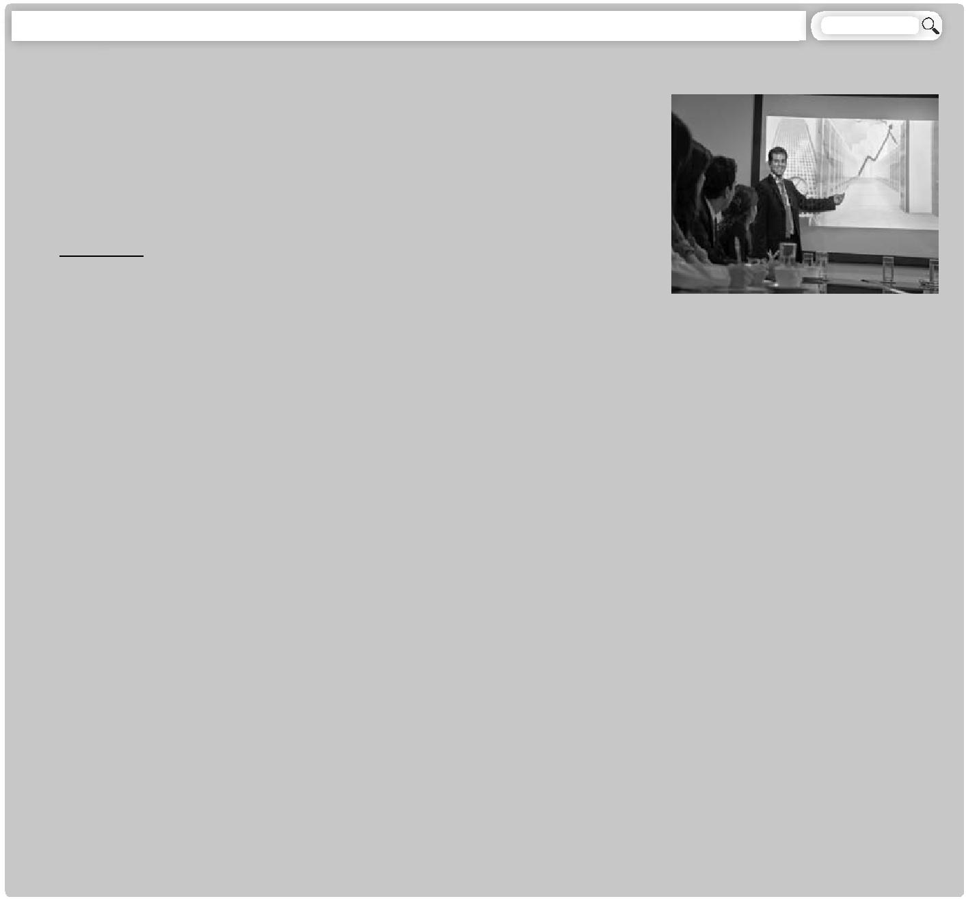

business-today/sales/how-to-make-a-sales-pitch

Whether you’re selling a new type of toothpaste to a chain of pharmacies, the latest computer software to a school or a new kind of package holiday to a travel

agency – you need to know …

How to make a sales pitch (WayS)

1 Do your research (how, ways)

Don't come away from a sales pitch wishing you had been better prepared. It is essential to know everything about your product.

B Do you know when it was developed, and where it is produced?
- You also need to know who the target market is – for 5 example, the age group or income of the people who might buy it. Not only that, you should know all about the competition – that is, similar products on the market. (2) __F Why is your product superior to others and why does it have better value?

In addition, you should know exactly which people you are speaking to, and what their needs are. For example, if they represent a middle-class department store in a humble neighborhood, be ready

10 to explain why your particular product would suit customers who do not have lots of money.

(3) _G_ What makes your product perfect for them?

Most of all, you need to believe in what you’re selling, and the best way to do that is to use it!

2 Prepare and practice (Steps)

Plan your presentation carefully, not just what you will say, but how you will say it. (4) __A Will you read it word by word, use notes or memorise

15 Whatever you decide, it is always a good idea to have a list of your main points, in case something interrupts you, or you simply freeze with nerves (it happens!).

Then practise it, if possible in front of colleagues. Make changes and practise it again.

3 Be professional

Keep your presentation short and simple. Start with some friendly comments. (5)_D__ For example, thank your hosts for allowing you to speak to them, and compliment their company.
_

20 Remember to speak slowly and clearly. It is important to appear confident (even if you’re nervous!).

While you’re speaking, don’t keep your head down. (6) C Instead, look round the room and make eye contact with your audience. Smile!

When you’ve finished speaking, invite questions. If you don’t know the answers, don’t pretend! Thank the questioner and promise to find out the answer (and do it!).

Finally, have a summary of your presentation ready to hand out at the end of the session.

25 I wish I had known all this when I started out in business! Good luck!

46



Vocabulary

10 Find the expressions 1–5 in the text, then match them with their meanings.

1 package holiday e
e
2 sales pitch d

3 target market a

4 age group b
b
5 department store c

a people who are identified as possible customers

b a set of people of similar age

c a large shop that sells many different types of things

d a presentation made by someone who is trying to sell a product

e an organised trip with everything included in the price (travel, accommodation, food)

Grammar

11 Complete the sentences using the correct form of the following prompts. The first one is done for you.

be older have a camera with me live in a big house

not have a headache not be so far away like the same things

1 Our flat is very small.
If only we lived in a big house.

2 Jaber isn’t old enough to drive a car. He wishes he were older.

3 My brother and I never want to watch the same TV programme.

I wish we liked the same things. _
4 I’m looking at a beautiful view, and I’d
love to take a photo.

If only I had a camera with me.
5. My cousins don’t live near here.
I wish they _weren’t so far away. __.
6 I want to go out this afternoon, but I
don’t feel well.

If only I _didn’t have a headache. ____.
Writing

12 Imagine you work for a travel company that specialises in package holidays in Jordan. First, design your package holiday, which should include a variety of locations. Make notes.

1 Who are your target customers? (Jordanians? Foreigners? Both?)

2 How long does the holiday last?

3 Where is it based? (one place or several?)

4 What is included?

5 What is there to do and see?

6 What is the accommodation like?

7 How much does it cost?

8 Why is it the best holiday on the market?

9 Add your own ideas.

13 Prepare an e-presentation about your holiday, and present it to your partner.

14 Now imagine you took your partner's holiday. Write a review of it in about 100 words.

47



WHAT I CAN DO

Always Sometimes Rarely

- I can use phrasal verbs correctly in sentences.

- I can complete sentences with new vocabulary words.

- I can rewrite sentences, using specific clues.

- I can distinguish between different phrasal verbs.

- I can select words from a text to match them with their meanings.

- I can combine words to make collocations.

- I can complete sentences with collocations.

- I can complete sentences with the correct form of words.

- I can identify the meaning of expressions from their context.

- I can rewrite sentences, using phrasal verbs.

- I can use pronouns with phrasal verbs correctly.

- I can complete sentences, using question tags.

- I can rewrite sentences in the passive form.

- I can complete and rewrite sentences to express wishes and regrets.

- I can carry out an e-presentation about a package holiday.

- I can demonstrate my understanding of a text about the language of twins by answering questions.

- I can complete a web page article with the missing information.

- I can plan for and write an article for my school newspaper.

- I can prepare a package holiday by writing down notes.

- I can write a review of my partner's holiday.

Total number of ticks

Always | Sometimes | Rarely

48

