**The National Orthodox School / Shmaisani**

**Subject: Biology Worksheet : Heart**

**Name:**

**Date:** **Grade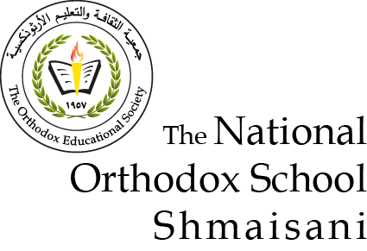 7 all sections**

*Objective : Be able to answer questions about the heart structure and the 2 circuits .*

**Question 1 :**

The diagram shows the human heart with four blood vessels labelled A,B,C and D.

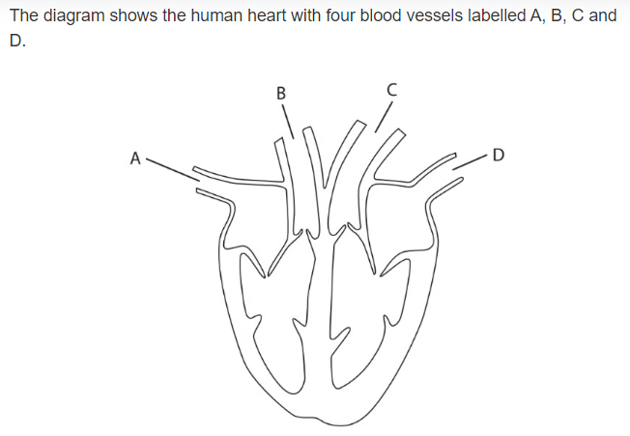

* Name blood vessels :

A : …………………………….

B : …………………………….

C : …………………………….

D : ……………………………

* Which blood vessel carries oxygen rich blood to the heart ……………..
* Which blood vessel contains blood at highest pressure …………….
* Which blood vessel carries oxygen poor blood back to the heart from the body ……………..
* Which blood vessel carries oxygen poor blood from the heart to the lungs …………
* On the diagram
* label the valves .
* Draw arrows to show the direction of blood flow .
* Label the 4 chambers .

**Question 2 :**

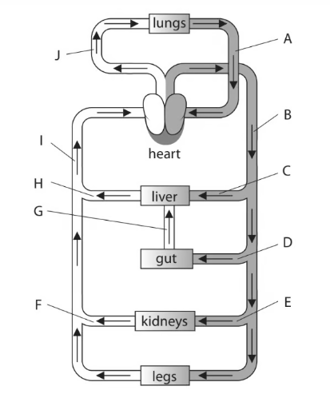

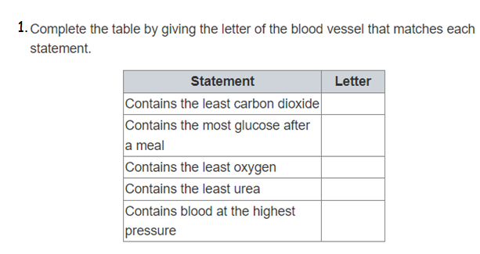



……………………………………………………………………………………………………………………………………………………………………………………………………………………………………………………………..

3. Describe how the blood in B differs than the blood in I .

………………………………………………………………………………………………………………………..