 **The National Orthodox School /Shmaisani**

**Subject: Science/ Biology**

**Name: study sheet: Blood Vessels**

**Date: Grade-Section: 7 CS**

|  |  |  |  |
| --- | --- | --- | --- |
| http://www.klbict.co.uk/interactive/science/artery.gifDiagram |  |  |  |
| **Name** | **Artery** | **Vein** | **Capillary** |
| Direction |  |  |  |
| Pressure |  |  |  |
| Size of Hole (lumen) |  |  |  |
| Wall Thickness |  |  |  |
| Valves? |  |  |  |

*Objective : To compare between the 3 types of the blood vessels .*

***Fill in the table below to compare between the 3 types of blood vessels .***

**Check your understanding :**

The diagram below represents two types of blood vessels .

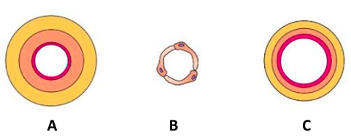

* Name blood vessel **A** : …………………….
* Name blood vessel **B** : …………………….
* Name blood vessel **C** : ……………
* Which blood vessel carries blood **at high pressure** ? ………………….
* Which blood vessel **carries blood back to the heart** ?....................

* Which blood vessel has **valves** ? ……………………
* Which blood vessel has **pulse** ? ……………….