

**Subject: Biology**

**Name: Worksheet:** Specialized cells

**Date: Grade-Section: 6 CS – all sections**

**Objective:** Relate the structure of cells to their functions.

Name the specialized plant and animal cells from the box below.

Red blood cell White blood cell Bone cell Ciliated cell Fat cell

Palisade cell Root hair cell Muscle cell Nerve cell

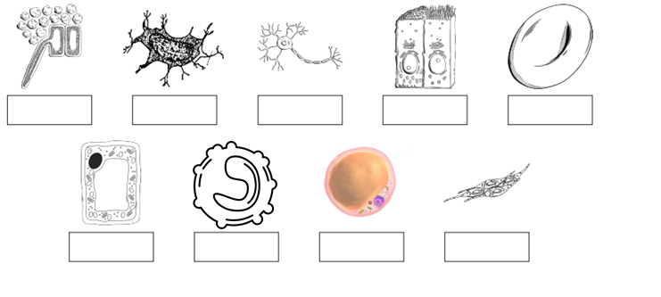

Cells with different functions have different structures. The cell is **adapted** to carry out its function really well.

* **Some specialized plant cells**

|  |  |
| --- | --- |
| **Cell** | **Function and adaptation** |
| 1. Image result for root hair cells diagram black and white **Root hair cells** | * Function: _______________________________________   _______________________________________   * The root hairs provide a _______ surface areafor substances to enter the root. * No chloroplast. |
| 1. **Palisade cells (leaf cell)** | * Function: _______________________________________   _______________________________________   * Lots of ______________for photosynthesis. * They have a shape that allows them **to pack closely together** in the _________ part of a **leaf**. |

* **Some specialized animal cells**

|  |  |
| --- | --- |
| **Cell** | **Function and adaptation** |
| 1. **Red blood cells**   Blood cells - Free healthcare and medical icons | * Designed to carry oxygen. * Found in ________________. * They are disc-shaped with large surface area, for _____________ to pass through. * Contains haemoglobin, which joins with oxygen. * Has no _______________. This makes more room for haemoglobin. |
| 1. **White blood cells** | * Function: _______________________________________   _______________________________________   * They are cells of the ___________system. * Lymphocytes produces__________, which attack harmful microorganisms in the blood. * ____________engulfs harmful microorganisms. |
| 1. **Muscle cells**   **Image result for cardiac smooth skeletal muscles** | * Function:   _______________________________________  _______________________________________   * Lots of ___________ to provide energy. * Each muscle cell is completely full of **__________**. They allow muscle cells to contract and produce movement. |

|  |  |
| --- | --- |
| **Cell** | **Function and adaptation** |
| 1. **Image result for nerve cell adaptationsNerve cells** | * They transfer messages from one part of the body to another. * Can carry electrical impulses. * Long, thin _________. * Branching ____________ at either end. |
| 1. **Fat cells**   ÙØªÙØ¬Ø© Ø¨Ø­Ø« Ø§ÙØµÙØ± Ø¹Ù âªfat cells diagramâ¬â | * They act as an ______________**__.** * Helps to keep you warm. * The ___________ and _________ are squeezed to the side to make room. |
| **6. Ciliated cells**  Related image | * Function:   _______________________________________  _______________________________________   * They line the air passages in the lungs. * They are found in structures like the nasal cavities, bronchial tubes and trachea. * They have tiny hairs called ___________. * Lots of mitochondria to provide _____________. |
| **7. Bone cells** | * Bone cells make _________ and excrete them into their surroundings. * Fibers attract _________ to make a rigid solid. |