**The National Orthodox School /Shmaisani**

**Subject: Chemistry**

**Name: Topic: Acids and alkalis**

**Date: Grade-Section: 6CS- all sections**

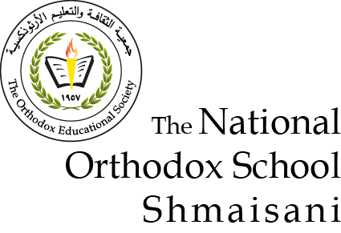

|  |  |  |
| --- | --- | --- |
| **Acid strength**  Acids have a pH _________ 7. The more H+ions, the ___________acidic it is and the __________the pH will be. | What ions do acids and bases produce when dissolved in water?  Acids:  Bases: | Label the **A**cid and **B**ase.  NaOH  HCl  H2SO4  HNO3  Ca(OH)2  KOH |
| List 3 properties of bases.  -  -  - | pH 7 is said to be _________ – this means there is a balance of H+ and OH- ions. | What are the two types of indicators?  -  - |
| Label the **A**cid and **B**ase.  Hydrochloric acid  Sodium hydroxide  Sulfuric acid  Potassium hydroxide  Nitric acid | **Base strength**  Bases have a pH_________ 7.  The more OH- ions, the ___________basic it is and the __________the pH will be. | List 3 properties of acids.  -  -  - |