
Writing A Newspaper Article
Name: ……………………………
Grade: 8 CS:…………………….

What is a newspaper report?
Newspapers report on news stories from around the world every day. They are written in the past tense because they are reporting on things that have already happened.


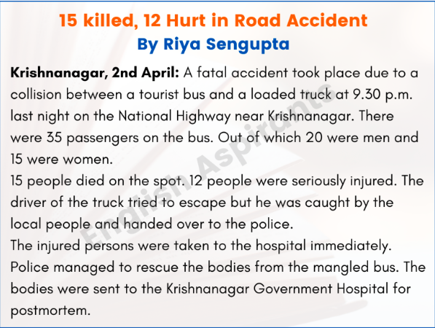

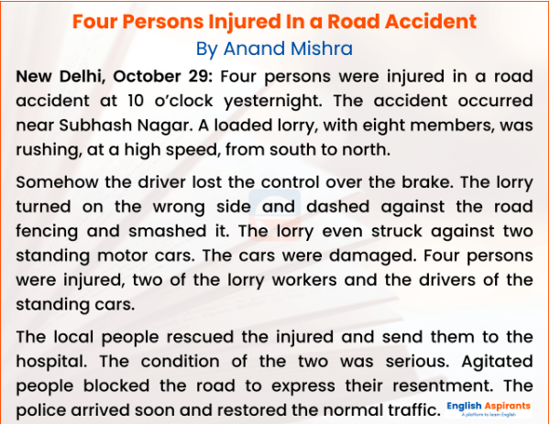

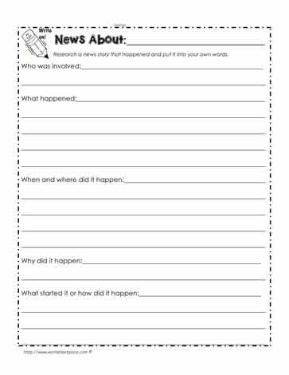
- The key elements of a News Report are:

  - Headline
Catches your attention
Sums up the story

  - Byline
Writer’s name
Writer’s Specialty, e.g. sports, food, crime, current events
  - Lead
4.
The opening section
Gives most important information
Should answer most of the 5W's
  - Body
Supplies detail
Most important details come first
Simple true statements
5.Quotation
What someone actually said
Adds accuracy
Adds “at the scene” feeling

