expresses true or very probable situation in the present or future.
If + Present Simple, Future Simple
Imperative
can/may/might/
must/should
+ bare infinitive
If it is sunny, we will go to the beach.
If you need help, ask me.
If you do your homework, you can go out.
If you go hiking, you must wear hiking boots.
expresses untrue or improbable situations in the present or future.
If + Past Simple, would/could/
might
+ bare infinitive
If I had more free time, I would take up gardening.
If I won a lot of money in a lottery, I might give some to charity.

expresses unreal, impossible situations in the past.
If + Past Perfect, would have
+ past participle
If I had seen Robert, I would have talked to him.

If Dave _ _ _ _ _ _ _ _ _ _ (not, invite) me to his birthday party, I would feel disappointed.
If I hadn’t got up earlier, I _ _ _ _ _ _ _ _ _ _ (miss) my flight to Vienna.
We _ _ _ _ _ _ _ _ _ _ (stay) at home if it snows tomorrow.
If we _ _ _ _ _ _ _ _ _ _ (earn) enough money, we’ll buy a new hi-fi system.
What would you do if you _ _ _ _ _ _ _ _ _ _ (get) lost in a forest at night?
Kevin wouldn’t have moved to Britain if he _ _ _ _ _ _ _ _ _ _ (find) a decent job here.
If I knew Diana’s address, I _ _ _ _ _ _ _ _ _ _ (send) her a valentine card.
What _ _ _ _ _ _ _ _ _ _ (Jane, do) if she fails the university entrance examination?
If John’s parents _ _ _ _ _ _ _ _ _ (know) French, they could help him with his project.
10. If Finn _ _ _ _ _ _ _ _ _ _ (apologize) to me, I would
have forgiven him.
11. My cousin would play video games all day long if his
parents _ _ _ _ _ _ _ _ _ _ (allow) him to.
12. If Emma _ _ _ _ _ _ _ _ _ _ (not, feel) better
tomorrow, she should see a doctor.
13. Who _ _ _ _ _ _ _ _ _ _ (you, choose) if you could take
one friend to go to Disneyland with you?
14. Kate _ _ _ _ _ _ _ _ _ (call) you if she had known you
were ill.
15. If you _ _ _ _ _ _ _ _ _ _ (be) cold, you can put on
warm socks and a bathrobe.
16. James would buy his wife a BMW if he _ _ _ _ _ _ _ _ _
(be) richer.
17. If Barbara and Paul _ _ _ _ _ _ _ _ _ _ (spend) more
time together their marriage would have lasted
longer.
18. My parents _ _ _ _ _ _ _ _ _ _ (buy) me a new MP3
player if I pass my final exams.
19. If my team _ _ _ _ _ _ _ _ _ _ (lose) the match, we will
fall to the second division.
20. If the concert _ _ _ _ _ _ _ _ _ _ (finish) earlier, I
would have taken the 10.30 bus.
Complete the sentences with the correct form of the verbs.

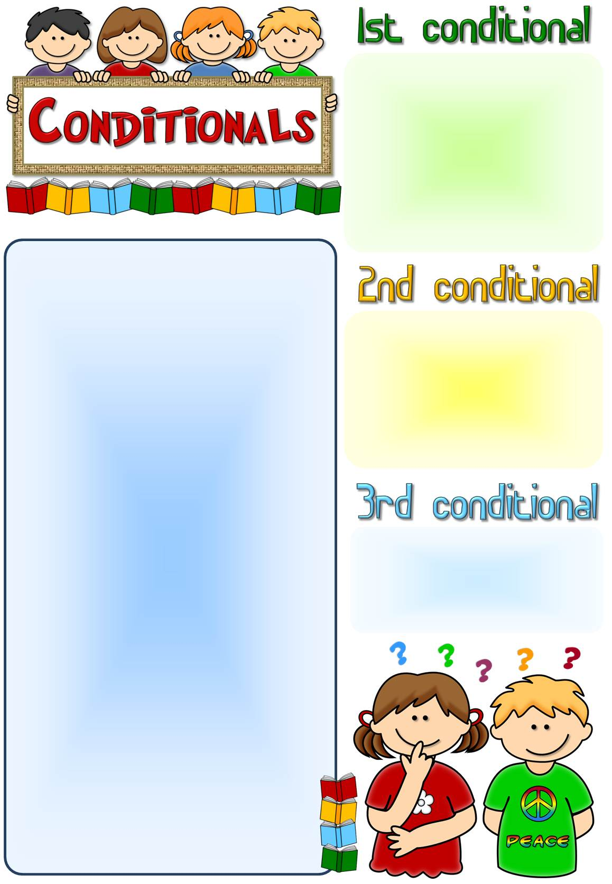

expresses true or very probable situation in the present or future.
If + Present Simple, Future Simple
Imperative
can/may/might/
must/should
+ bare infinitive
If it is sunny, we will go to the beach.
If you need help, ask me.
If you do your homework, you can go out.
If you go hiking, you must wear hiking boots.
expresses untrue or improbable situations in the present or future.
If + Past Simple, would/could/
might
+ bare infinitive
If I had more free time, I would take up gardening.
If I won a lot of money in a lottery, I might give some to charity.

expresses unreal, impossible situations in the past.
If + Past Perfect, would have
+ past participle
If I had seen Robert, I would have talked to him.

If Dave _ _ _ _ _ _ _ _ _ _ (not, invite) me to his birthday party, I would feel disappointed.
If I hadn’t got up earlier, I _ _ _ _ _ _ _ _ _ _ (miss) my flight to Vienna.
We _ _ _ _ _ _ _ _ _ _ (stay) at home if it snows tomorrow.
If we _ _ _ _ _ _ _ _ _ _ (earn) enough money, we’ll buy a new hi-fi system.
What would you do if you _ _ _ _ _ _ _ _ _ _ (get) lost in a forest at night?
Kevin wouldn’t have moved to Britain if he _ _ _ _ _ _ _ _ _ _ (find) a decent job here.
If I knew Diana’s address, I _ _ _ _ _ _ _ _ _ _ (send) her a valentine card.
What _ _ _ _ _ _ _ _ _ _ (Jane, do) if she fails the university entrance examination?
If John’s parents _ _ _ _ _ _ _ _ _ (know) French, they could help him with his project.
10. If Finn _ _ _ _ _ _ _ _ _ _ (apologize) to me, I would
have forgiven him.
11. My cousin would play video games all day long if his
parents _ _ _ _ _ _ _ _ _ _ (allow) him to.
12. If Emma _ _ _ _ _ _ _ _ _ _ (not, feel) better
tomorrow, she should see a doctor.
13. Who _ _ _ _ _ _ _ _ _ _ (you, choose) if you could take
one friend to go to Disneyland with you?
14. Kate _ _ _ _ _ _ _ _ _ (call) you if she had known you
were ill.
15. If you _ _ _ _ _ _ _ _ _ _ (be) cold, you can put on
warm socks and a bathrobe.
16. James would buy his wife a BMW if he _ _ _ _ _ _ _ _ _
(be) richer.
17. If Barbara and Paul _ _ _ _ _ _ _ _ _ _ (spend) more
time together their marriage would have lasted
longer.
18. My parents _ _ _ _ _ _ _ _ _ _ (buy) me a new MP3
player if I pass my final exams.
19. If my team _ _ _ _ _ _ _ _ _ _ (lose) the match, we will
fall to the second division.
20. If the concert _ _ _ _ _ _ _ _ _ _ (finish) earlier, I
would have taken the 10.30 bus.
Complete the sentences with the correct form of the verbs.

If Dave didn’t invite me to his birthday party, I would feel disappointed.
If I hadn’t got up earlier, I would have missed my flight to Vienna.
We will stay at home if it snows tomorrow.
If we earn enough money, we’ll buy a new hi-fi system.
What would you do if you got) lost in a forest at night?
Kevin wouldn’t have moved to Britain if he had found a decent job here.
If I knew Diana’s address, I would send her a valentine card.
What will Jane do if she fails the university entrance examination?
If John’s parents knew French, they could help him with his project.
10. If Finn had apologized to me, I would have forgiven him.
11. My cousin would play video games all day long if his parents allowed him to.
12. If Emma doesn’t feel better tomorrow, she should see a doctor.
13. Who would you choose if you could take one friend to go to Disneyland with you?
14. Kate would have called you if she had known you were ill.
15. If you are cold, you can put on warm socks and a bathrobe.
16. James would buy his wife a BMW if he were/was richer.
17. If Barbara and Paul had spent more time together their marriage would have lasted longer.
18. My parents will buy me a new MP3 player if I pass my final exams.
19. If my team loses the match, we will fall to the second division.
20. If the concert had finished earlier, I would have taken the 10.30 bus.
Complete the sentences with the correct form of the verbs.
Answers

