

**UNIT 9**

**S+ Wish +S =if only +S**



1. **Unreal past forms for past regrets**



**The function**:

● *wish* or *If only* + Past Perfect



1. To express regrets about the past.



2. To reflect on past actions if we are trying to improve our work or our behavior.



● The tense of the verb after *wish* is more in the past than the action it is describing.



e.g.

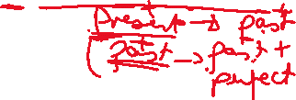

1. I didn't do much work for my exam.



**I wish** I had done more work for my exam.



**If only** I had done more work for my exam.



1. I bought these shoes. They hurt my feet.



**I wish** I hadn’t bought these shoes. They hurt my feet.



**If only** I hadn’t bought these shoes. They hurt my feet.



1. We’re late. We didn’t catch the earlier bus.



**We’re late.** **If only** we’d caught the earlier bus.

**I wish** we’d caught the earlier bus.

**BE**

4. He wasn’t happy.

I wish he had been happy.



If only _________________



5. He was sad.



**I wish** he hadn’t been sad.

**If only** ________________



6. She couldn’t find smart clothes for the party.



I wish she had found smart clothes…..



**If only** __________________________



He couldn’t have elaborated …..



**If only** he had elaborated………….

REGRET



7. Sami regrets not going to the party.

She wishes he had gone to the party.



8. Sami regrets going to the party.



She wishes he hadn’t gone to the party.



9. I regret going to bed late.



If only ……………………………. Later.



If only……………not………………. earlier.



10. Rami should have slept earlier.

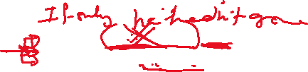

I wish Rami had slept earlier.



11. I would like to be a pilot.



I wish I was/were a pilot.



I would like to travel to India.



I wish I travelled to India.



1. **Unreal past forms for present wishes**



**The function**:



● wishor *If only* + Past Simple



1.We use wish + if only to express wishes about the present that are impossible or unlikely to happen.



NOTE: We usually say *I wish/If only* + *were*.

I wish I knew the answer.



I wish we lived in a bigger flat.



He wishes he were /was taller.



If only we were younger.



e.g.



1. Lina talks all the time in class.



If only Lina didn’t talk all the time in the class.



I wish Lina didn’t talk all the time in the class.



2. I don’t know the answer.



**I wish** I knew the answer.



**If only** I knew the answer.



3. He doesn’t live in a bigger flat.



**I wish** he lived in a bigger flat.



**If only** he lived in a bigger flat.



**4.Be**



He isn’t tall.



**He wishes** he were taller.



**If only** he were taller.



We are not old.



**If only** we were older.



**I wish** we were older.

They **aren’t sending…….**



**If only** they were sending ……..

He **is translating**……..

**If only** he **weren’t translating**.

I **haven’t found** the …………………

**If only……………**

She **hasn’t corrected the test papers.**

**If only ………………**

**Modals**

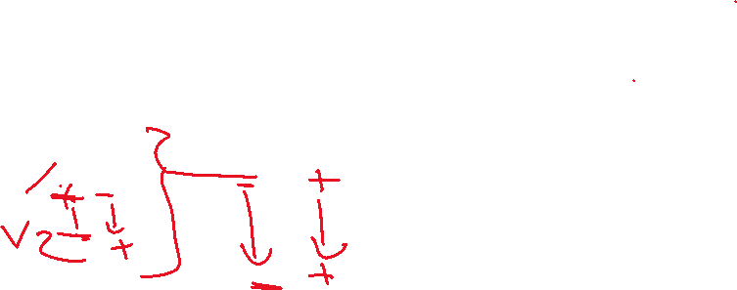

(Can, could, should)



I can’t sleep at night. Past

I wish I slept at night. (could slept)



If only I slept at night.



Oh! I have forgotten my library books.



If only I hadn’t forgotten ……



I wish



S.B. P.65 Ex. 5

**Complete the sentences with the correct form of the verbs in brackets.**

1 Ali did not pass his exams. If only he--------------- harder last year. (study)

2 Ziad did not know about Chinese culture when he went on a business trip to China. He wishes he--------------- a cultural awareness course. (do)



3 It was too hot to go to the beach yesterday. If only it---------------- cooler. (be)



4 I feel ill. I wish I-------------------so many sweets! (not eat)



A.B. P.45 Ex. 5

**Complete the sentences with words from the box.**

|  |  |  |  |  |  |
| --- | --- | --- | --- | --- | --- |
| **hadn’t** | **if** | **wish** | **had** | **had** | **only** |

**1** I couldn’t understand anything. ---------- only I’d studied Chinese!

**2** Ibrahim was right and I was wrong. I wish I ---------- listened to him.

**3** I---------- I’d known more about the company. If I’d done some research!

**4** I am very hungry! I wish I---------- eaten before I went to the conference.

**5** I regret the deal now. I wish we ---------- done it.

A.B. P.45 Ex. 6

**Read the situations and complete the sentences.**

**1** Sultan forgot to do his Science homework.

If only he ------------------------ to do it.

**2** I regret going to bed late last night.

I wish I--------------------------earlier.

**3** Nahla could not find her way round the city very easily.

If only she-----------------------------a map.

**4** Oh no! I’ve forgotten my library book. I left it at home.

I wish I--------------------------------------- .

**5** Our team didn’t play very well yesterday.

If only they-----------------------------------better.

A.B. P.45 Ex. 7

Use the prompts and write sentences with ***I wish*** and ***If only***. The first one is done for you.

**1** I’m cold. (bring a coat)

**If only** I’d brought a coat.

**I wish** I’d brought a coat.

**2** We’re late. (get up earlier)

……………………………………………………………………………..

……………………………………………………………………………..

**3** I feel ill. (not eat so many sweets)

……………………………………………………………………………..

……………………………………………………………………………..

**4** Fadi has lost his wallet. (be more careful)

……………………………………………………………………………..

……………………………………………………………………………..

**5** Huda was too busy to visit us yesterday. (be able to come)

……………………………………………………………………………..

……………………………………………………………………………..

**6** I’ve broken my watch. (not drop it)

……………………………………………………………………………..

……………………………………………………………………………..

A.B. P.45 Ex. 8

**Rewrite the sentences with the words in brackets.**

**1** Samia regrets being angry at breakfast time. (only)

……………………………………………………………………………..

……………………………………………………………………………..

**2** If only I had concentrated properly in class today. This homework is really difficult. (I)

……………………………………………………………………………..

……………………………………………………………………………..

**3** Nader should have been more careful with his essay. He didn’t get a good mark. (wishes)

……………………………………………………………………………..

……………………………………………………………………………..

**4** I wish I had learnt English better when I was younger. (if)

……………………………………………………………………………..

……………………………………………………………………………..

A.B. P.47 Ex. 11

**Complete the sentences using the correct form of the following prompts. The first one is done for you.**

|  |
| --- |
| be older  have a camera with me  live in a big house  not have a headache  not be so far away  like the same things |

1 Our flat is very small.

**If only** **we** lived in a big house.

2 Jaber isn’t old enough to drive a car.

**He wishes he**______________________.

3 My brother and I never want to watch the same TV programme.

**I wish we** _________________________.

4 I’m looking at a beautiful view, and I’d love to take a photo.

**If only I** ___________________________.

5 My cousins don’t live near here.

**I wish they** ________________________.

6 I want to go out this afternoon, but I don’t feel well.

**If only I** ___________________________.

S.B. P.68 Ex. 4

**Choose the most suitable verb form to complete these sentences.**

1 Ziad is not very good at basketball. He wishes he---------- taller! (is / were / was)

2 I can’t do this exercise. I wish I---------- it. (understood / understand / understanding)

3 Mr Haddad does not understand the Chinese businessman. If only he-------- Chinese. (speak / spoke / had spoken)

4 Jordan needs to import a lot of oil. If only it----- larger oil reserves. (has / had / had had)

c