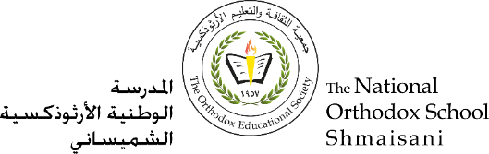

**The Primary Stage of Grades (4-5)**

**School Year 2022 - 2023**

**Name**: ___________ **Subject**: Science

Worksheet #2: The digestive system

**Date: / / Class: Grade Four National (All Sections)**

**_____________________________________________________________**

**Objective/s:**

* **Identify different organs of the digestive system and the function of each organ.**

**Question one:**

The diagram shows the organs of the human digestive system.

Label each organ.



**Question Two:**

Identify the path of food as it enters your body through your mouth.

**Mouth 🡺 ………………………..…… 🡺 ………………………….…………. 🡺 ……………………………..….. 🡺…………………………………………… 🡺 Anus**

**Question Three:**

In which organ of the digestive system does each of the following functions take place:

|  |  |
| --- | --- |
| **Function** | **Organ** |
| Food is chewed into smaller pieces here. |  |
| Transfers food from the mouth to the stomach. |  |
| Absorb water from the undigested food. |  |
| Produces digestive juices. |  |
| Digestion starts here. |  |
| The digested food is absorbed into the blood here. |  |
| Churns food and squeezes it to turn it into thick liquid. |  |
| The food is mixed with saliva here. |  |
| Digestion ends here. |  |