**6-8 Department**

**Global Perspectives**

**Challenge (1) Water Crisis**

**Boolean Modifiers**

**Name: ---------------------------- Grade 7 (A, C, D, E, F,G)**

**Objectives: Identify and begin to reference a range of print and multimedia sources and use them to locate relevant information and answer research questions.**

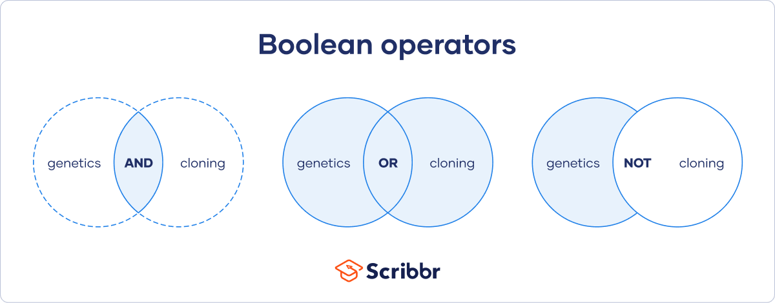

**How to use Boolean operators**

Knowing how to use Boolean operators effectively can save you a lot of time and help you to find useful sources, determine the [relevance](https://www.scribbr.com/research-process/relevance-dissertation-topic/) of your research topic, and create strong [research questions](https://www.scribbr.com/research-process/research-questions/).

**AND**

**AND** will provide search results containing**both or all** of your keywords.

Use this when you want results that contain two or more specific keywords.

Example: Using AND Anthropocene AND climate change AND ecosystem



**OR**

**OR** will provide search results containing **at least one** of your keywords.

Use this when you want results that contain at least one (though not necessarily both) of your chosen keywords.

Example: Using OR horticultural OR agricultural

**NOT**

**NOT** will provide search results containing**the first** of your keywords **but not the second**. Make sure to put your keywords in the correct order when using NOT, as the search results provided will exclude the latter keyword.

Use this when you want results that contain one specific keyword but not another.

Example: Using NOT centrifugal NOT centripetal

**Parentheses: ()**

[Parentheses](https://www.scribbr.com/language-rules/parentheses/) allow you to **group together**keywords and control the order in which the terms will be searched, just like in a mathematical statement. Keywords and Boolean operators **within** **parentheses will be searched first**, followed by keywords outside parentheses.

For example, the combination shown below will provide results that are initially filtered to contain at least one of “id” or “ego,” and then further refined to also include “developmental.”

Example: Using parentheses (id OR ego) AND developmental

You can also use more than one pair of parentheses. The search will filter results based on the innermost parenthetical keywords first, followed by the keywords in outer parentheses, and finally the keyword(s) outside parentheses.

Example: Using multiple sets of parentheses ((id OR ego) AND Lacan) AND developmental

**Quotation marks: “”**

[Quotation marks](https://www.scribbr.com/language-rules/quotation-marks/) will provide search results containing the **exact**keyword(s) contained within.

Use this when you want results that contain a precise keyword or keywords.

Example: Using quotation marks “Holocene epoch”

***References and sources***

Ryan, E. (2022, November 4). *Boolean operators: Quick Guide, examples & tips*. Scribbr. Retrieved February 16, 2023, from https://www.scribbr.com/working-with-sources/boolean-operators/