

**Our value: Self – belief and hard work will always earn you success**

worksheet U. 5

Grade 7 (A + B)

Name: Date: / /2023

**Objectives: To review degrees of comparison.**

**To practise using comparative and superlative adjectives.**

Degrees of comparison

Comparative and superlative

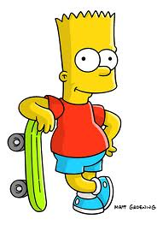

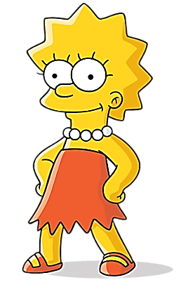

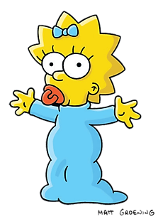

10 years 9 years 2 years

Bart is young. Lisa is young**er**. Maggie is **the** young**est**.

|  |  |  |  |
| --- | --- | --- | --- |
| * **Use** 1. We use the **comparative form + than** to compare two people or things.   Alex is **taller** than Jim. (one syllable)  My house is **more attractive than** your house. ( 3 syllables)   1. We use **the + superlative form + of/in** to compare one person or thing with more than two people or things in the same group.   Alex is the **tallest of** all.  New York is **the most exciting city in** the USA. ~~(~~**~~Not: of the USA)~~**  **We use in when we talk about places.** | | | |
| **Formation** | **ADJECTIVE** | **COMPARATIVE** | **SUPERLATIVE** |
| **1.General rule** (short words)   * **adj. + -er + than** * **the + adj. + -est**   ***2.Ending in –e:***   * Adj. + -r + than * the + Adj. + -st   ***3.Ending in short vowel + consonant:***  double the consonant  ***4.Ending in consonant + –y:***   * replace –y --> –ier or -iest | long  smart  old  tall  nic**e**  big  laz**y**  funn**y**  happ**y** | long**er**  smart**er than**  old**er**  tall**er**  nice**r**  bi**gg**er  laz**ier**  funn**ier**  happ**ier** | long**est**  the smart**est**  old**est**  tall**est**  nice**st**  bi**gg**est  laz**iest**  funn**iest**  happ**iest** |
| **5.General rule** (long words)   * **MORE + Adj.** * **MOST + Adj.** | popular  responsible  handsome  nervous | **more** popular  **more** responsible  **more** handsome  **more** nervous | **most** popular  **most** responsible  **most** handsome  **most** nervous |
| ***6.Exceptions*** | good  well  bad  badly  far  much  many  little | **better**  **better**  **worse**  **worse**  **further**  **more**  **more**  **less** | **best**  **best**  **worst**  **worst**  **furthest**  **most**  **most**  **least** |

|  |
| --- |
| **Examples:**   * Bart is **young**. Lisa is **younger** **than** Bart but Maggie is **the** **youngest**. * Marge is **funny**. Bart is **funnier than** Marge but Homer is **the funniest**. * Bart is **responsible**. Lisa is **more responsible** than Bart but Marge is **the most responsible**. |

**as+ adjective + as**

We use **as +adjective + as** to show that two people or things **are similar in some way.**

The sofa is **as comfortable as** the armchair.

Paul **is as old as** Richard.

Peter is **as tall as** Tom.

**In negative sentences, we use not as ……as**

Alison **is not as clever as** Cynthia**.**

John **is not as strong as** Sam.

**Examples:**

1. Paul is stronger than Alan.

**As** Alan **is not as strong as** Paul.

1. This book has got 160 pages, that book has got 160 pages, too.

**As** This book **is as thick as** that one.

1. **Lisa is prettier than Clara.**

**As** Clara is not as pretty as Lisa.

**Exercise 1: Complete the sentences with the comparative form of adjectives between brackets.**

1. This story is (**funny**) funnier than that one.

2. I think mathematics is (**difficult**) more difficult than English.

3. A giraffe's neck is (**thin**) thinner than an elephant’s neck.

4. The weather today is (**good**) better than it was yesterday.

5. A holiday by the sea is (**expensive**) more expensive than a holiday in the mountains.

6. The weather yesterday was (**bad**)worse than it is today.

7. Non-smokers usually live (**long**) longer than smokers.

8. A rose is (**beautiful**) more beautiful than a weed.

**Exercise 2:** [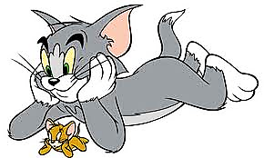](http://www.google.be/imgres?q=tom+and+jerry&um=1&hl=nl&rlz=1W1WZPH_nlBE443&biw=1366&bih=589&tbm=isch&tbnid=D_iyDXhLqgVuuM:&imgrefurl=http://www.yeti.be/fotodoos/foto/8549&docid=PmnVQ9Me6jvTDM&imgurl=http://www.yeti.be/files/img/fotodoos/137368/tomenjerry.jpg&w=470&h=282&ei=VoVTT6X4FJGbOp-o6cUO&zoom=1)**Make comparative sentences:**

1. Tom – tall – Jerry

Tom is taller than Jerry.

2. Vegetables – good – sweets

Vegetables are better than sweets.

3. English – interesting – biology

English is more interesting than biology.

4. Europe – small – Asia

Europe is smaller than Asia.

**Exercise 3: Complete the sentences with the superlative form of adjectives between brackets.**

1. The Nile is (**long**)the longest river in the world.

2. Morocco is (**hot**) the hottest country I’ve ever been to.

3. This exercise is (**easy**) the easiest exercise in the whole book.

4. Which is (**safe**)the safest way to travel?

5. Who is (**intelligent**)the most intelligent pupil in the class?

6. This party will be (**big**) the biggest party in his life.

7. Harry Potter is the most successful (**Successful**) fantasy film.

**Exercise 4: Fill in the following sentences with a comparative or a superlative. Use the adjective in brackets.**

1. Men can read (**small**) print than woman can; woman can hear (**good**)than men.

Men can read smaller print than woman can, woman can hear better than men.

2. A kangaroo rat can last (**long**) without water than a camel. A kangaroo rat can last longer without water than a camel.

3. “I am” is the (**short**) complete sentence in the English language. ‘’I am’’ is the shortest complete sentence in the English language.

4. You will be able to walk (**far**) if you wear professional hiking shoes. You’ll be able to walk farther than if you wear professional hiking shoes.

**Exercise 5: Write the comparative and superlative forms.**

|  |  |  |
| --- | --- | --- |
| **Long** | Longer than | The longest |
| **Expensive** | More expensive than | The most expensive |
| **happy** | Happier than | The happiest |
| **Fat** | Fatter than | The fattest |
| **Pretty** | Prettier than | The prettiest |
| **Good** | Better than | The best |
| **Far** | Farther than | The farthest |
| **Big** | Bigger than | The biggest |
| **Loud** | Louder than | The loudest |

**Thank You**