
Our value: A loving heart is the truest wisdom.

Worksheet (4 )
Grade 2
Name: ------------ Date: / /2023
Objectives: -To review the past of verb to be.
-To practice using the past of verb to be in questions and negative.
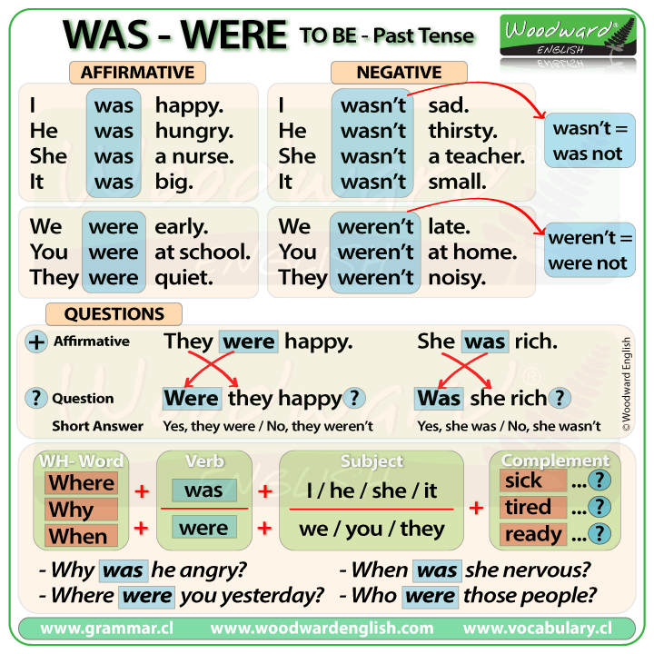______________________________________________
We use the simple past of (verb to) be to talk about things in the past.
**Some time expressions that indicate the past: yesterday, ago, last year, last month, last week, then.

Examples:
It was rainy yesterday.
It was not (wasn’t) sunny yesterday.
Was it rainy yesterday?
No, it wasn’t.
1)Make the sentence below negative and interrogative( questions).

A-She was at the park yesterday.
- (Negative): She wasn’t at the park yesterday.
- (Question): Was she at the park yesterday?
B- They were at home last month.
- (Negative): They weren’t at home last month.
- (Question): Were they at home last month?

- Complete the sentences using the past form of (verb to be).
was - wasn’t – were - weren’t - Was - Were

- The dog was sitting under the tree.
- It was sunny yesterday. It wasn’t raining yesterday.
- When was Lara’s birthday?
- Were they at school yesterday?
- Khalil and Sama were in the garden.
- You were in grade one last year.
- I was singing all the time yesterday.
- Where were you last week?
- The freezer door was open all night so it wasn’t closed.
- They were at home so they weren’t at school.

T.Taghreed Alnimri Coordinator’s Signature:

