The National Orthodox School/AL-Ashrafieh

Science Worksheet 1

**Mixtures and solutions**

Grade: 4 Date:

Name:

* Mixture (المخلوط) is a combination of two or more substances.
* Mixtures can be liquids , solids and gases.

**Kinds of mixtures**

1. **A solution**: is a mixture where one of the substances dissolves in the other. Ex: salty water

* Some solids **dissolve** in water to make a solution. These solids are **soluble**.
* 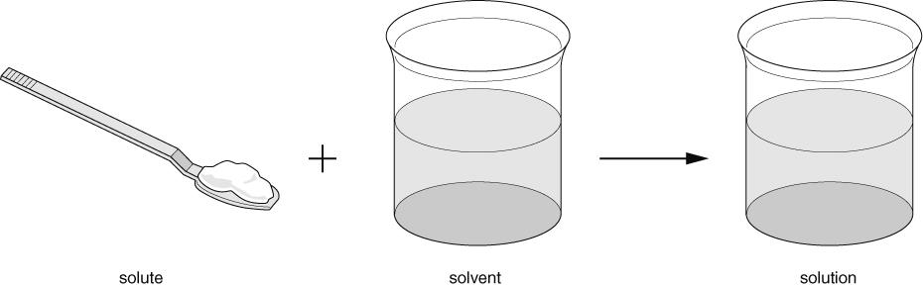A solution is made from a **solute** and a **solvent** (liquid).

Solute - **substance that is dissolved in a solvent**.

Solvent - **substance that dissolves the solute.**

Soluble - **a substance that can be dissolved.**

Insoluble - **a substance that is unable of being dissolved.**

Soluble and Insoluble

1)**Complete the table below**

|  |  |
| --- | --- |
| Substance | Soluble/ Insoluble |
| Salt | soluble |
| Seeds | insoluble |
| Rice | insoluble |
| Flour | insoluble |
| Sugar | soluble |
| Black pepper | insoluble |

1. What does the word ***soluble*** mean?

A substance that can be dissolved.

_____________________________________________________________________________

1. What does the word ***insoluble*** mean?

_____ A substance that cannot be dissolved.

_______________________________________________________________

1. Sand is soluble in water. (True / False)
2. Which one of these substances dissolves in water?

a-Wood b- plastic c- salt

1. Which material will not dissolve in water?

a- Sugar b- pepper c- salt

1. Sugar is soluble in water? (True / False)

8) Fill in with the missing words.

Soluble dissolve insoluble solute solvent

Salt can ___dissolve_____ in water, therefore salt is the

___solute_. Water is the ____solvent______________.

We say that salt is ___soluble________in water.

When something does not dissolve in water we say it is ________insoluble__________ in water.

*Teacher:Diala Al-azrai*