The National Orthodox School/AL-Ashrafieh

Science Worksheet 3

**Separating mixtures**

Grade: 4 Date:

Name:

When some materials are mixed together, it is possible to separate the mixture and get the original materials back again.

There are several different ways of separating mixtures.

**1- By Evaporation**:

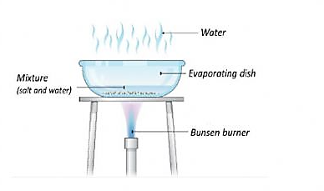This process is best used to separate solutions - mixtures in which a solid has dissolved in a liquid.

The water will evaporate and the salt will be left behind.

**2- By Filtering**

* 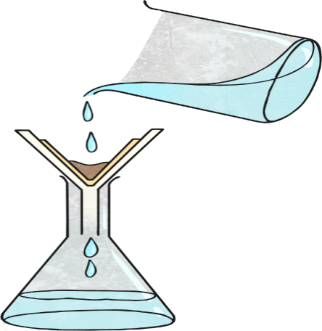This process should be used to separate a mixture of an insoluble solid and a liquid.

Ex: separating a mixture of sand and water

* The water will pass the filter paper, but the sand

Will be left on the filter paper.

**3- By Magnet**

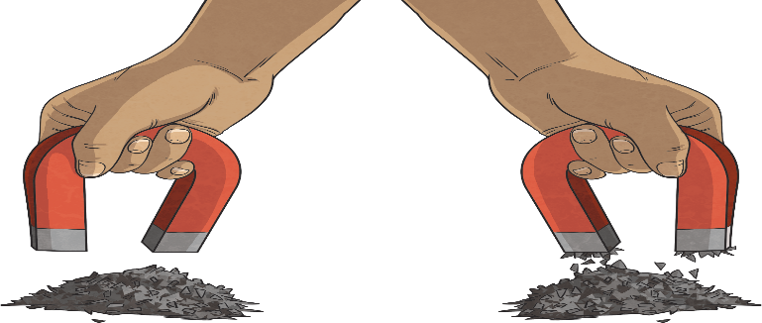Use this process to separate magnetic materials   
from non-magnetic materials.

Ex: separating iron filings and black pepper

**4- By Sieving**

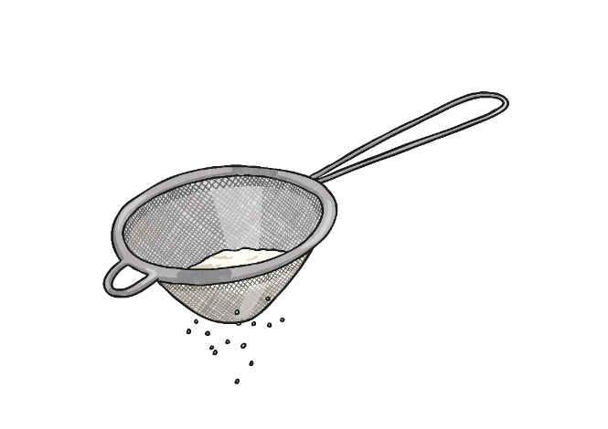Use this process to separate a mixture of different sized solids.

Ex: separating a mixture of flour

and rice or pasta.

**5- By Hand**

It is used to separate substances that are large enough to be seen.

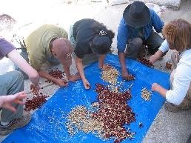Ex: separating nuts or small stones from rice

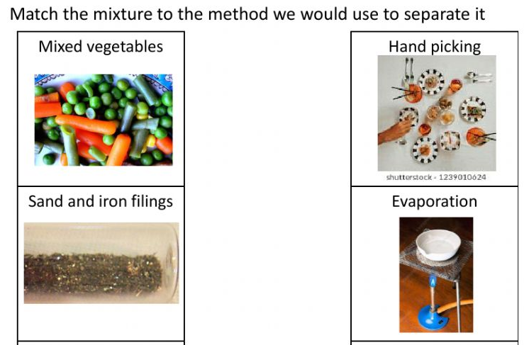

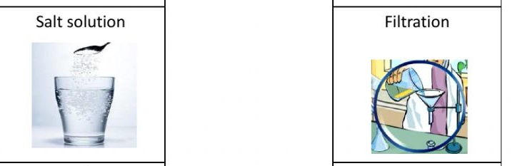

*Teacher:Diala Al-azrai*

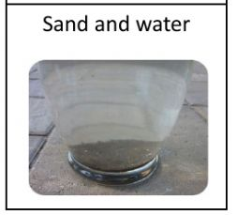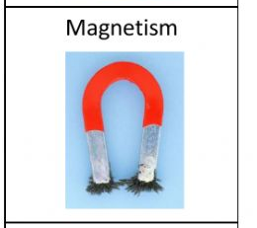

Teacher: Diala Alazrai