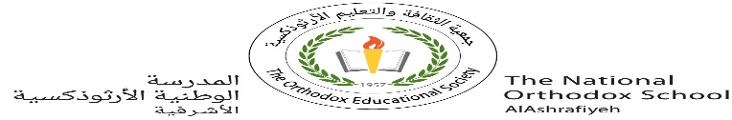

**Value*: The price of greatness is responsibility...***

The National Orthodox School

Science Worksheet

Name: Grade: 7(A+B)

Date: / /2023 Unit: 3

***Lesson 1: Density of solids and liquids***

### - All objects are made of matter.

**Mass, density and volume** are physical properties of matter.

- Mass : the amount of matter in an object. The units of mass are usually kilograms(kg) or grams (g).

### - Volume : is a measure of how much space an object takes up.  It is measured in cubic centimeters (cm3)or cubic meters (m3).

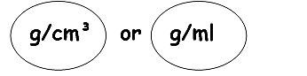- **Density**: is a measure of the amount of matter there is per unit volume.

** The unit for density is

** It is the relationship between mass and volume.

** The density of **water** is **1 g/cm****3**

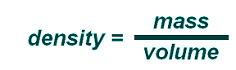

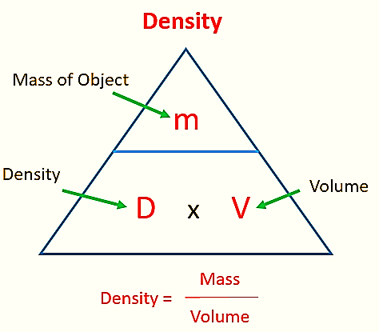

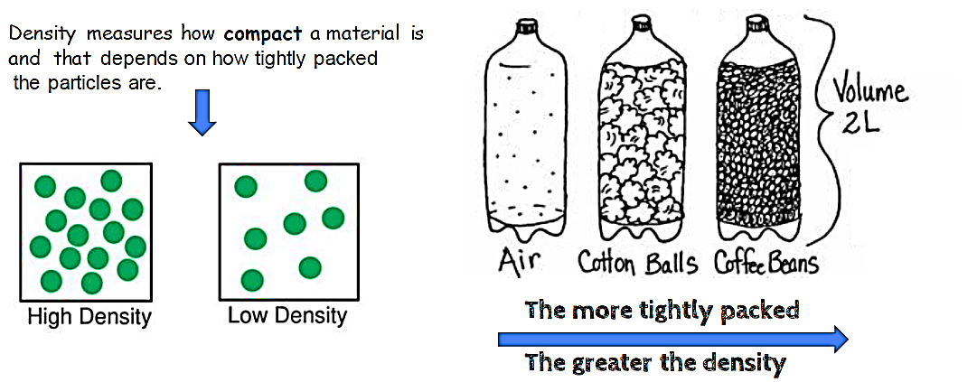

**1.** An aluminum bar measures 5.0 cm long, 4.0 cm wide, and 1.5 cm thick (height). It has a mass of 700.0 grams.

a. Calculate the volume of the aluminum bar.

Volume of the bar= Length*width*height(thickness)

5*4*1.5=30 cm3

b. Calculate the density of the aluminum bar.

Density= mass/volume

700/ 30=23.3 g/cm3

**2.** Find the mass of 250.0 mL of benzene. The density of benzene is 0.8765 g/mL

Mass= density* volume

= 0.8765*250=219.125 gram

3. A lead cylinder has a mass of 540 grams and a density of 2.70 g/ml. Calculate the volume of the lead cylinder.

Volume= mass /density

540/ 2.7=200 ml

**4. Arrange** the following according to their densities and **label** them in the picture below:

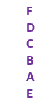

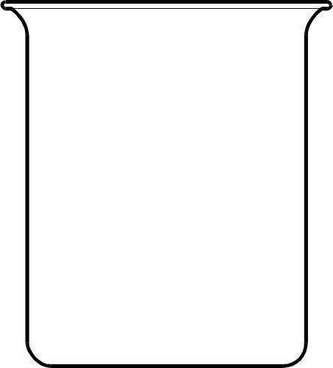

**LIQUID**

**LIQUID**

**LIQUID**

**LIQUID**

**LIQUID**

**LIQUID**

|  |  |
| --- | --- |
| **SUBSTANCE** | **DENSITY** |
| Liquid A | 15.30 g/cm3 |
| Liquid B | 10.01 g/cm3 |
| Liquid C | 7.39 g/cm3 |
| Liquid D | 5 g/cm3 |
| Liquid E | 18.20 g/cm3 |
| Liquid F | 3.25 g/cm3 |

a- Which liquid is most dense? __E______

b- Which liquid is less dense? ___F_______



**Rule # 1**- If the density of the substance is **GREATER/MORE** than the density of the liquid, the object will **SINK.**

**Rule#2 –** If the density of the substance is **LESS/LOWER** than the density of the liquid, the object will **FLOAT.**

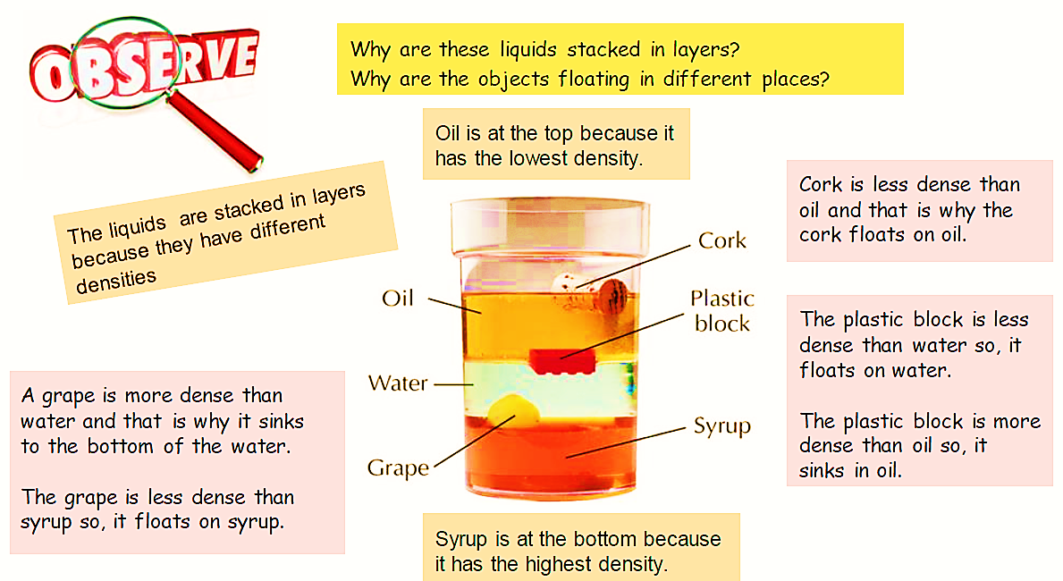

The following list contains information for four liquids and two solid objects. Complete the density table below by determining the density of each object.

* a yellow liquid with a mass of 2.8 g and a volume of 2 mL
* 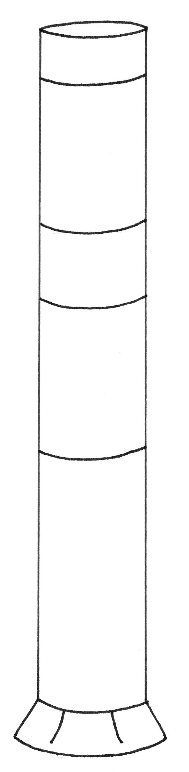a green liquid with a mass of 6 g and a volume of 3 mL
* a red liquid with a mass of 1.8 g and a volume of 2 mL
* an orange liquid with a mass of 1.3 g and a volume of 1 mL
* a blue cube with a mass of .8 g and a volume of 2 cm3
* a pink star with a mass of 2.4 g and a volume of .8 cm3

|  |  |  |  |
| --- | --- | --- | --- |
| **Object** | **Mass**  **(g)** | **Volume**  **(mL or cm3)** | **Density**  **(g/mL or g/cm3)** |
| yellow liquid |  |  |  |
| green liquid |  |  |  |
| red liquid |  |  |  |
| orange liquid |  |  |  |
| blue cube |  |  |  |
| pink star |  |  |  |

1. Which liquid is the most dense?
2. Which liquid is the least dense?
3. Which object will settle to the bottom?

*Use colored pencils to sketch the liquid layers in the container on*

*the right. Add the two solid objects at the appropriate locations.*

