 Compound Nouns Worksheet

Worksheet no.(3)

**Name………………… Grade (5)**

|  |
| --- |
| **Objectives**  **To practice using compound nouns correctly to finish the sentences.** |

**A compound word is when two words are put together to make a new word with a different meaning. It can be written as two words *(living room)*, but sometimes it is joined by a hyphen *(baby-sitter)*, or written as one word *(bathroom)*.

-Add a word from the bank below to each word on the list. You may add the word before or after the word on the list, but make sure they make a real compound word. Write the new compound word in the blank.

Word Bank

ball _ bread _ brow_ case _ cloth _ note _ pop _ room_ spoon _ tub

1) foot football

2) book notebook / bookcase

3) corn popcorn / cornbread

4) table tablespoon / tablecloth

5) bath bathroom / bathtub

6) eye eyebrow

**FURNISHINGS**

**In English**

**Match the words to build compound nouns. Then match and write the words under the pictures. Follow the example:**

**A HOUSE**

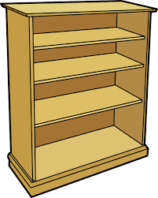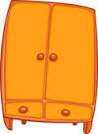

4

**stand**

**1. arm**

9

**wave**

**2. bedside**

14

**robe**

**3. book**

7

**place**

**4. coat**

bookcase

wardrobe

1

**chair**

**5. cup**

11

**lamp**

**6. dish**

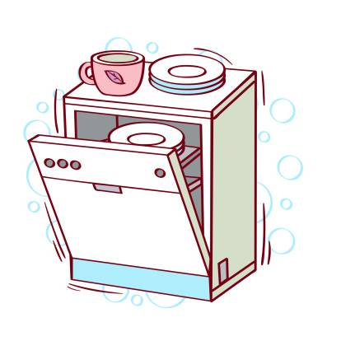

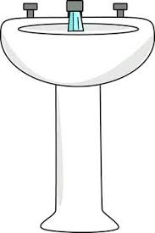

5

**board**

**7. fire**

10

**plant**

**8. front**

13

**clock**

**9. micro**

3

**case**

**10. pot**

washbasin

dishwasher

16

**machine**

**11. reading**

6

**washer**

**12. TV**

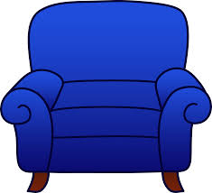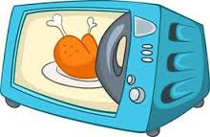

15

**basin**

**13. wall**

12

**set**

**14. ward**

2

**table**

**15. wash**

**ARMCHAIR**

microwave

8

**door**

**16. washing**

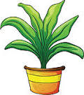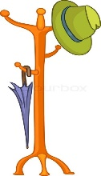

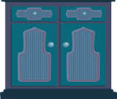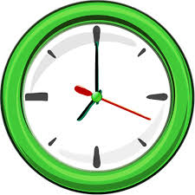

wall clock

cupboard

pot plant

washing machine

coat stand

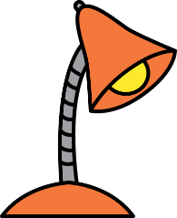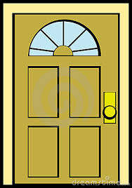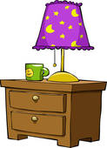

TV set

bedside table

fireplace

reading lamp

front door

**\*Use the following compound nouns in sentences of your own.**

**1. Wheelchair: He's been confined to a wheelchair since the accident.**

**2. Spaceship: The spaceship orbited the moon.**

**3. butterfly: The butterfly is black and white with a blue stripe running down each wing.**

**4. Rainbow: All the children run out to see the rainbow.**

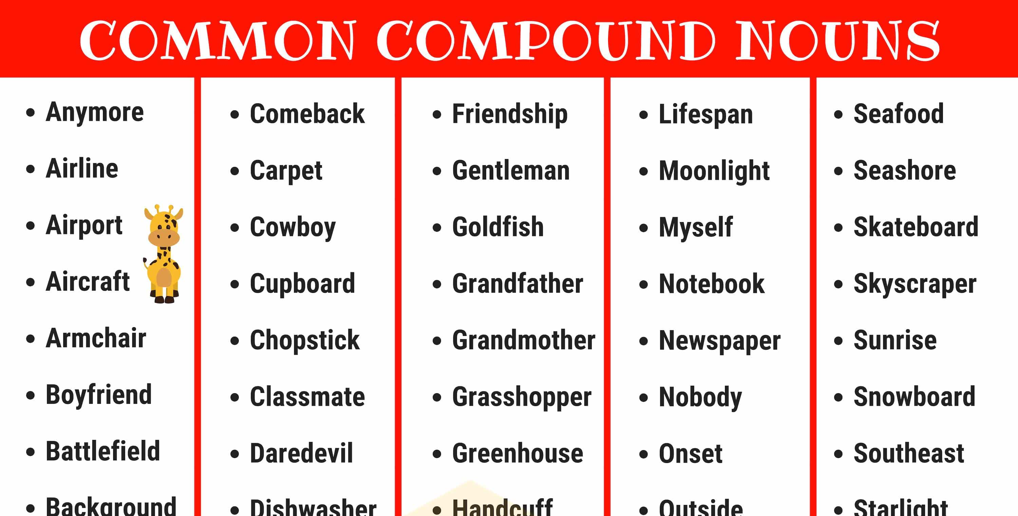

Tea