* 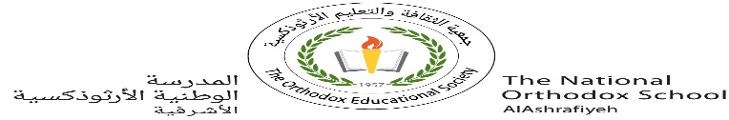

Our value: Be Truthful in what you say and do..

The National Orthodox School

Science Worksheet (2)

Name: Grade: 4

Date: / /2023

**Unit 4: Kinds of Mixtures**

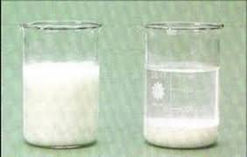**Kinds of mixtures**

1. **A solution**: is a mixture where one of the substances dissolves in the other.

Ex: salty water

1. **A suspension**: is a mixture between a liquid and an insoluble solid. ( The solid particles don’t dissolve).

The result : cloudy solution

A key characteristic of a suspension is that the solid particles will settle if left alone.

Ex: a mixture of chalk (or sand) and water



1. **An emulsion**: is a mixture of two or more liquids that don’t mix.

Ex: 1- oil and water

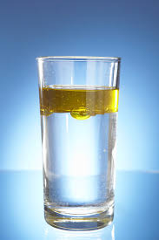 2- Paints

3- Ice cream

1. **An alloy**: is a mixture of metals.

Ex: 1- steel (ironحديد + carbonكربون)

2- Brass (copper نحاس+ zincخارصين)

3- Bronze: (copper + tin قصدير)

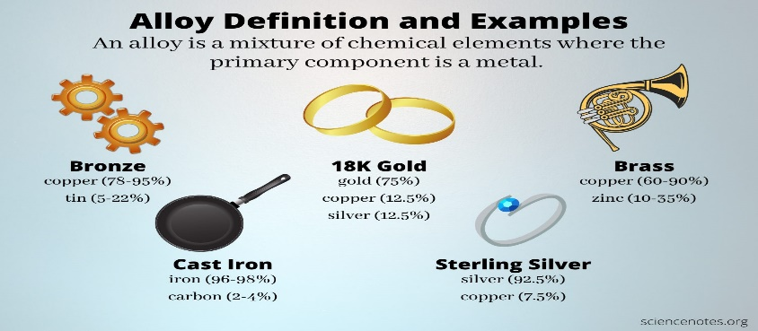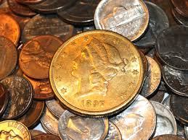

*Teacher:Diala Al-azrai*