**Education in Jordan**

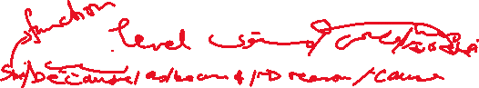

Our country has a high standard of education. This is mainly due to the fact that the government considers education a necessity. All schools, from kindergarten to secondary, are the responsibility of the Ministry of Education (MOE). Pre-school and kindergarten education is optional, followed by ten years of free, compulsory education. For higher education, students enter university, either for academic or vocational courses.

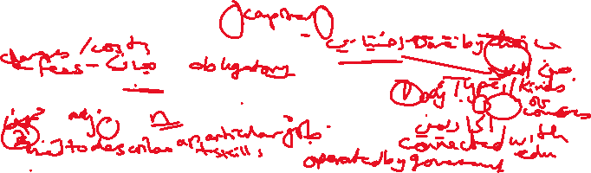

Students can attend one of ten public universities, or one of nineteen private universities. A large number of Jordanian students choose to study at these institutions, as well as foreign students from all over the world. These are undergraduates studying for a first degree, or postgraduates studying for a Master’s degree, a PhD or a higher diploma.

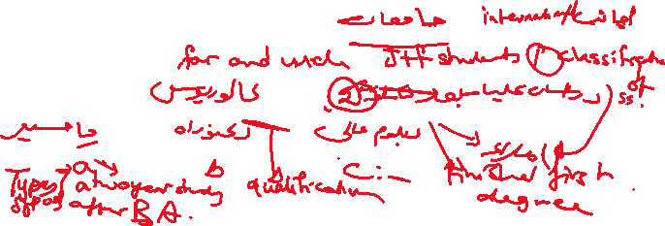

The three universities with the most undergraduates are the University of Jordan in Amman, Yarmouk University in Irbid and Al Balqa Applied University in Salt. These are all public universities. An example of a newer university is the German-Jordanian University in Amman, which was set up in 2005 CE. It is a collaboration between the MOHE and Germany’s Federal Ministry of Education and Research, and it follows Germany’s model of education in Applied Sciences.

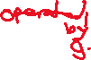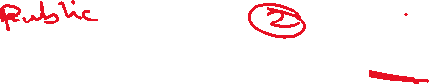

For students who wish to complete their university studies while working at the same time, it is also possible in some Jordanian universities to enrol onto online distance learning programmes. In the future, this option will become available in many other universities.

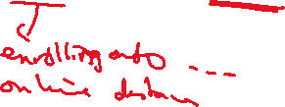

Ways to improve the education sysytem

1. Using technology in the classroom
2. Offering all kinds of services/facilities.
3. Granting scholarships for outstanding students.





