**The National Orthodox School / Shmaisani**

**Subject: Biology Pages 211,213**

**Name:** answer key

 **Date:** **Grade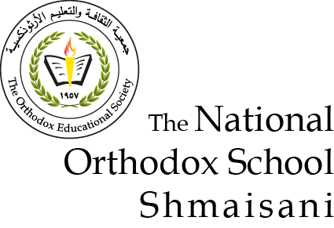 8 all sections**

**Q1. Each egg and sperm cell contains half of each parent’s genes. These combine to give each embryo a full set of genes.**

**Q3. Child inherits a different combination of genes from the same parents.**

**Q4. Identical twins look the same when they are young because they have identical genes and these control their characteristics.**

**Q5. One human characteristic controlled only by genes is your blood group.**

**Q6 Any two examples: height, body mass, intelligence.**

**Q7 Any example of a characteristic influenced only by the environment, e.g. language spoken.**



**Q2.The nucleus of a human cell contains 23 pairs of chromosomes or 46 individual chromosomes.**

**Q4. Sex cells (eggs and sperm) each contain – 23 individual chromosomes.**

**Q5. according to the sperm cell .**

**Q6. Parents are equally likely to have a girl or a boy because half a man’s sperm cells carry an X chromosome and the other half carry a Y chromosome.**