

**Our value: A loving heart is the truest wisdom.**

**Will Vs Be going to**

Grade 5 ( A + B ) worksheet no. ( )

Name: ___________________ Date : / /2023

Objectives: To identify how to talk about the future simple using (will + be going to)

To learn the different uses of will / be going to.

**When to use GOING TO?**

**1. When we have already decided or we intended to do something in the future. (Prior Plan)**

The decision has been made before the moment of speaking.

* They**'re going to** retire to the beach - in fact they have already bought a little beach house.
* I**'m going to** accept the job offer.

**2. When there are definite signs that something is going to happen. (prediction with evidence)**

Something is likely to happen based on the **evidence** or experience you have.

* Look at the clouds! It **is going to** rain.
* I don't feel well. I**'m going to** throw up. (throw up = vomit)

**When to use WILL?**

In other cases, where there is no implicit or explicit connection to the present, use **WILL**:

**1. For things that we decide to do now. (on_ spot Decisions)**

This is when you make a decision at that moment, in a spontaneous way.

* Do you like it? I'll buy one for you too.
* It’s hot. I will open the window. (I just decided this right now)

**2. When we think or believe something about the future. (Prediction) without evidence**

* Perhaps my team will not win the league this season.
* I think it will rain later so take an umbrella with you.

Note: (to express prediction especially with: probably, I expect, I hope, I believe, I think, I’m afraid, I’m sure, I know….)

Ex:

I hope it will be snowy tomorrow.

**3. To make an offer, a promise or a threat.**

* I'll give you a discount if you buy it right now. (offer)
* I promise I will behave next time. (promise)
* If you don’t stop, I will tell your mother. (threat)

**4. You use WON'T when someone refuses to do something.**

* I told him to take out the trash but he **won't** do it.
* My kids **won't** listen to anything I say.
* My car **won't** start.

**Time expressions:**

Tomorrow / tonight / next week , month , year / in two days / the day after tomorrow / soon / in a week , month …. etc.

**Practice**

A) Put the verbs in brackets into the correct future form. (**will-** or **be** **going to)**

1. A: We don’t have any bread.

B: I know. I am going to get some from the shop.

2. A: We don’t have any bread.

B: Really? I will get some from the shop then.

3. A: Why do you need to borrow my suitcase?

B: I am going to visit my mother in Scotland next month.

4. A: I’m really cold.

B: I will turn the heating on.

5. A: Are you going to John’s party tonight?

B: Yes. Are you going too? I will give you a lift.

6. A: What are your plans after you leave university?

B: I am going to work in a hospital in Africa. I leave on the 28th.

7. (The phone rings)

A: I will get it!

8. A: Are you ready to order?

B: I can’t decide … Okay, I will have the steak, please.

9. A: Are you busy tonight? Would you like to have coffee?

B: Sorry. I am going to go to the library. I’ve been planning to study all day.

10. A: Why are you carrying a hammer?

B: I am going to put up some pictures. Top of Form

B) **Write the correct form of going to or will to complete the dialogue.**  
  
  
**LAURA:** What are you doing this weekend, Tanya?  
  
**TANYA:** I am going to see (see) a new play tomorrow at the Royal Court theater.  
  
**LAURA:** Have you got the tickets yet?  
  
**TANYA:** NO, I am going to get (get) them this afternoon, actually. Would you like to come?  
  
**LAURA:** Oh, thank you, that would be nice.  
  
**TANYA:** OK, I will get (get) you a ticket too.  
  
**LAURA:** Great ... what time does it start?  
  
**TANYA:** Eight o'clock, but we will all meet (all meet) in the Green Cafe at 7.15.  
  
**LAURA:** OK, I will meet (meet) you in the cafe, but, er...  
  
I will be (be) there around 7.30.  
  
**TANYA:** That's fine.  
  
**LAURA:** Oh, one other thing ... I've got no money at the moment... I am going to pay (pay) for the ticket on Saturday. Is that OK?  
  
**TANYA:** Yes, that's OK, no problem.  
  
**LAURA:** Great! Why don't we go eat something in the restaurant?  
  
**TANYA:** That's a good idea. I will phone (phone) the others and see if they want to come too.  
  
**LAURA:** Good, and I will book (book) a table for us.  
  
**TANYA:** Great! I will meet (meet) you there in a moment.

C)**Use the following time expressions in meaningful sentences:**

* 1. Tomorrow: I think it will rain tomorrow.
  2. Tonight: We are going to have a party tonight.
  3. Next month: We are going to visit Canada next month.
  4. In two days: He will be back in two days.
  5. Soon: Old equipment will soon be remembered.

**Teacher: Mirna Nawaf Al- Sahawneh.**

Coordinator’s Signature: ____________________

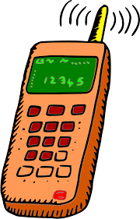The phone is ringing.

I will get it for you / I will answer. (on spot decision)

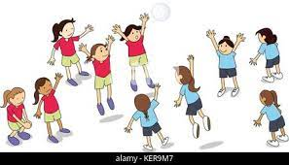 The blue(red) team will win the match.

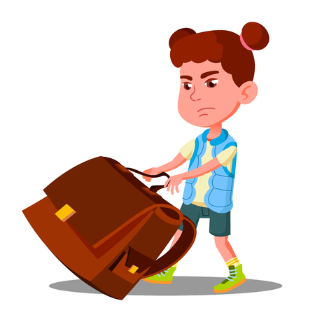I will help you.

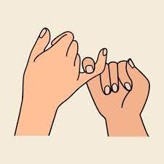 I promise, I won’t do it again.

I promise I will do my homework.

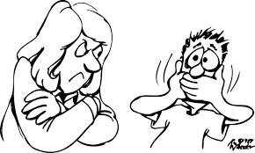 if you don’t stop bullying him, I will call your mom.



I am going to visit Egypt next month. I have already bought the ticket.

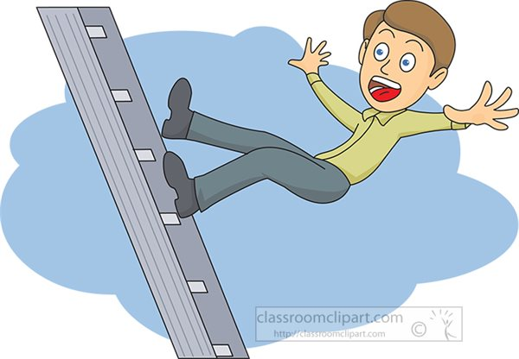

Watch out! You’re going to fall down.