  **Question Tags**

**Our value: A loving heart is the truest wisdom.**

**Name: Grade (6)**

Objectives: To review question tags and how they are formed.

To practice using the question tags.

Question tags are short questions that we use at the end of sentences – particularly in spoken English. There are lots of different question tags but the rules are not difficult to learn.  
  
**Positive/negative**  
  
If the main part of the sentence is positive, the question tag is negative ….

* *He’****s*** *a doctor,* ***isn’t he?***
* *You* ***work*** *in a bank,* ***don’t you?***

... and if the main part of the sentence is negative, the question tag is positive.

* *You* ***didn’t*** *meet him,* ***did you?***
* *She* ***isn’t*** *coming,* ***is she?***

-Note: A comma should precede the tag question.

He didn't know you***,*** did he?

**With auxiliary verbs**  
The question tag uses the same verb as the main part of the sentence. If this is an auxiliary verb (‘*have*’, ‘*be*’) then the question tag is made with the auxiliary verb.

They **weren’t having dinner yesterday at 7.00** , **were they?**

She doesn’t **have** a brother, **does she?**

**Without auxiliary verbs**  
  
If the main part of the sentence doesn’t have an auxiliary verb, the question tag uses an appropriate form of ‘*do*’.

* *I* ***said*** *that,* ***didn’t I?***
* *She* ***eats*** *meat,* ***doesn’t she?***

**With ‘I am’**  
If the main verb or auxiliary verb in the statement is **am**, the positive question tag is **am I?** but the negative question tag is usually **aren't I?**

***I'm*** never on time, am I?

***I’m*** *the fastest, aren’t I?*

|  |
| --- |
| **A positive statement tag** |

|  |
| --- |
| **A negative question tag** |

**+ -**

**Jordanian,**

are

aren’t

|  |
| --- |
| **A positive statement tag** |

|  |
| --- |
| **A negative question tag** |

**+**

**absent,**

was

wasn’t

[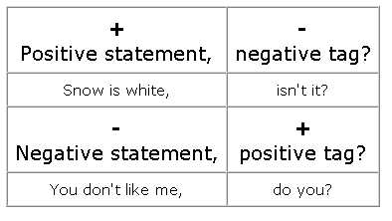](https://www.google.com/url?sa=i&url=http://www.ats.edu.mx/ifs/salc/?tag=tag-questions&psig=AOvVaw2jXf1skD18m9i5kTl4gltA&ust=1583258868203000&source=images&cd=vfe&ved=0CAIQjRxqFwoTCJDm6oax_OcCFQAAAAAdAAAAABAj)

***Fill in the gaps with the correct question tag.

1.Emma is twenty years old, isn’t she?

2.I am late, aren’t I?

3.They don't get up early, do they?

4.Our teacher isn't in the classroom, is she/he?

5.Your brother knows a lot about computers, doesn’t he?

6.Andrew doesn't drink coffee, does he?

7.John and Liam are interested in science, aren’t they?

8.It often rains in autumn, doesn’t it?

9.We sing well, don’t we?

10.They aren't from England, are they?

--------------------------------------------------------------------------

***Fill in the gaps with the correct question tag.

1. Daniel was busy last week, wasn’t he?

2.We didn't turn off the lights, did we?

3.You were at home yesterday, weren’t you?

4.The shop wasn't closed, was it?

5.Matthew invited you to the party, didn’t he?

6.She didn't call you yesterday, did she?

7.They were on holiday, weren’t they?

8.We saw Chris last week, didn’t we?

9.Amelia wasn't in Italy, was she

10.You didn't keep your promise, did you?

--------------------------------------------------------------------------

Fill in the gaps with the correct question tag.

1.The teacher is explaining a new grammar rule, isn’t she/he?

2.They aren’t playing computer games, are they?

3.Chris is writing the essay, isn’t he?

4.The girls are watering the flowers, aren’t they?

5.Lilly isn’t talking on the phone, is she?

6.They are getting late, aren’t they?

7.Your cat is scratching the sofa, isn’t it?

8.It is raining outside, isn’t it?

9.Kate and Jim aren’t waiting for me, are they?

10.She isn’t having lunch now, is she?

--------------------------------------------------------------------------

**Complete with the correct question tag.

1. John and Max don't like math, do they?

2. Peter played handball yesterday, didn’t he?

3. Mary didn't do her homework last Monday, did she?

4. I'm clever, aren’t I?

5. Mr. Brown is studying now, isn’t he?

6. The car isn't in the garage, is it?

7. You are John, aren’t you?

8. She went to the library yesterday, didn’t she?

9. He didn't recognize me, did he?

10. Cars pollute the environment, don’t they?

11. The trip is very expensive, isn’t it?

--------------------------------------------------------------------------

**Complete with the correct question tag.

* 1. They were exercising, weren’t they?
  2. Samantha was running, wasn’t she?
  3. Mary and Peter weren’t playing, were they?
  4. Silvio wasn’t watching a movie, was he?
  5. She was living in Rio, wasn’t she?

--------------------------------------------------------------------------

**Circle the correct tag question to complete the questions.

1. It's next to the supermarket, **don’t it / isn’t it** ?

2. You've met my brother before, **don’t you / haven’t you** ?

3. He was born in 1970, **didn’t he / wasn’t he** ?

4. You're coming tomorrow, **aren’t you / do you** ?

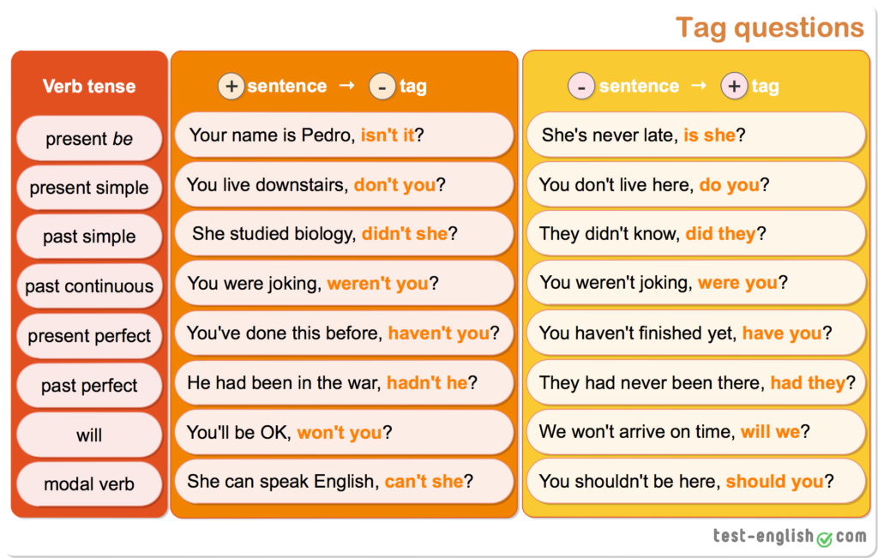

Teacher: Mirna Nawaf Al-Sahawneh.

Coordinator’s Signature: ____________________