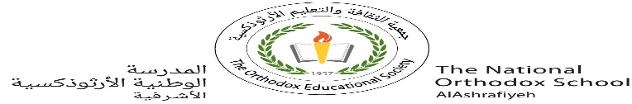

Our value: Be Truthful in what you say and do..

The National Orthodox School

Science Worksheet /**Unit 4: Matter**

Name**: (3)** Grade: 3

Date: / /2023

***Changing states of matter***

Any material can exist in three forms: solid, liquid or gas.



Cooling makes liquid turn into solids.

This is called: **freezing**.



Heating makes some solids change into liquids.

This is called:

**melting**.

When **heated or cooled**, matter changes its state.



Cooling makes gases turn into liquids.

This is called :

**condensation**.



Heating liquids turn them steam.

This is called:

**evaporation**.

What changes of state are shown in the pictures?

