

Our value: Be Truthful in what you say and do..

The National Orthodox School

Science Worksheet /**Unit 4: Matter**

Name**: (2)** Grade: 3

Date: / /2023

***Properties of the states of matter***

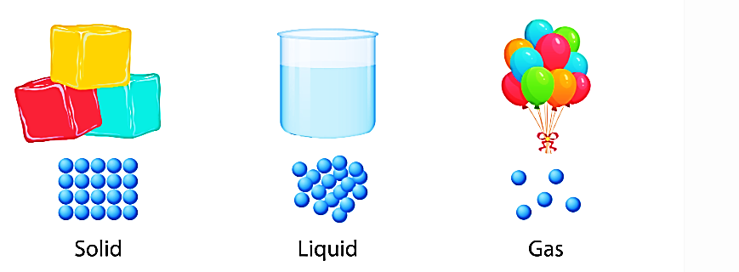

|  |
| --- |
|  |

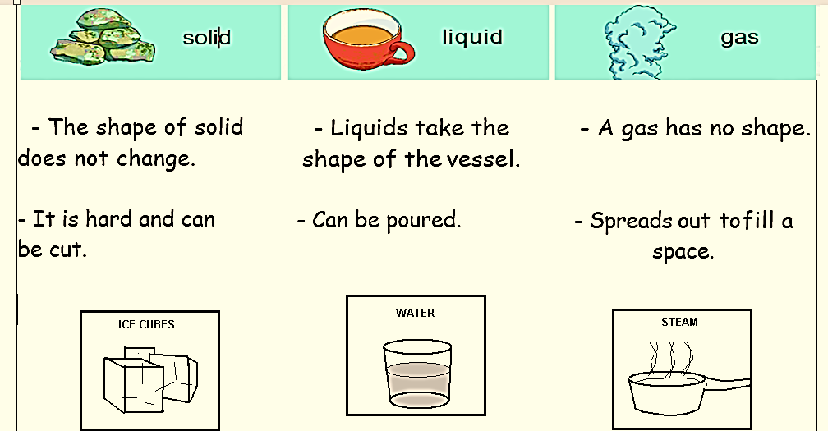

|  |  |  |  |
| --- | --- | --- | --- |
| **Property** | **Solid** | **Liquid** | **Gas** |
| **Shape**  **الشكل** | Fixed shape | **No** fixed shape | **No** fixed shape |
| **Space between molecules**  **المسافة بين الجسيمات** | Very close to each other | Not very close to each other | Very far away from each other |
| **Movement of molecules**  **حركة الجسيمات** | Vibrateيهتزوا | Move  and can be poured | Move quickly in all directions and spread(ينتشر) |

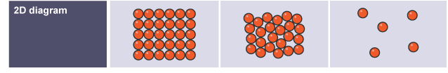

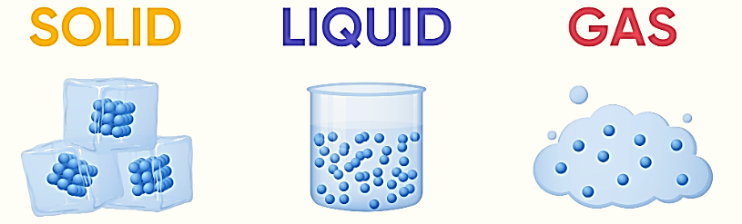

1- Match the pictures with the description and Write whether it is a **solid, liquid, or a gas.**

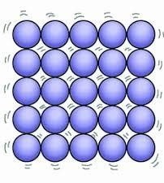

|  |
| --- |
| Particles are **far away** and can **move freely** in all directions. |
| Particles are **very** **close** together and **vibrate** in place. |
| Particles are **not very closed,** and can **flow** |



2- Fill in the table with the correct properties of solid, liquid, and gas

|  |  |  |  |
| --- | --- | --- | --- |
|  | **Solid** | **liquid** | **Gas** |
| Distance  between molecules |  |  |  |
| Movement of molecules |  |  |  |
| Shape |  |  |  |
| Examples |  |  |  |