

Our value: Be Truthful in what you say and do..

The National Orthodox School

Science Worksheet /**Unit 4: Matter**

Name: Grade: 3

Date: / /2023

***States of Matter***

|  |
| --- |
|  |

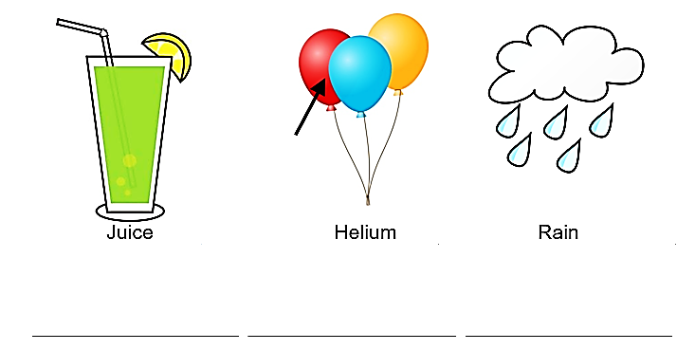Classify each object as a **liquid, solid** or **gas.**

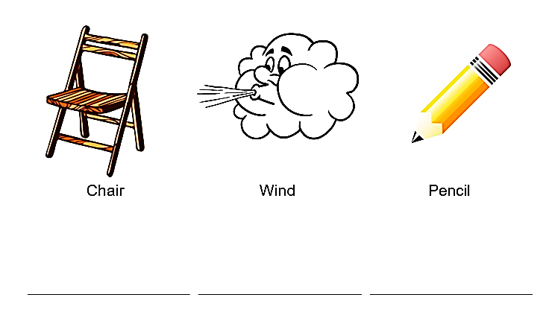

Choose the words from the bottom of the page and write them in the correct column.

