

**The Primary Stage of Grades (4-5)**

**School Year 2022 - 2023**

**Name**: ___________ **Subject**: **English Language**

**Revision Worksheet #1**

**Date:** ________________ **Class: Grade 4 National (all sections) _______________________________________________________________________**

**Read the following text and answer the questions:**

Objectives: -To read a text and answer comprehension questions.

-To practise some grammatical concepts covered.

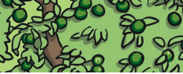

**How Does an Apple Seed Become an Apple Tree?**

Apple trees are a type of deciduous tree. Each year they lose their leaves in autumn and grow new leaves in spring. There are more than 7,500 different types of apples grown on apple trees around the world. Apple trees are members of the rose family.

Other plants in the rose family include strawberries, raspberries, plums, and pears.

After an apple tree seed is planted, it will take between 5 and 7 years before the tree will produce apples of its own. When an apple tree is ready to grow apples, small flowers will blossom first. The flowers come in different colours, for example, white, yellow and pink.

There are many stages in the life cycle of an apple tree.

1. 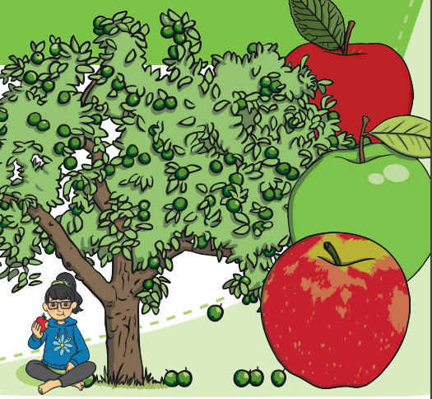The seed is planted into the soil. It sprouts a seedling. The roots go down into the soil. The seedling sprouts leaves that soak up energy from the sun.
2. Over time the seedling grows into a tree. This can take between 5 and 7 years before it is fully grown.
3. Flowers begin to blossom on the tree in spring. Insects such as bees carry pollen between the flowers. This helps the tree to make fruit.
4. In autumn, the flowers stop growing and apples begin to grow. The apples grow bigger and have seeds inside. The apples can then be picked and are ready for eating or cooking.
5. Some apples fall off the tree and rot on the ground. The seeds in the fallen apples go down into the soil and the cycle begins again. Animals, like birds, help spread the seeds around nearly and further away.

There are many different types of apples. Some of the more common types we see in the supermarket are Granny Smith, Pink Lady, Kerry Pippin and Irish Peach. Apples are very versatile and nutritious; they can be used in baking and cooking. Some examples of how you could use them when cooking are apple tarts, apple sauce, baby food or just eat them by themselves as a snack.

**Read the text then answer the questions that follow.**

1. **What does the word deciduous mean?**

________________________________________________________________________________________________________________________________________________________________________________________________

1. **How many different types of apple trees are there around the world?**

________________________________________________________________

1. **Name two other fruits that are part of the Rose family.**

_____________________________________________________________

1. **How long does it take for an apple tree to grow fully? Tick one.**

2 years

3-4 years

5-7 years

1. **How do we know that an apple tree is ready to grow apples? Select evidence from the text.**

________________________________________________________________

1. **Put the stages of an apple tree in the correct order.**

In Autumn, the flowers stop growing and apples begin to grow. The apples grow bigger with seeds inside. The apples can then be picked and are ready for eating or cooking.

Over time the seedling grows into a tree. This may take up to 5-7 years before it is fully grown.

Some apples fall off the tree and rot on the ground. The seeds in the apple go down into the soil and the cycle begins again. Some animals, like birds, help spread the seeds around.

The seed is planted into the soil. It sprouts a seedling. The roots go down into the soil. The seedling sprouts leaves that soak up energy from the sun.

Flowers begin to blossom on the tree in Spring. Insects such as bees, carry pollen between the flowers. This helps the tree to make fruit.

1. **How do you think animals help spread apple seeds?**

________________________________________________________________________________________________________________________________

1. **Draw a line to match the word to the correct meaning.**

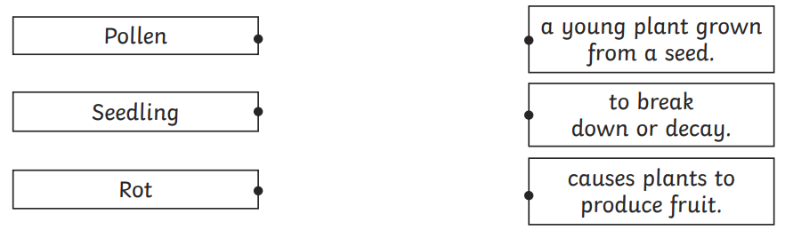

1. **Write three types of apples we might find in the supermarket.**

________________________________________________________________

1. **How do you like to eat your apples?**

________________________________________________________________________________________________________________________________

1. **Complete the sentences with words from the box.**

|  |
| --- |
| **cinnamon plantation vanilla ingredients bark steamship** |

____________ is a spice obtained from the _______ of several trees. Cinnamon is one of the most common _____________ used in making many delicious recipes. Cinnamon ____________ requires hot and humid climate. Many people like cinnamon, but some people prefer the taste of ____________.

1. **Read and choose.**
2. Please close the window. I’m __________________ **(cold / freezing)**
3. That cake my mom made looked _______________ (**mouth-watering / nice)**
4. For a snack, I brought a ____________ orange. **(fresh/ juicy)**
5. She always wears ________________ clothes. **(elegant / good)**
6. **Complete the conversation with the words from the box. There are five extra words.**

|  |
| --- |
| **doing would do go making will made going please wouldn’t** |

**Ana:** What are you ___________ on Saturday, Elena?

**Elena:** Well, I usually have a swimming lesson in the morning, but it’s a vacation this weekend. So, I’m _____________ shopping with my mom.

**Ana:** What about in the afternoon?

**Elena:** My cousins are coming over at about four o’clock and we’re __________ pizza.

**Ana:** That sounds fun!

**Elena:** ___________ you like to come?

**Ana:** Yes, _____________. I’d love to come. I’ll bring some cake.

**Elena:** Great! See you on Saturday.

**13. Fill in the spaces with the correct form of the verbs in brackets using present continuous tense.**

1. My mum _____________________ banana cakes. **(bake)**

2. The cat ____________________under the table. **(not/sleep)**

3. The birds _____________________ in the sky. **(fly)**

4. We ______________________lunch. **(have)**

5. ____________the boy __________________ his bicycle? **(ride)**

6. My sister ____________________ her hands. **(clap)**

**14.**  **Underline the present continuous tense. Write *F* (future) *P* (present).**

1.My friends are drinking some apple juice tomorrow. _______

2. They are playing badminton next Friday. __________

3. Bob and Kate aren’t swimming in the sea at the moment. __________

4. I am watching TV now. __________

**15.** **Complete the following sentences using the correct form of phrasal verb with drop.**

|  |
| --- |
| **drop back drop by drop out drop off** |

1. Some parents **__________** their kids **_________** at school.
2. He **___________________** the woman’s house to ask for money.
3. The soldiers got orders to **_________________**.
4. She had to **________________** of the race half way through.