

**Microsoft Excel – Classwork#2**

**Name: 2nd Semester 2022/ 2023**

**Date: Grade 6 – Section ………**

**Objective –** Validation rules, sorting and filtering data.

* Open the file Classwork2.xlsx using MS-Excel.
* Use the instructions below to edit the table to appear as in the following image.

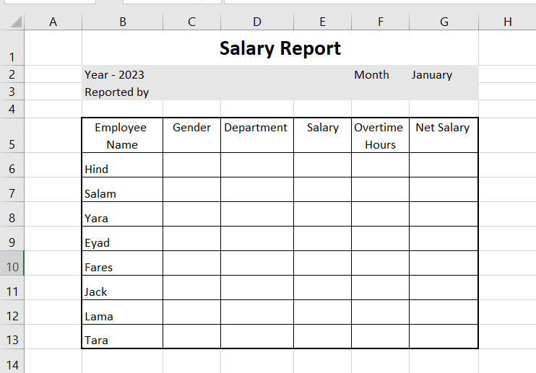

* 1. Change the row height for Row#1 to 40 points.
  2. Change the row height for Row#2 and Row#3 to 20 points.
  3. Change the row height for Row#5 30 points.
  4. In the range [B2:G3], change the fill color to be gray.
  5. Set the text “Salary Report” so that: size: 18, Calibri, bold.
  6. Set the width of column B to 12 points.
  7. Set the width of the columns: C, D, E, F and G to 11 points.
  8. The text in the cells: B5 and F5 must **wrap** over two lines as shown above.
  9. Format the range [E6:E13] to currency(£), 0 decimal places.
  10. The data in the range [C6:C13] must be restricted to [Male,Female].
  11. The data in the range [D6:D13] must be restricted to [HR,Secretary,Manager,Accounting].
  12. The data in the range [F6:F13] must be restricted to a whole number, between 0 🡪 12.
  13. In G6, use the following formula to calculate the Net Salary:

**Net salary = Salary +(overtime hours * 8)**

* 1. Fill in the table with data.
  2. In Cell C16 use a function to find out the **minimum net salary**.
  3. In Cell C17 use a function to find out the **maximum net salary**.
  4. In Cell C18 use a function to find out the **Total Salaries (use the net salary).**
  5. In Cell C3 type **your *name***.
  6. Save the file.