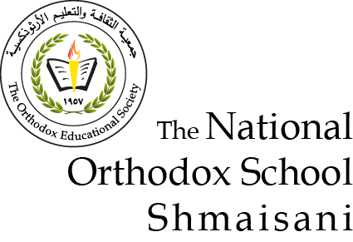

**In the name of the Father, the Son and the Holy Spirit**

**Name: Worksheet:(1)**

**Date: Grade: 6**

______________________________________________________________________ **The Apostles**

**“Go into all the world and preach the gospel to every creature”**

**(Mark 16: 15)**

**Q1: What do you know about:**

|  |  |
| --- | --- |
| **7-Thomas the apostle**  **C:\Users\Mondo Blanco\Desktop\REEM32\أيقونات\الرسل الاثنا عشر\41.jpg** | **1-His name means the twin**  **2-He** **was known for his stubbornness and doubt.**  **3-He doubted the first Lord Jesus appearance.** |

|  |  |
| --- | --- |
| **8-Matthew the apostle** | **1His original name is Levi son of Alphaeus.**  **2-****Matthew means “God’s gift “.**  **3-He** **was a tax collector that’s why he was known by the sinner “.**  **4-He wrote one book:” The gospel of**  **Matthew”.** |

|  |  |
| --- | --- |
| **9-James, son of Alphaeus,**  **the apostle**  **C:\Users\Mondo Blanco\Desktop\REEM32\أيقونات\الرسل الاثنا عشر\49.jpg** | **1-He was called James the Lord’s brother.**  **2-His nickname was: the holy seed.**  **3-He wrote one letter.** |

|  |  |
| --- | --- |
| **10- Lebbaeus the apostle**  **C:\Users\Mondo Blanco\Desktop\REEM32\أيقونات\الرسل الاثنا عشر\57.jpg** | **1-His name means the brave.**  **2-He was called Thaddaeus.**  **3-. He wrote one letter.** |

|  |  |
| --- | --- |
| **11-Simon, the Canaanite the apostle**  **C:\Users\Mondo Blanco\Desktop\REEM32\أيقونات\الرسل الاثنا عشر\53.jpg** | **1-He is from Cana in Galilee**  **2-It was told that he was the groom in the wedding of Cana where Jesus made his first miracle.** |

|  |  |
| --- | --- |
| **12-Judas Iscariot**  **C:\Users\Mondo Blanco\Desktop\REEM32\أيقونات\الرسل الاثنا عشر\59.jpg** | **1-He betrayed Jesus and sold him for 30 silver coins.**  **2-He was remorse but he didn’t repent but hanged himself.** |

|  |  |
| --- | --- |
| **13-Matthias the apostle**  **C:\Users\Mondo Blanco\Desktop\REEM32\أيقونات\الرسل الاثنا عشر\61.jpg** | **1-He was chosen to replace Judas Iscariot.**  **2-The disciples made a lot, and the lot fell on Matthias, and he was chosen after prayer.**  **3-He was filled with the Holy Spirit at Pentecost.** |

|  |  |
| --- | --- |
| **14-Paul the apostle**  **C:\Users\Mondo Blanco\Desktop\REEM32\أيقونات\الرسل الاثنا عشر\61.jpg** | 1. **Also called Saul** 2. **He was chosen by the Lord on his way to Damascus** 3. **He wrote 14 epistles in the New Testament** |

**Q2: Choose (True) or (False)**

1. The apostle who betrayed Jesus is Matthew F
2. The apostle who was called Thaddaeus was Judas T
3. The apostle who hanged himself and he was no more one of the disciplesis Judas Iscariot T
4. Matthias was chosen to replace Judas Iscariot T
5. The Apostle Paul was weaving tents T
6. The apostle who was known for his stubbornness and doubt is Thomas T
7. The apostle who was a tax collector is Matthew T
8. Thomas means the twin T
9. Matthew means “God’s gift “ T