Indirect questions



Verb to be (am, is, are, was, were)

1. Sentence: Peter is happy.



Yes/No Direct Question: Is Peter happy?



Indirect question: Could you tell me if Peter is happy?

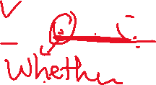

1. Sentence: They are angry.

** Direct Question: Yes/ No question

Are they angry?

***Indirect question

Could you tell me if they are angry?

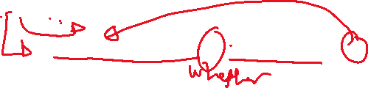

**Wh question

Why is Mary happy?



Could you tell me why Mary is angry?



3.The children are /were stressed about ……



**Yes/ No questions

Q: Are/Were the children stressed ….?

Indirect questions

Could you tell me if the children are /were stressed…?



**Wh questions

The children are/were stressed…..

Q: Why are/were the children…?

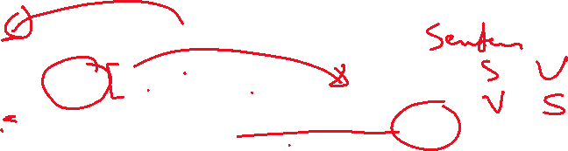

Indirect questions: Could you tell me why the children are /were stressed….?



Present Simple

4.Sentence: Peter eats an apple.



**Yes/No question direct questions

Q: Does Peter eat an apple?



Indirect question: Could you tell me if Peter eats an apple?



**Wh-questions

Peter eats an apple.

Direct questions: What does Peter eat?



Indirect question: Could you tell me what Peter eats?



Past Simple

5.Peter ate an apple.

Direct question: Did Peter eat an apple?

Indirect question: Could you tell me if Peter ate an apple?

Peter ate an apple.



Wh Question:

What Did Peter eat?



Indirect question: Could you tell me what Peter ate?



Present continuous



6. Peter is eating an apple.

***Yes /No question direct questions

Q: Is Peter eating an apple?



Indirect questions:

Could you tell me if Peter is eating an apple?



7. Peter is eating an apple.



Wh- question direct question

Q: What is Peter eating?



Indirect question:

Could you tell me what Peter is eating?



Present/Past perfect

8. Peter has/had eaten an apple.



***Yes /No question

Q: Has/had Peter eaten an apple?



Indirect:

Could you tell me if Peter has/had eaten an apple?



9. Peter has/had eaten an apple.



Wh- question

Q: What has/had Peter eaten?

Indirect question:

Could you tell me what Peter has/had eaten?



Modals

8. Peter will/can /should study hard for the exam.



***Yes /No direct Question

Q: Will/Can/Should Peter study….?



Indirect question: Could you tell me if Peter will/can/should study….?



Peter will/can /should study hard for the exam.

***Wh - direct Question

Q: What will/can/should Peter study….?



Indirect question: Could you tell me what Peter will/can/should study….?



Indirect questions

Function: asking questions in a polite and formal way.

1. Indirect questions start with

Could you tell me …………………………?

Do you know……………….?



Can you explain……………………?



Do you mind telling me……………...?

I wonder………………………………....

**************************************

1. There= Subject

Yes/No questions

Is/ was/were there a station near here?

Do you know if there is a station near here?

Wh questions

Why Is there a table here……...?



Could you tell me why there is …….?

1. Please at the beginning of the question = omit or move it to the end.

Please, help me prepare a revision timetable.

Do you mind_________________?

*************************************

4. How to identify the wh word? (all the words that precedes the helping verb.)

What are you doing ….?

What reasons do you….?

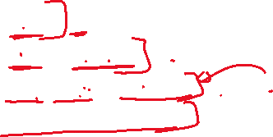

How many students are there…...?

How much coffee/money do you………?

*************************************

1. Possessive adjective+ noun = one block

(My, his, her, our, your, their, its) + noun

Is your mother happy about your results?

Could you tell me if your mother is happy..?

Exercise

1. What have you prepared for the seminar?

Could you tell me __________________?

1. Are you studying for the final exam?

I wonder ____________________________ .

1. Is there a cultural center near here?

Do you know _______________?

1. How many students will you test?

Do you mind telling me ________________?

1. What is your major?

Could you tell me _____________________?

1. Where does Ahmad go daily?

Could you tell me _____________________?

1. Did your friend have an interview?

I wonder ___________________________.

1. Do you speak any foreign language?

Do you mind telling me_________________?

1. Do you do your research?

Do you mind telling me_________________?



Do you mind

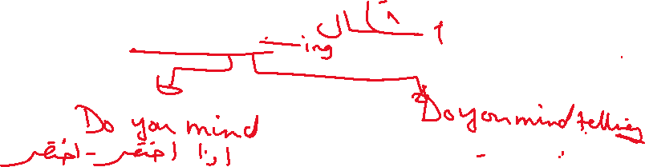

1. Help me move the table, please.

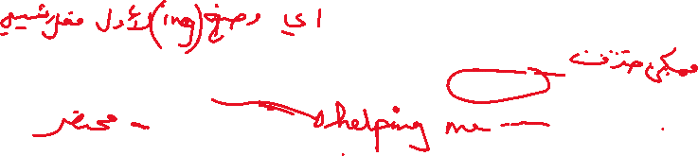

Do you mind _________________________ ?

1. Can you answer such questions?

Do you mind______________?

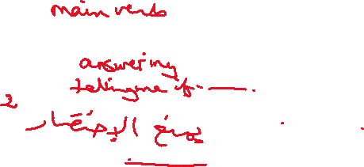

We have to write telling me after wh yes/no (do /have /be)

1. What are you drawing?

Do you mind__________ __________?



1. Have you accomplished your tasks?

Do you mind___________________ ?



14.Are you happy ….?

Do you mind____________________?

