  **Question Tags**

**Our value: A loving heart is the truest wisdom.**

**Name: Grade (6)**

Objectives: To review question tags and how they are formed.

To practice using the question tags.

Question tags are short questions that we use at the end of sentences – particularly in spoken English. There are lots of different question tags but the rules are not difficult to learn.  
  
**Positive/negative**  
  
If the main part of the sentence is positive, the question tag is negative ….

* *He’****s*** *a doctor,* ***isn’t he?***
* *You* ***work*** *in a bank,* ***don’t you?***

... and if the main part of the sentence is negative, the question tag is positive.

* *You* ***didn’t*** *meet him,* ***did you?***
* *She* ***isn’t*** *coming,* ***is she?***

-Note: A comma should precede the tag question.

He didn't know you***,*** did he?

**With auxiliary verbs**  
The question tag uses the same verb as the main part of the sentence. If this is an auxiliary verb (‘*have*’, ‘*be*’) then the question tag is made with the auxiliary verb.

They **weren’t having dinner yesterday at 7.00** , **were they?**

She doesn’t **have** a brother, **does she?**

**Without auxiliary verbs**  
  
If the main part of the sentence doesn’t have an auxiliary verb, the question tag uses an appropriate form of ‘*do*’.

* *I* ***said*** *that,* ***didn’t I?***
* *She* ***eats*** *meat,* ***doesn’t she?***

**With ‘I am’**  
If the main verb or auxiliary verb in the statement is **am**, the positive question tag is **am I?** but the negative question tag is usually **aren't I?**

***I'm*** never on time, am I?

***I’m*** *the fastest, aren’t I?*

|  |
| --- |
| **A positive statement tag** |

|  |
| --- |
| **A negative question tag** |

**+ -**

**Jordanian,**

are

aren’t

|  |
| --- |
| **A positive statement tag** |

|  |
| --- |
| **A negative question tag** |

**+**

**absent,**

was

wasn’t

[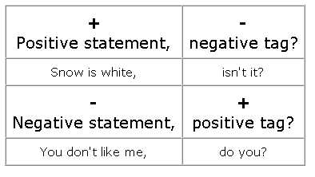](https://www.google.com/url?sa=i&url=http://www.ats.edu.mx/ifs/salc/?tag=tag-questions&psig=AOvVaw2jXf1skD18m9i5kTl4gltA&ust=1583258868203000&source=images&cd=vfe&ved=0CAIQjRxqFwoTCJDm6oax_OcCFQAAAAAdAAAAABAj)

***Fill in the gaps with the correct question tag.

1.Emma is twenty years old, ---------------?

2.I am late, ---------------?

3.They don't get up early, ---------------?

4.Our teacher isn't in the classroom, ------------------?

5.Your brother knows a lot about computers, -----------------?

6.Andrew doesn't drink coffee, -----------------------?

7.John and Liam are interested in science, --------------------?

8.It often rains in autumn, ----------------?

9.We sing well, -----------------?

10.They aren't from England, ------------------?

--------------------------------------------------------------------------

***Fill in the gaps with the correct question tag.

1. Daniel was busy last week, ---------------?

2.We didn't turn off the lights, ----------------?

3.You were at home yesterday, ------------------?

4.The shop wasn't closed, -----------------?

5.Matthew invited you to the party, -------------------?

6.She didn't call you yesterday, ---------------------?

7.They were on holiday, --------------------?

8.We saw Chris last week, ----------------------?

9.Amelia wasn't in Italy, ---------------------?

10.You didn't keep your promise, -------------------?

--------------------------------------------------------------------------

Fill in the gaps with the correct question tag.

1.The teacher is explaining a new grammar rule, ------------------?

2.They aren’t playing computer games, ----------------------?

3.Chris is writing the essay, ----------------------?

4.The girls are watering the flowers, -------------------?

5.Lilly isn’t talking on the phone, --------------------?

6.They are getting late, -------------------?

7.Your cat is scratching the sofa, ------------------?

8.It is raining outside, ----------------------?

9.Kate and Jim aren’t waiting for me, ------------------------?

10.She isn’t having lunch now, -----------------------?

--------------------------------------------------------------------------

**Complete with the correct question tag.

1. John and Max don't like math, -----------------?

2. Peter played handball yesterday, -------------------?

3. Mary didn't do her homework last Monday, -----------------?

4. I'm clever, ---------------------?

5. Mr. Brown is studying now, ------------------?

6. The car isn't in the garage, -------------------?

7. You are John, ----------------------?

8. She went to the library yesterday, --------------------?

9. He didn't recognize me, --------------------?

10. Cars pollute the environment, -------------------------?

11. The trip is very expensive, ------------------?

--------------------------------------------------------------------------

**Complete with the correct question tag.

* 1. They were exercising, ----------------?
  2. Samantha was running, -----------------?
  3. Mary and Peter weren’t playing, -----------------?
  4. Silvio wasn’t watching a movie, -------------------?
  5. She was living in Rio, -------------------?

--------------------------------------------------------------------------

**Circle the correct tag question to complete the questions.

1. It's next to the supermarket, **don’t it / isn’t it** ?

2. You've met my brother before, **don’t you / haven’t you** ?

3. He was born in 1970, **didn’t he / wasn’t he** ?

4. You're coming tomorrow, **aren’t you / do you** ?

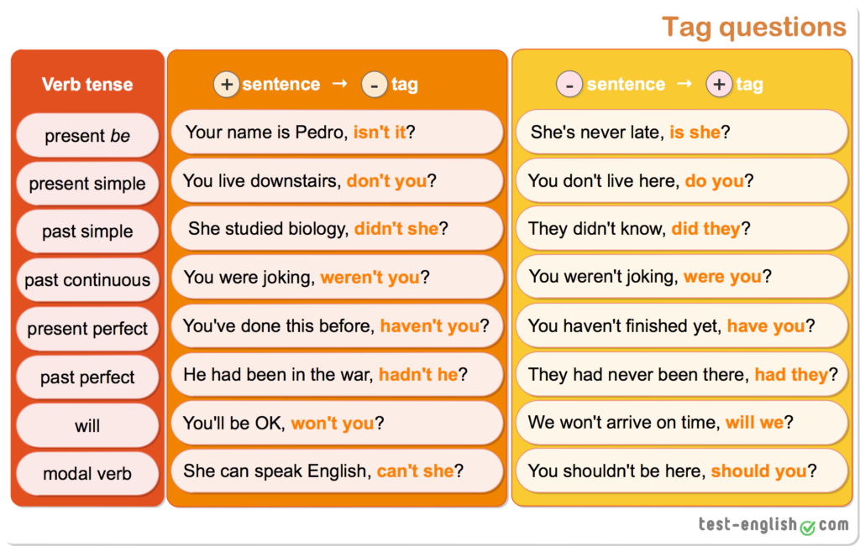

Teacher: Mirna Nawaf Al-Sahawneh.

Coordinator’s Signature: ____________________