

**The name of The Father, The Son and The Holy Spirit. Amen**

**The Primary Stage (4-5)**

**Second Semester 2022/2023**

**Name** : ___________ **Subject**: **The miracle of calming the storm**

**Date : / / Class : Grade four (All Sections)**

**_____________________________________________________________**

**The miracle of calming the storm**

|  |
| --- |
| **Golden verse: “There is no fear in love; but perfect love casts out fear” (1 John4: 18)** |

Q1: What does the miracle of calming the storm indicates?

A1: The calming of the storm by Lord Jesus Christ indicates that He is the Creator of the universe.

Q2: Reason:

1. Lord Jesus Christ did not intervene since the start of the storm.

Lord Jesus Christ has not intervened to test the disciples' faith in Him.

1. The disciples were afraid despite the presence of Lord Jesus Christ with them.

Because of the weakness of their faith and trust in Him



Q3: Why we should not be afraid?

Because Lord Jesus Christ loves us and will not leave us.

Q4: How do we get rid of fear?

We get rid of fear:

1- With complete trust and faith in Lord Jesus Christ.

2- By praying constantly.

3- Reading the Holy Bible.

4-Always participate in the Holy Communion.

Q5: What do you learn from the miracle of calming the storm?

I learned that Lord Jesus Christ has authority over:

1- Nature

2- Diseases

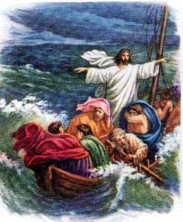

What does the Lord Jesus Christ calm down the storm?

C 3) T calming of the storm by the Lord Jesus Christ indicates and the

**Religion teachers**

**Suha Barhoumeh/Marlin Halabi**