** Vocabulary _ Unit 5**

**(A Revolution in History) worksheet no. (1)**

**Name ………………… Grade (5)**

|  |
| --- |
| **Objectives**  **1. Identify the meaning of the new words.**  **2. Identify the synonyms of the new words.**  **3. Practice using the new words in sentences.** |

**Verbs**

|  |  |  |
| --- | --- | --- |
| **Word** | **Synonym** | **Meaning** |
| Transfer | Move | To move or to make someone or something move from one place to another.  **Example**: They will **transfer** those books into the new library. |
| Haul | Pull | To pull or drag something with great effort.  **Example**: If you **haul** hard you will divert the fish. |
| Rotate | Go round | To turn in circles around a certain point; to make something do this.  **Example**: **Rotate** the wheel through 180 degrees. |
| Grind | Crush | To crush something into very small pieces or into a powder, using a machine.  **Example**: Shall I **grind** a little black pepper over your pizza? |

**Adjectives**

|  |  |  |
| --- | --- | --- |
| **Word** | **Synonym** | **Meaning** |
| Durable | Long-lasting | That is able to last for a long time.  **Example**:  Things unreasonable are never **durable**. |
| Mechanical | Automatic | Connected with, worked by, or produced by machines.  **Example**: The company produces **mechanical** parts for airplane engines. |
| Inspiring | Encouraging | Exciting and encouraging you to do or feel something.  **Example**: The sound of martial music is always **inspiring**. |

**Nouns**

|  |  |  |
| --- | --- | --- |
| **Word** | **Synonym** | **Meaning** |
| Transportation | Carrier | Vehicles that you travel in.  **Example**: The city needs to improve its public **transportation**. |
| Axle | Bar | A bar that connects a pair of wheels on a vehicle.  **Example**: The back **axle** is broken. |
| Spoke | Wires | One of the thin pieces of metal that connect the center of a wheel to the outside edge.  **Example**:There's always the button gear change above the steering wheel **spoke**. |
| Rim | Edge | An edge at the top or outside of something that is round.  **Example**: Coffee slopped over the **rim** of her cup. |
| Traction | Resistance | The force that stops something, for example the wheels of a vehicle, from sliding on the ground.  **Example**: The tires were bald and lost **traction** on the wet road. |
| Gear | Cog | The machinery in a vehicle that turns engine power into a movement forward or backward.  **Example**: The car is out of **gear**. |
| Rod | Stick | A thin, straight piece of wood or metal.  **Example**: The **rod** bent as he pulled in the fish. |
| Platform | Stand | A flat raised surface on which a piece of equipment stands.  **Example:** Use a wooden platform to put your stuff. |
| Vehicle | Automobile | Something which transports people or things from place to place, especially on land, for example cars, bicycles, trucks, and buses.  **Example:** Have you locked your **vehicle**? |
| Mill | Factory | A building that contains a large machine that is used for crushing grain into flour.  **Example:** The farmer took his grain to the **mill**. |
| Technology | Automation | The scientific knowledge and/or equipment that is needed for a particular industry.  **Example**: Modern **technology** is amazing, isn't it? |

1. **Write the synonym of each of these words**:
2. Transfer move
3. Haul pull
4. Rotate go round
5. Grind crush
6. Durable long-lasting
7. Mechanical automatic
8. Inspiring encouraging
9. Transportation carrier
10. Axle bar
11. Spoke wires
12. Rim edge

12.Traction resistance

13.Gear cog

14. Rod stick

15. Platform stand

16. Vehicle automobile

17. Mill factory

18. Technology automation

1. **Write the correct word under each picture.**

|  |
| --- |
| Transfer_ Haul_ Rotate_ Grind_ Durable_ Mechanical_ Inspiring Transportation_ Axle_ Spoke_ Rim_ Traction_ Gear_ Rod_ Platform_ Vehicle_ Mill_ Technology |

 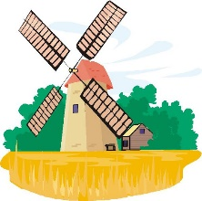 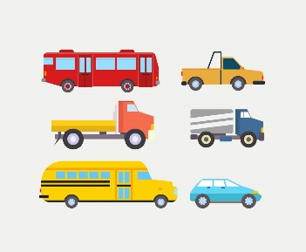 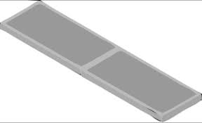

Technology mill vehicle platform

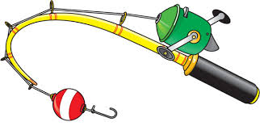  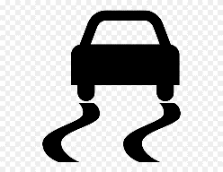 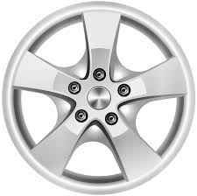

Rod gear traction rim

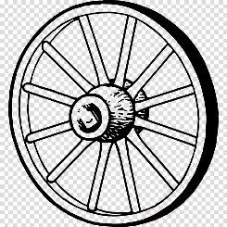 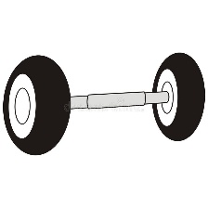 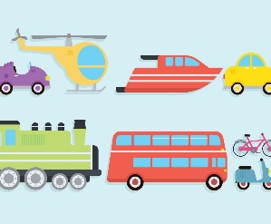 

Spoke axle transportation inspiring

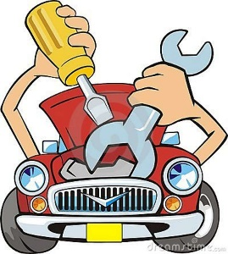 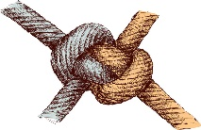 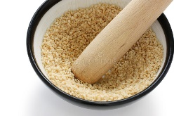 

Mechanical durable grind rotate

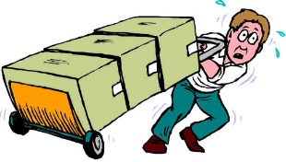 

Haul transfer

1. **Fill in the gaps with the correct words from the box.**

Transfer_ Haul_ Rotate_ Grind_ Durable_ Mechanical_ Inspiring Transportation_ Axle_ Spokes_ Rim_ Traction_ Gear_ Rod_ Platforms_ Vehicle_ Mill_ Technology

1. New technology is going to revolutionize everything we do.
2. This old mill has been grinding wheat for over 50 years.
3. The police pursued the stolen vehicle along the motorway.
4. This cement mass is heightened at many places so as to make platforms and supports for huts.
5. The weight of fish snapped the fishing rod in two.
6. He put the car in gear and drove away.
7. Locked-up wheels have no traction and slide.
8. He looked at them over the rim of his glass.
9. Both wheels were rebuilt with stainless spokes by John Smith.

10. He hit a rock and snapped the truck's axle.

11. The train is a safe means of transportation.

12. She has the power for inspiring confidence in people.

13. The flight has been cancelled due to mechanical failure.

14. Store food in durable containers with lids.

15. Grind the sugar into a powder.

16. You can rotate the wheel with your hand.

17. The fishermen haul the net.

18. How can I transfer money from my bank account to his?

1. **Find the synonyms of the following words in the crossword and write them down.**

|  |  |  |  |  |  |  |  |  |  |  |  |
| --- | --- | --- | --- | --- | --- | --- | --- | --- | --- | --- | --- |
| v | e | c | m | o | v | e | e | g | f | i | n |
| a | w | d | p | u | l | l | g | e | a | r | y |
| u | n | c | r | u | s | h | i | n | b | n | m |
| a | u | t | o | m | a | t | i | c | n | a | d |
| c | a | r | r | i | e | r | p | y | o | r | h |
| r | e | s | i | s | t | a | n | c | e | e | n |
| e | c | g | a | s | t | a | n | d | s | e | c |
| t | f | a | c | t | o | r | y | l | y | n | v |

1. Transfer ------------ 2. Haul ---------------

3. Grind ------------ 4. Mechanical -------------

5. Transportation ----------- 6. Traction -------------

7. Platform ------------ 8. Mill -------------

.

**Teacher: Mirna Nawaf Al- Sahawneh.**