 **Vocabulary _ Unit 4**

**Our value: A loving heart is the truest wisdom.**

**(The Secret of Vesuvius) Worksheet no. ( ) Name ………………… Grade (6)**

|  |
| --- |
| **Objectives**  **1. Identify the meaning of the new words.**  **2. Identify the synonyms of the new words.**  **3. Practice using the new words in sentences.** |

**Verbs**

|  |  |  |
| --- | --- | --- |
| **Word** | **Synonym** | **Meaning** |
| Wheeze | Whistle | To make noises when you breathe, especially if you have an illness in your chest.  **Example**: He has a slight **wheeze** in his chest. |
| Cough | Expel air. | To send air out of your throat and mouth with a sudden loud noise, especially when you have a cold, have something in your throat, etc.  **Example**: John began to **cough** violently. |
| Flutter | Flap | To move up and down or from side to side quickly and lightly.  **Example**: She smiled and **flutter** her eyelashes. |
| Spatter | Splash | To cover someone or something with drops of liquid, dirt, etc., especially by accidents.  **Example**: Don't **spatter** the soup onto the table. |
| Gasp | Breathe | To breathe quickly and noisily or to say something while you are finding it difficult to breathe.  **Example**: She managed to **gasp** a few words. |
| Shift | Switch | To move from one position or place to another.  **Example**: Lend me a hand to **shift** this box, will you? |

**Adjectives**

|  |  |  |
| --- | --- | --- |
| **Word** | **Synonym** | **Meaning** |
| Flaming | Blazing | Burning brightly.  **Example**: **Flaming** torches were positioned at intervals along the terrace. |
| Charred | Burned | Black and partly burned by fire.  **Example**: The **charred** body of a man was found by police in a burnt-out car last night. |
| Boiling | Fiery | Very hot.  **Example**: The water was bubbling and **boiling** away. |

**Nouns**

|  |  |  |
| --- | --- | --- |
| **Word** | **Synonym** | **Meaning** |
| Shower | Fall | -A short period of rain or snow.  **Example**: Many drops makes a **shower**. |
| Gravel | Small stones | Very small stones that are used for making roads, paths, etc.  **Example**: The workmen shoveled **gravel** onto the road. |
| Pumice | Grey stone. | A type of grey stone that comes from a mountain with a hole in the top and is very light in weight. It is used in powder form for cleaning and polishing, and in pieces for rubbing on the skin to make it softer.  **Example**: **Pumice** is produced in volcanic eruptions. |
| Debris | Wreck | Pieces from something that has been destroyed, especially in an accident.  **Example**: Several people were injured by flying **debris** in the explosion. |
| Boulder | Large rock | A very large rock.  **Example**: The **boulder** hit the ground with a resounding thud. |
| Scribe | Copier / Writer | A person who made copies of written documents before printing was invented.  **Example**: Each of the assistants was accompanied by a **scribe**. |
| Observations | Notes | Things that you say or write.  **Example**: He's just published his **observations** on British bird life. |
| Shore | Beach | The land along the edge of an ocean, a lake, or a sea.  **Example**: Huge waves lashed the **shore**. |
| Retreat | Fall back | The action of moving backwards, away from a difficult or dangerous situation.  **Example**: I made a tactful **retreat** before they started arguing. |

**Adverbs**

|  |  |  |
| --- | --- | --- |
| **Word** | **Synonym** | **Meaning** |
| Deftly | Cleverly | In a skillful and quick way.  **Example**: They **deftly** avoided answering my questions. |

1. **Write the synonym of each of these words**:
2. Wheeze whistle
3. Cough expel air
4. Flutter flap
5. Spatter splash
6. Gasp breathe
7. Shift switch
8. Flaming blazing
9. Charred burned
10. Boiling fiery
11. Shower fall
12. Gravel small stones
13. Pumice grey stone
14. Debris wreck
15. Boulder large rock
16. Scribe writer
17. Observations notes
18. Shore beach
19. Retreat fall back
20. Deftly cleverly

1. **Write the correct word under each picture.**

|  |
| --- |
| Wheeze_ Cough _ Flutter_ Spatter_ Gasp_ Shift _Flaming_ Charred _ Boiling _ Shower_ Gravel_ Pumice_ Debris_ Boulder  Scribe_ Observations_ Shore_ Retreat_ Deftly |

  

Deftly retreat shore observations

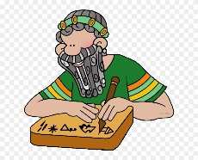 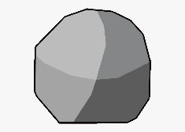 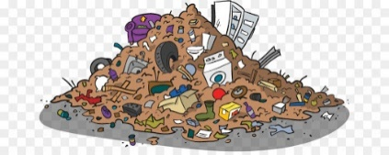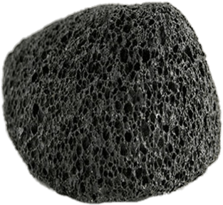

Scribe boulder debris pumice

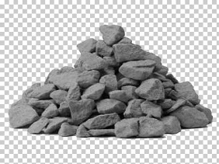 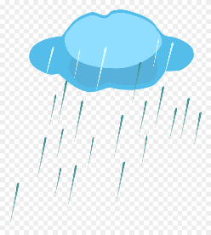 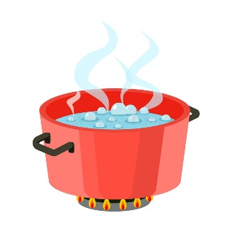 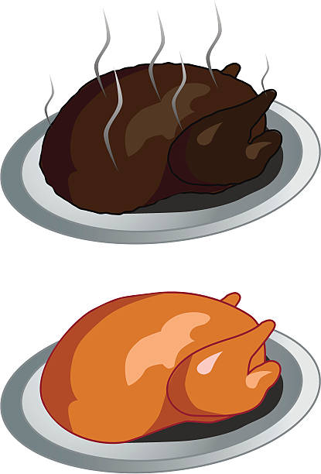

Gravel shower boiling charred

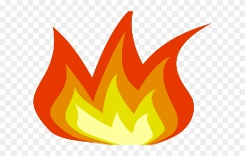  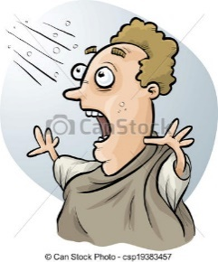 

Flaming shift gasp spatter

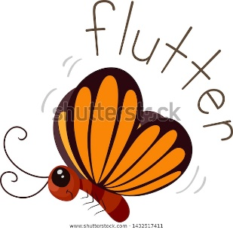 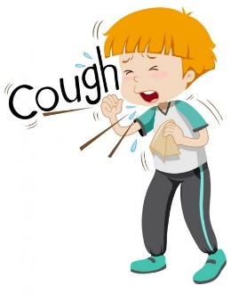 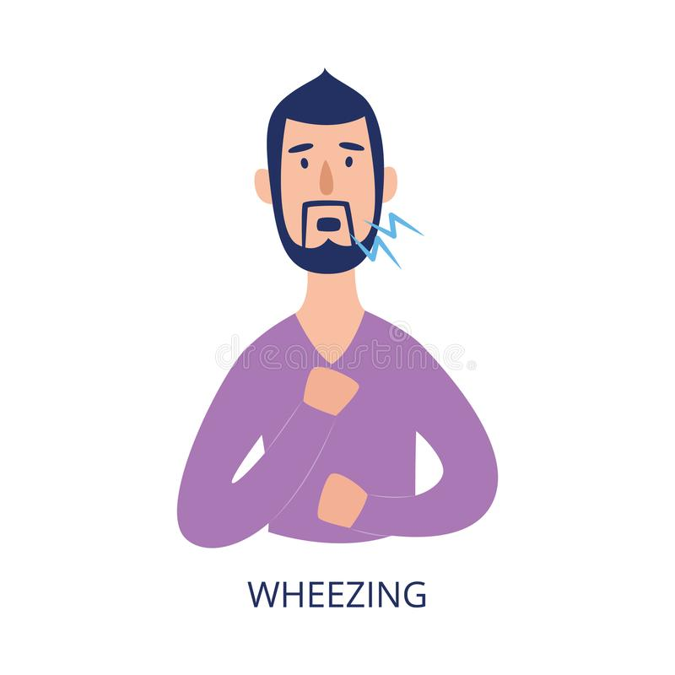

Flutter cough wheezing

1. **Fill in the gaps with the correct words from the box.**

|  |
| --- |
| Wheeze_ Coughing _ Flutter_ Spatter_ Gasp_ Shift _Flaming_ Charred _ Boiling _ Shower_ Gravel_ Pumice_ Debris_ Boulder  Scribe_ Observations_ Shore_ Retreat_ Deftly |

1. He **deftly** folded the typed sheets and replaced them in the envelope.
2. Eventually the police forced the crowd into retreat.
3. This island is two miles off shore.
4. Some interesting observations emerged from this research.
5. The scribe worked hard to support his family.
6. The boulder sheltered them from the chilling wind.
7. The debris blocked the road.
8. You can use a pumice stone in the bath to remove dry skin from your feet.
9. I fell on the gravel, severely injuring my knee.
10. It looks like we are going to have a thunder shower.
11. Don't put boiling water in the glass or it will crack.
12. The meat was slightly charred.
13. Twenty flaming arrows hit the castle.
14. You should learn to shift gear at the right moment.
15. Most people gasp when they hear how much money Patsy makes.
16. Gently turn the fish, being careful not to spatter any hot butter on yourself.
17. The paper didn't flutter about from side to side; it just went straight down.
18. He was coughing and wheezing all night.
19. The cough, wheeze and shortness of breath are things that go with smoking, not with age.
20. **Find the synonyms of the following words in the crossword and write them down.**

|  |  |  |  |  |  |  |  |  |  |  |  |  |  |  |  |
| --- | --- | --- | --- | --- | --- | --- | --- | --- | --- | --- | --- | --- | --- | --- | --- |
| c | l | e | v | e | r | l | y | u | s | r | s | u | i | o | b |
| q | c | o | p | i | e | r | s | r | i | c | u | o | u | s | e |
| c | w | e | s | t | a | r | e | h | b | n | e | d | l | e | a |
| s | r | p | o | i | s | k | e | p | t | i | c | a | l | x | c |
| t | e | a | l | t | h | a | z | a | r | d | o | u | s | q | h |
| r | c | r | a | p | f | p | d | s | h | a | i | e | c | u | d |
| e | k | t | t | o | c | o | p | x | i | f | c | k | e | i | e |
| f | r | h | e | b | p | p | j | o | k | e | a | x | z | s | n |
| a | e | i | d | r | s | w | h | i | s | t | l | e | e | i | t |
| l | s | r | i | p | r | s | f | g | l | a | b | o | r | t | u |
| l | e | e | t | y | b | u | r | n | e | d | r | a | g | e | m |
| r | o | t | v | h | e | a | d | g | q | p | d | h | u | h | g |
| e | q | u | d | o | h | f | m | s | w | i | t | c | h | x | z |

1. Deftly ------------ 2. Shore ---------------

3. Scribe ------------ 4. Debris -------------

5. Shower ----------- 6. Charred -------------

7. Shift ------------ 8. Wheeze -------------