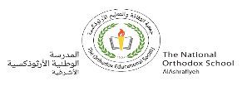
Worksheet (1 )
Grade 2
Name: ------------ Date: /2 /2023
_________________________________________________ *Objective: To review nouns and proper nouns .
A noun is the name of a person, place, thing or animal.

Nouns
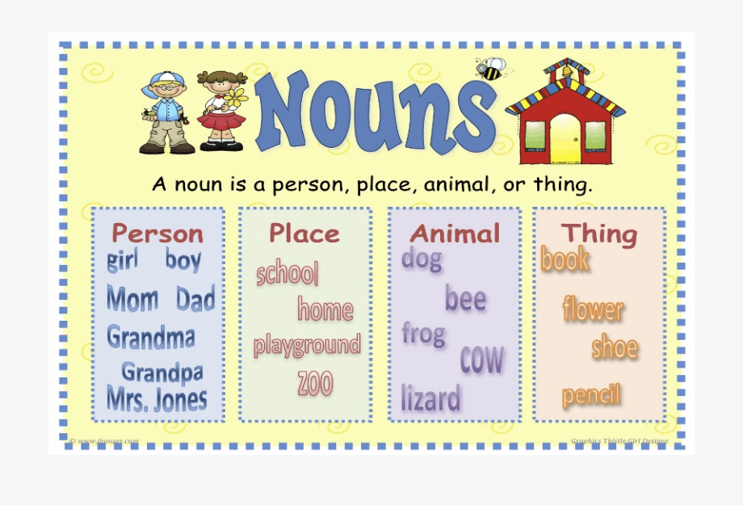
The most important thing to remember about common nouns is that they are general names so they don’t need to be capitalized.
Proper nouns are special names given to a person or place. They start with a capital letter.
Dana Pizza Hut Steven
Some proper nouns are names of days of the week and months
Saturday October

- Read the words in the box. Write them under the correct column.
whale teacher pen school house lions flower mouse book horse hospital doctor Ward snake zoo Sama table kitchen
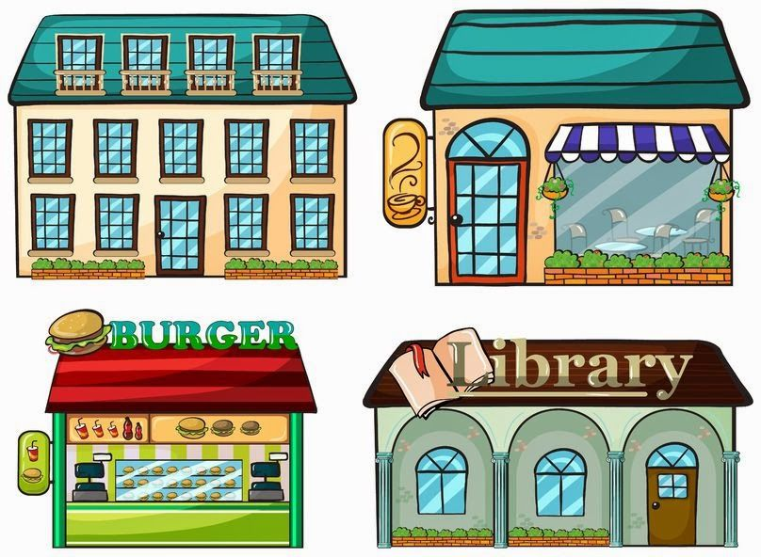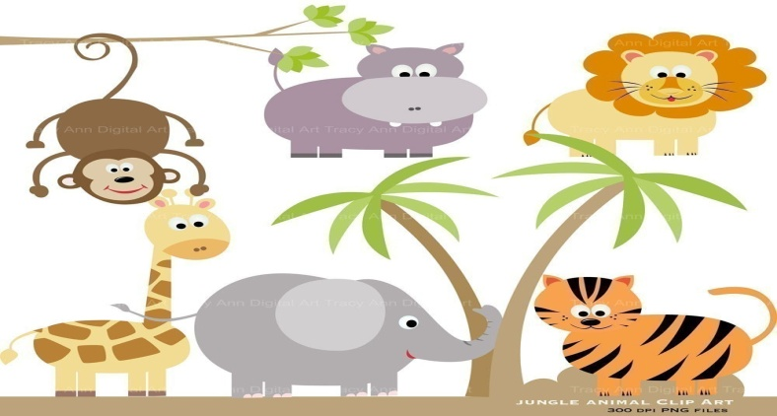
(person) ( place) (animal) ( thing)
Ward zoo lions flower
Teacher kitchen snake table
Doctor school horse pen
Sama house , hospital whale, mouse book

2) Choose the proper noun. Write it correctly on the line below.
1.january 2. computer
bag board
home tuesday
January Tuesday
3.cat 4. hospital
zaid mammals
chair Sunday
Zaid Sunday
3)Underline the mistakes in the sentences below and correct them.
a- I don’t go to school on sundays and fridays.
- I don’t go to school on Sundays and Fridays.
b- december is the last month in the year.
December is the last month in the year.
c- rama and adam are twins.
Rama and Adam are twins
T.Taghreed Alnimri Coordinator’s Signature:

