|  |
| --- |
| **Writing an Informal Letter / Unit 5** |
| **Name:** |
| **Grade: 7 ( A )** |

**Replying to a letter:**

* When you’re replying to a letter, remember to react to what the writer has said.
* Read it carefully to see if you have to apologize, give an explanation, express enthusiasm, ask for or give information, thank the sender, accept or decline a request, or accept or reject an invitation.
* You can organize your letter by replying to the writer’s comments in similar order.

**Useful Expressions:**

If I were you, I would/ I wouldn’t…

Why don’t you…?

How/ What about…?

I’d love to come…

I’ll definitely be there.

I’m sorry, I can’t make it.

Unfortunately, I won’t be able to come.

What exciting/ sad/ great … news!

I’m really pleased for/ proud of you.

It’ll be fun/ great…!

Examples:

Dear Friend,

First of all, I would like to thank you for inviting me to your success party to be held on 31 March 2021.

I am writing this letter in response to your invite. I am really very sorry that I won’t’ be able to be part of your success as it is year-end. Year-end brings many responsibilities in filing our income returns and have put a great workload on us.

However, I will pray to God to bring the best of best for you and bring success to your doorstep and good promotion in the future. I hope you will understand my problem, but I assure you that I will meet you by the end of April.

Yours Truly,

Sender’s Name

----------------------------------------------------------------------------------------------------------------------

Example:

Dear Receiver’s Name,

We are really very thankful to you and the staff members who have worked so hard for our help. You have done your work within committed time.

I am writing this letter in response to your letter received on 22 March 2021. I read that you are expecting a salary raise this year. I know you have completed your committed time with us and shown your best performance.

I am thrilled to inform you that you will experience a good raise in your salary, seeing your better performance in the past year. Along with that, our office has planned to provide you with some goodies as a term of encouragement to help you work hard in the coming future. We commit you to provide a raise of 10% income this year.

We are glad you are a part of our company. Looking forward to your good performance.

Thank You

Yours Sincerely,

Sender’s Name

--------------------------------------------------------------------------------------------------------------

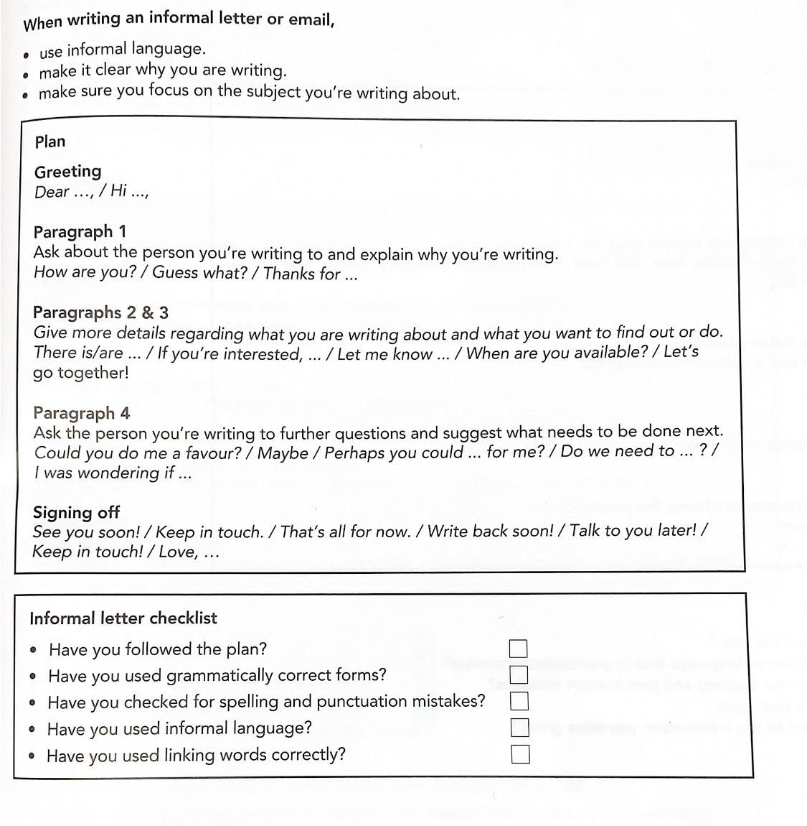

You have received a letter from your friend, Robbie, who is moving house. Write a letter to reply to Robbie. (100 – 150 words)

