**The National Orthodox School / Shmaisan**

**Subject: Biology Study sheet : Diffusion in biology**

**Name:**

**Date:** **Grade 7 all sections**

**Objective : be able to describe the process of diffusion in biology**

**How do substances move in and out of cells? The answer is, often, by diffusion.**

As scientists, we know that matter is made up of moving particles which are too small for us to see. Diffusion takes place in gases and liquids as a result of the random movements of these tiny particles. **Diffusion is the net (overall) movement of particles from an area where there are lots of them (a high concentration) to an area where there are fewer of them (a lower concentration).** Understanding diffusion is important for understanding many biological processes, including gas exchange in the respiratory system, transport in the blood, and the examples shown here.

1. **Diffusion in action**

Let's do a thought experiment. You are walking home from school. Your evening meal is cooking in the kitchen. As soon as you go into your home, you can smell the food. You probably start to feel hungry! How did the smell of the food reach your nose?

**Particles escape from the cooking food, where they are at a high concentration. They spread out randomly through the air by diffusion,** ***down a concentration gradient***. You breathe in some of these particles and your nose sends signals to your brain, which recognizes the food.

1. **Diffusion in the digestive system**

What happens when you eat a meal? Your body cannot use the food you eat until it is broken down and carried in your blood to the cells which need it. **The digested food moves into your blood from your digestive system by diffusion down a concentration gradient.**

1. **Blood and sharks**The oceans of the world are very large, but sharks still find their prey. How do they do it? Once again, diffusion is part of the answer. **If an animal is injured it will bleed. The blood spreads out through the water by diffusion.**
2. **Diffusion and the lungs**Gases are exchanged in our lungs by diffusion . In the next chapter, you are going to look at how we breathe, and how gases are exchanged in our lungs.

**Diffusion: The net movement of particles in a liquid or gas down a concentration gradient, from a high concentration to a lower concentration.**

**Check your understanding :**

1. Give a definition of diffusion.

…………………………………………………………………………………………………………………………

1. Describe how you can tell if there are some flowers in a dark room.

…………………………………………………………………………………………………………………………

1. Explain how you think oxygen might get from the air in your lungs into your blood.

………………………………………………………………………………………………………………………….

1. The diagram below shows particles in containers A and B separated by a permeable membrane .

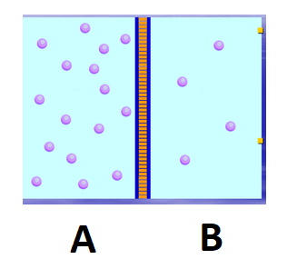

1. Draw an arrow to show the movement of particles .
2. Explain your answer .

……………………………………………..

……………………………………………..

………………………………………………..

…………………………………………………………………………………………………………………….

<https://phet.colorado.edu/sims/html/diffusion/latest/diffusion_en.html>