**Pronouns**

**Grammar Sheet**

* **What is a pronoun?**

**→** A pronoun is a word that stands in for a [noun](https://www.scribbr.com/category/nouns-and-pronouns/), often to avoid the need to repeat the same noun over and over.

* Like nouns, **pronouns** can refer to people, things, concepts, and places. Most sentences contain at least one noun or pronoun.
* For example:

→ **I** asked **her** if the headphones were **hers**, but **she** said **they** belonged to someone else.

* **There are different types of pronouns:**

1. Personal Pronouns
2. Possessive Pronouns
3. Reflexive Pronouns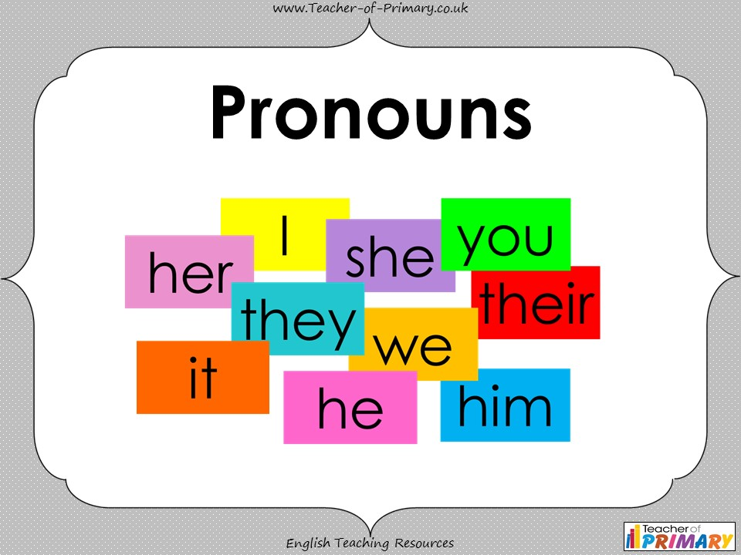
4. Relative Pronouns

* **Personal Pronouns:**

→ replace the name of a person or a thing.

→ such as: I, you, he, she, it, we, and they **(Subject pronouns)**

me, him, her, us, and them **(Object pronouns)**

For example:

**We** would like to invite Stacy to join **us** for dinner.

* **Possessive Pronouns:**

→ replace a noun in a sentence but also show ownership.

→ such as: Mine, Ours, Hers, His, Theirs, and Yours.

For example:

I didn’t have my umbrella so Marta lent me **hers**.

David’s car is faster than **mine**.

* **Reflexive Pronouns:**

→ are used to refer back to the subject (person/thing).

→ such as: myself, yourself, himself, herself, itself, ourselves, yourselves and themselves**.**

For example:

I hope you enjoy **yourselves** at the party tonight!

We need to believe in **ourselves** more.

* **Relative Pronouns:**

→ are used to describe or limit the subject.

→ such as: who, whom, which, whose, and that.

For example:

The man **who** donated this money is my brother.

Kate, **whose** sister I used to share a house with, has gone to work in Australia.

**Exercises**

**Question 1: Complete the following sentences using the correct pronoun.**

1. Murat is a good boy. __ always listens to__ teacher.
2. Amit and Sumit are twin brothers. ___ take the same bag to school.
3. Milly and I are very good friends. ___ have known each other since childhood.
4. The mangoes are very sour. Where did you buy ___?
5. I love watching Tom and Jerry. __ reminds me of my childhood days.
6. I bought this book for my sister. __ often read it together.
7. This is Steve. Do you know __?
8. There are many windows here. But all of ___ are jammed.
9. The army has reached __ destination.
10. My aunt and uncle live in Delhi. ___ often visit ___.

**Question 2: Choose the correct pronoun and use it in the sentence.**

1. (Me/I) feel like taking a short trip to the Maldives
2. (I/me) think you should participate in the debate.
3. Wuthering Heights is (her/hers) favorite book.
4. Those papers are (mine/my).
5. The box was lying around. Is (it/its) yours?
6. The dog almost choked (himself/itself).
7. Natasha was all by (yourselves/herself).
8. I got (me/myself) all wet while walking in the rain.
9. (That/this) book lying here is mine.
10. (Each/neither) of us were given a gift hamper.