**The National Orthodox School / Shmaisani**

**Subject: Biology Worksheet : chlorophyll**

**Name:**

**Date:** **Grade 9 IB**

**Question 1**

1. Chloroplasts contain various photosynthetic pigments. State the role of a photosynthetic pigment.

…………………………………………………………………………………………………………..

1. b) The pigments in a chloroplast can be separated and identified using a technique called thin layer chromatography. After extracting pigments from a spinach leaf a student carried out thin layer chromatography Some of their results can be seen below.

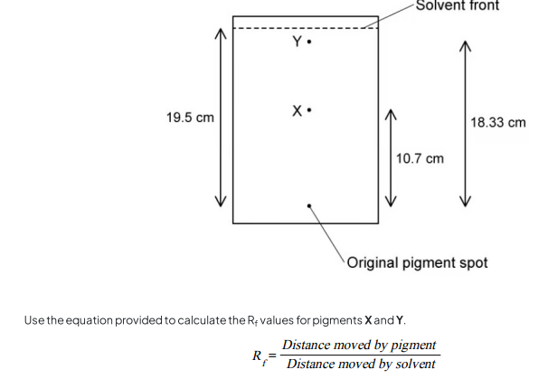

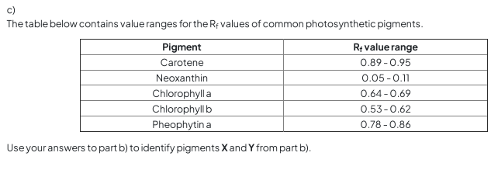………………………………………………………………………………………………………………………………………………………………………………………………………………………………………………………………………………………………………………………………………………………………………………………………………………………………………………………………………………………………………………………………………………………………………………………………………………………………………………………………………..

………………………………………………………………………………………………………………………………………………………..

**Question 2**

1. State why the majority of plants look green to human eyes.



