

**Conditionals Study Sheet**

**Name: …………………………………… Date: ………………………………..**

**7 CS/………….**

**=========================================================**

**If conditional**

Conditional tenses are used to speculate about what could happen, what might have happened, and what we wish would happen.

| **Conditional sentence type** | **Usage** | **If clause verb tense** | **Main clause verb tense** |
| --- | --- | --- | --- |
| Type 1 | A possible condition and its probable result | Simple present | Simple future |
| Type 2 | A hypothetical condition and its probable result | Simple past | Present conditional or Present continuous conditional |

**Type 1 conditional:**

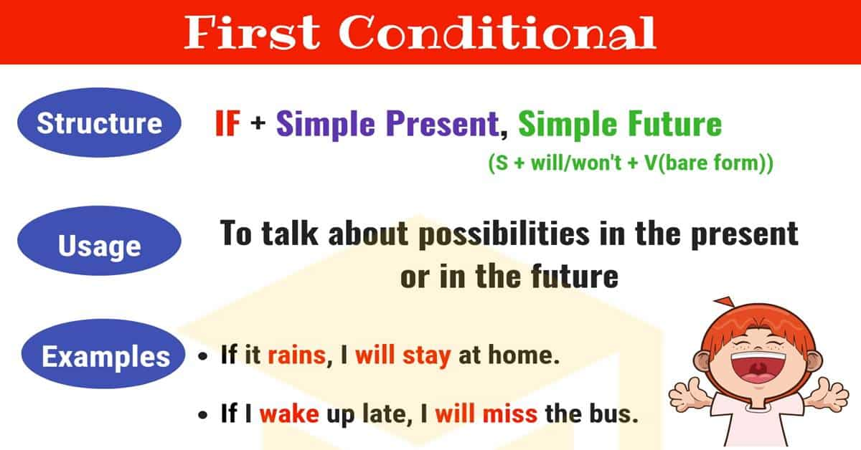

The type 1 conditional is used to refer to the **present or future** where the **situation is real**. The type 1 conditional refers to a possible condition and its probable result. In these sentences the if clause is in the simple present, and the main clause is in the simple future.

| **If clause** | **Main clause** |
| --- | --- |
| **If + simple present** | **simple future** |
| If this thing happens | that thing will happen. |
| If you don't hurry | you will miss the train. |
| If it rains today | you will get wet. |

**Type 2 conditional:**

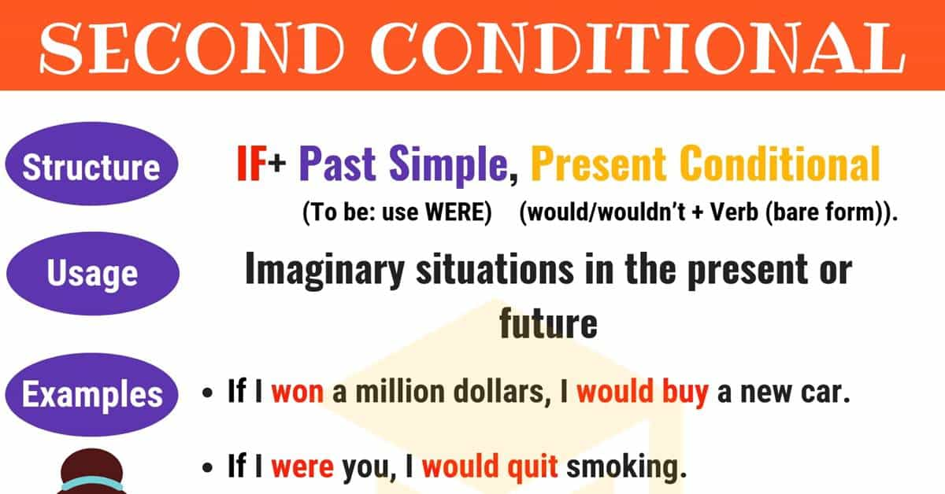

The type 2 conditional is used to refer to a time that is **now or any time**, and a situation that is **unreal**. These sentences are not based on fact. The type 2 conditional is used to refer to a hypothetical condition and its probable result. In type 2 conditional sentences, the if clause uses the simple past, and the main clause uses the present conditional.

| **If clause** | **Main clause** |
| --- | --- |
| **If + simple past** | **present conditional or present continuous conditional** |
| If this thing happened | that thing would happen. (but I'm not sure this thing will happen) OR that thing would be happening. |
| If you went to bed earlier | you would not be so tired. |
| If it rained | you would get wet. |
| If I spoke Italian | I would be working in Italy. |

**Type 1 examples:**

* If you **don’t leave**, **I’ll call** the police.
* If you **don’t drop** the gun, **I’ll** **shoot**!
* If you**drop** that glass, it **will** **break**.
* Nobody **will** **notice** if you **make** a mistake.
* If I **have** time,**I’ll finish** that letter.

**Type 2 examples:**

* If it **rained,** you **would get** wet.
* You **would get** wet if it **rained.**
* If you **went** to bed earlier you **wouldn't be** so tired.
* You **wouldn't be** so tired if you **went** to bed earlier.
* If the weather **wasn't** so bad, we **would go** to the park.
* If you really **loved** me, you **would buy** me a diamond ring.
* If I **knew** where she lived, I **would go** and **see** her.

**Complete the following sentences with the correct form of the verbs in brackets:**

1. If I **saw** (see) her, I **would give** (give) her the news.

2. If Sally **didn’t speak** (speak/not) English, she **wouldn’t understand** (not understand) most of her courses.

3. If I **won** (win) the lottery, I **would buy** (buy) my dream car.

4. If someone **rang** (ring) the bell at four in the morning, **would you**

(You/answer) the door?

5. If my car **breaks** (break), my mechanic **will repair** (repair) it.

6. You would feel a lot better, if you **didn’t smoke** (not/ smoke) much.

7. If we drink too much coffee tonight, we **won’t sleep** (not sleep).

8. If I **were** (be) you, I **would accept** (accept) the offer.