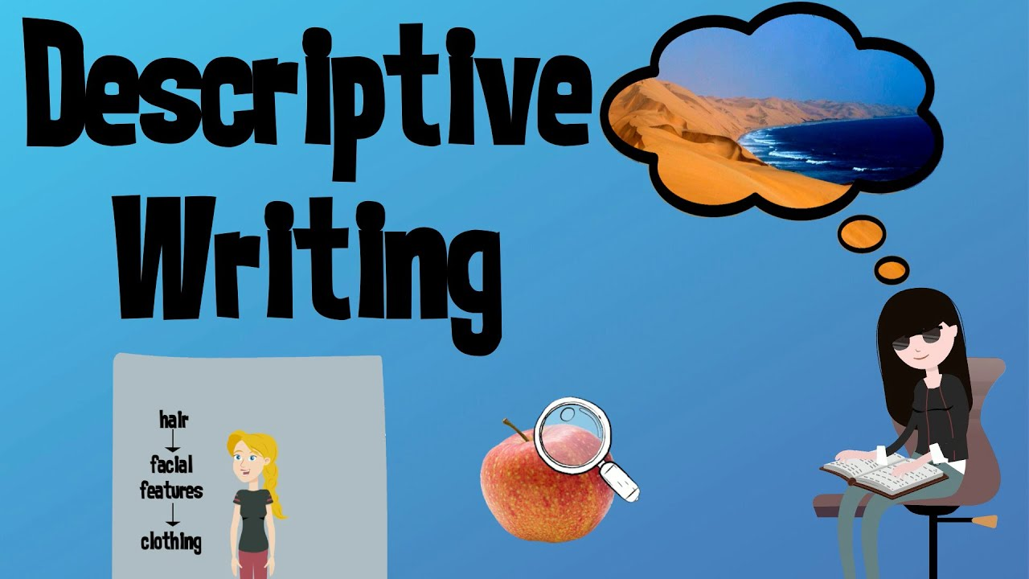

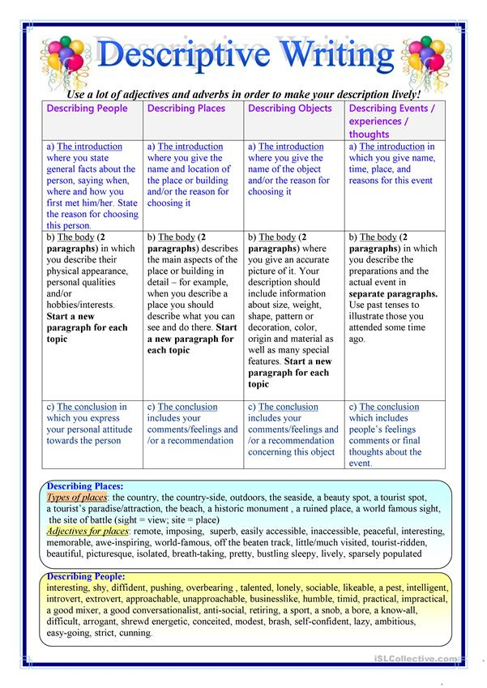

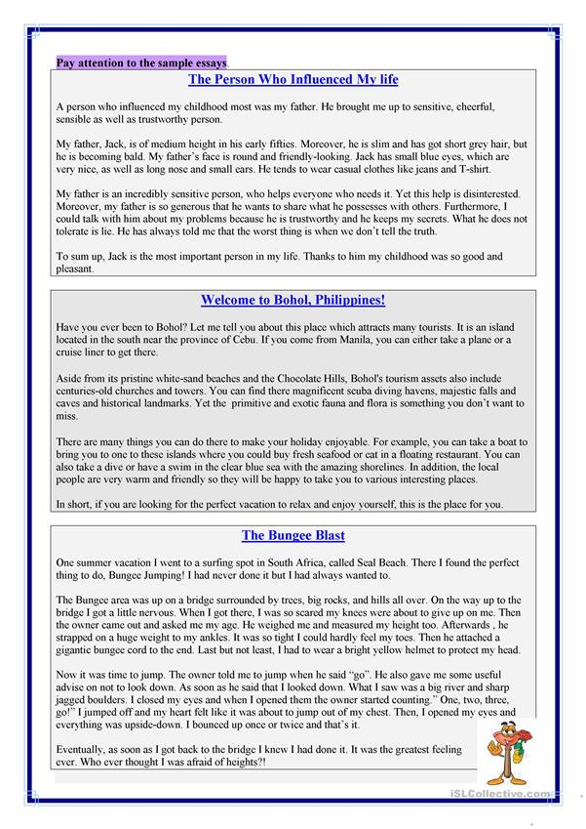

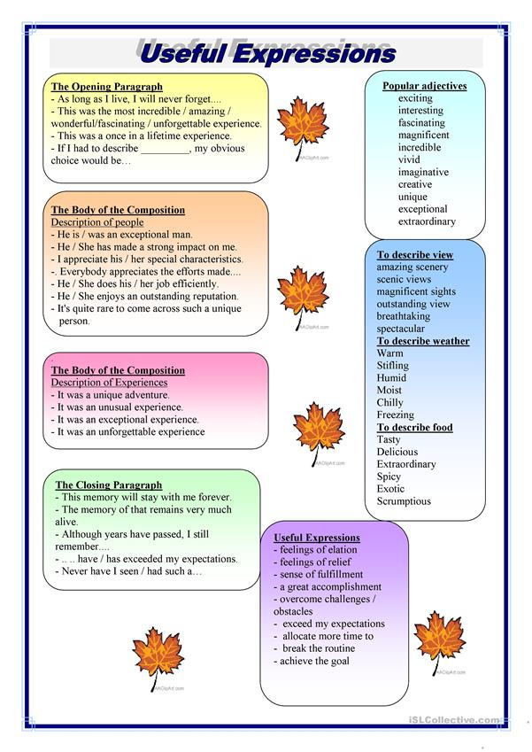

**Figures of speech that can be used in descriptive writing:**

A [figure of speech](https://www.thoughtco.com/figure-of-speech-term-1690793) is a rhetorical device that achieves a special effect by using words in a distinctive way. Though there are hundreds of figures of speech, here are the explanation of some of them.

**Alliteration**

The repetition of an initial consonant sound.

**Example:** She sells seashells by the seashore.

**Euphemism**

The substitution of an inoffensive term for one considered offensively explicit.

**Example:**"We're teaching our toddler how to go potty," Bob said.

**Hyperbole**

An extravagant statement; the use of exaggerated terms for the purpose of emphasis or heightened effect.

**Example:** I have a ton of things to do when I get home.

**Irony**

The use of words to convey the opposite of their literal meaning. Also, a statement or situation where the meaning is contradicted by the appearance or presentation of the idea.

**Example:** "Oh, I love spending big bucks," said my dad, a notorious penny pincher

**Metaphor**

An implied comparison between two dissimilar things that have something in common.

**Example:** "All the world's a stage."

**Personification**

A figure of speech in which an inanimate object or abstraction is endowed with human qualities or abilities.

**Example:** That kitchen knife will take a bite out of your hand if you don't handle it safely.

**Simile**

A stated comparison (usually formed with "like" or "as") between two fundamentally dissimilar things that have certain qualities in common.

**Example:** Roberto was white as a sheet after he walked out of the horror movie