Grammar Worksheet #1

Name: ____________________ Grade: One ( )

Date: 30 /1/2023 Term Two

Learning Objective: To be able to identify and use adjectives.

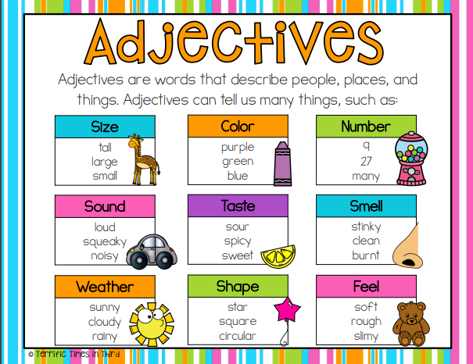

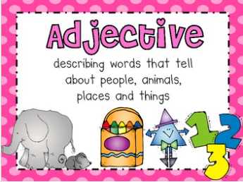

Q1) Underline the **adjective** that is in the sentence.

1. The sky is blue.

2. Mary saw a huge giraffe.

3. My father is tall.

4. She likes green apples.

5. The sun is hot.

Q2) Pick the two best adjective choices to complete each sentence. Make sure the sentences make sense.

1. The dog had a ­­______________ nose and __________________ ears.

**( wet, green ) ( floppy, many )**

1. The sunflowers in my backyard are ____________ and ______________.

**( tall, cold ) (spicy, yellow)**

1. The ­­­__________________ tiger had ________________ teeth.

**( blue, striped ) ( sharp, frozen )**

1. We all ate the_______________, ______________ pizza.

**( dull , cheesy ) ( sandy, hot )**

Q3) Rewrite each sentence. Add an adjective to make the sentence more interesting. Underline your adjective. Accept any reasonable answers.

1. Tia baked cookies.

Tia baked (delicious, yummy) cookies.

1. Do you see a bird?

Do you see a (blue, yellow, beautiful, cute) bird?

1. Hala looked for her dog.

Hala looked for her (brown, black, cute, naughty) dog.

____________________________________________________________________