**Higher Education in the United Kingdom**



**After school …**

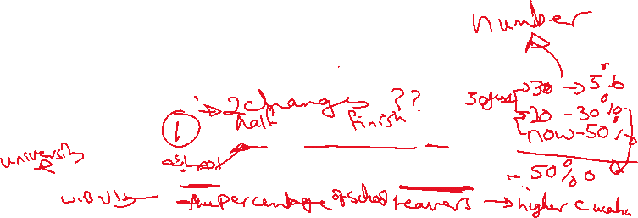

In England, almost 50% of school leavers go on higher education. The figure has not always been as high as this. Twenty years ago, **it** was closer to 30%, and thirty years before that, it was only about 5%. **Another huge change** has been financial. Before 1998 CE, higher education in the UK was completely free for UK citizens. Since then, tuition fees have been introduced. Most students borrow this money from the government. They don't have to repay it immediately. Instead, they pay it back slowly out of future earnings.

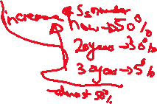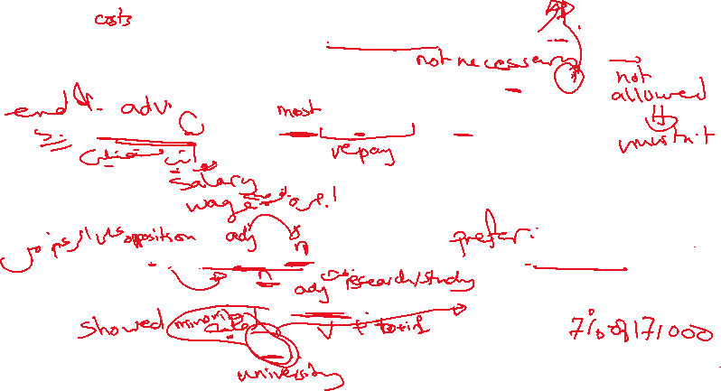

Despite the high cost, most students choose to study away from home. A recent survey of 17,000 students revealed that only 7% wanted to stay at home while they studied for their degree. Of course, for most young people, living away from home means borrowing even more money from the government. So why don’t students choose to avoid debt by staying at home, where they don't have to pay rent? Most of them say that they want to move to the university of their choice, rather than the nearest one. Another strong motive is the desire to live in a new culture. Where do these students live? Many have rooms in halls of residence, especially in their first year; others rent flats or houses. A lucky minority live in property that their parents have bought for them. Most of them need to learn to cook, do their own washing and manage their time and money.

