

**Converting Binary to Decimal**

Name: Answer key Grade: 7 ___________

**Transistors:**

* The computer’s microprocessor is a small component made up of millions of tiny electrical switches.
* Transistors can be only either **On or Off**

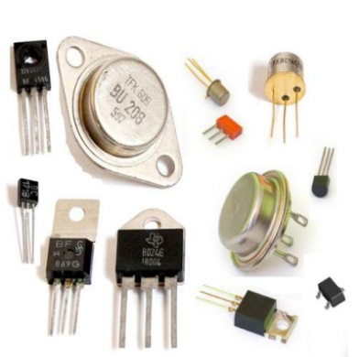

* A computer stores and processes data in a simple format because it only understands these two states On **and Off**

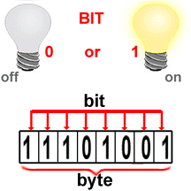

**Binary system:**

* The binary number system only uses zero and one to represent data.

**Byte:**

* Byte is the basic word that a computer uses.
* A byte is eight bits’ long

**Measuring computer memory:**

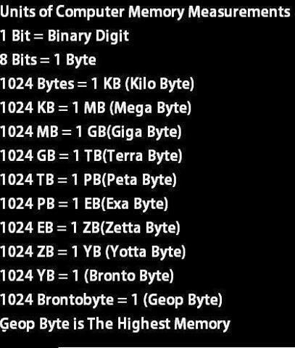

Write each binary number as a decimal number:

|  |  |  |  |  |  |  |  |  |  |  |  |  |  |  |  |  |  |  |  |  |  |
| --- | --- | --- | --- | --- | --- | --- | --- | --- | --- | --- | --- | --- | --- | --- | --- | --- | --- | --- | --- | --- | --- |
| 1- Binary = (10011) 2  Decimal =19   |  |  |  |  |  | | --- | --- | --- | --- | --- | | 1 | 0 | 0 | 1 | 1 | | 16 | 8 | 4 | 2 | 1 |   16+0+0+2+1=19 | 2- Binary = (10000) 2  Decimal =16   |  |  |  |  |  | | --- | --- | --- | --- | --- | | 1 | 0 | 0 | 0 | 0 | | 16 | 8 | 4 | 2 | 1 |   16+0+0+0+0=16 |
| 3- Binary = (101011) 2  Decimal =43   |  |  |  |  |  |  | | --- | --- | --- | --- | --- | --- | | 1 | 0 | 1 | 0 | 1 | 1 | | 32 | 16 | 8 | 4 | 2 | 1 |   32+0+8+0+2+1=43 | 4- Binary = (1111) 2  Decimal =15   |  |  |  |  | | --- | --- | --- | --- | | 1 | 1 | 1 | 1 | | 8 | 4 | 2 | 1 |   8+4+2+1=15 |
| 5- Binary = (110011) 2  Decimal =51   |  |  |  |  |  |  | | --- | --- | --- | --- | --- | --- | | 1 | 1 | 0 | 0 | 1 | 1 | | 32 | 16 | 8 | 4 | 2 | 1 |   32+16+0+0+2+1=51 | 6-Binary = (11000) 2  Decimal =24   |  |  |  |  |  | | --- | --- | --- | --- | --- | | 1 | 1 | 0 | 0 | 0 | | 16 | 8 | 4 | 2 | 1 |   16+8+0+0+0=24 |