Reported Speech” ----"

Direct speech

*” I am happy,” Peter said.

*” I am happy,” said Peter.

*Peter said,” I am happy.”

*said Peter,” I am happy.”

*” I am happy,” he said.

*” I am happy,” said he.

* He said,” I am happy.”

* Said he,” I am happy.”

*” I am happy,” said Peter.

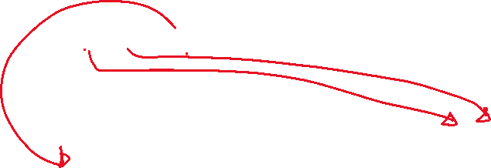

Reported speech Peter said that he was happy.



*” I am happy,” said Manal.



Manal__________________________

*The boys said,” We are going to visit Petra.”



The boys said______________________



*Rami said,” The man took me to hospital.”



Rami said ________________________



*Manal said,” The man took me to hospital.”

Manal said________________________

Hassan said,” My book has been stolen.”

Hassan said_______________________

*Mona said,” My book has been stolen.”

Mona said_______________________

*The workers said, “Our manager is very tough.

The workers said___________________

*Huda told Ahmad,” You are clever.”

Huda said to Ahmad_______________

*Huda told Rana,” You are clever.”



Huda said to Rana________________

*Nawal said, “The man is looking for you, Ahmad.”

Nawal told Ahmad__________________

1.Ali said, ‘” We are working here in this lab.’’

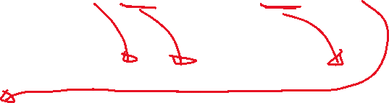

Ali said (that) they were working there in that lab.



2.Hadeel said, “I am using these tools today.”



Hadeel said (that) she was using those tools that day.

