1. Adjectives

****An adjective describes a noun. It comes before nouns but after verb to be.



***** He **is** a clever child.

****** I met a happy baby.

****We can use more than one adjective to describe a noun.

Their high academic achievements.



****If we want to compare two things according to an adjective and there is a difference (INEQUAL) we use:



The comparative form **(----- er than, more ------- than,less ------- than )** to compare between two different things or people. While we use the superlative form **(the ---- est, the most, the least-----)** to compare between three or more different things or people(INEQUAL).



1.One syllable



|  |  |  |
| --- | --- | --- |
| **Adjective** | **Comparative** | **Superlative** |
| Tall | Taller than | the tallest |
| Cold |  |  |
| Old |  |  |
| Nice | Nicer than | The nicest |
| Late |  |  |



1. One and two syllables ending in (y)



|  |  |  |
| --- | --- | --- |
| **Adjective** | **Comparative** | **superlative** |
| Hap/py 2 | Happier than | The happiest |
| Easy 1 |  |  |
| Hun/gry 2 |  |  |
| Thir/sty 2 |  |  |
| Lone/ly2 |  |  |

****Note

Friendly, likely, lively, lonely, lovely, silly, ugly



Peter is a friendly person.



Mark is friendlier than Peter.



3. One syllable CVC (consonant/Vowel/Consonant)



|  |  |  |
| --- | --- | --- |
| **Adjectives** | **Comparatives** | **Superlatives** |
| Big | Bigger than | The biggest |
| Hot |  |  |
| Fat |  |  |
| New | Newer than | The newest |

4.More than two syllables



|  |  |  |
| --- | --- | --- |
| **Adjective** | **comparative** | **superlative** |
| Fam/ous | More famous than | The most famous |
| In/teres/ting |  |  |
| Beau/ti/ful |  |  |
| Di/ffi/cult |  |  |



5.Irregular adjectives



|  |  |  |
| --- | --- | --- |
| **Adjectives** | **Comparative** | **superlative** |
| Good | **Better** than | The best |
| Bad | Worse than | The worst |
| Far | Farther /further than | The farthest/the furthest |
| Many/much | More than | The most |
| Little | Less than | The least |



If we want to compare two things according to an adjective and we find out that there is no difference (EQUAL)we use: As + Adj + As



1. X (Verb to Be)  As + Adj + As Y



Example:

Paul is 14 years old.



Peter is 14 years old.



X (Verb to Be) As + Adj + As Y



Paul is as old as Peter.



If we want to compare two things according to an adjective and we find out that there is a difference



(INEQUAL) we use:

( not /be) As + Adj + As



1. X (Verb to Be /not) As + Adj + As Y



Paul is 14 years old.



Peter is 19 years old.



X (Verb to Be /not) As + Adj + Y

Paul isn’t as old as Peter.



Paul is younger than Peter.



Peter is older than Paul.



2.Nouns

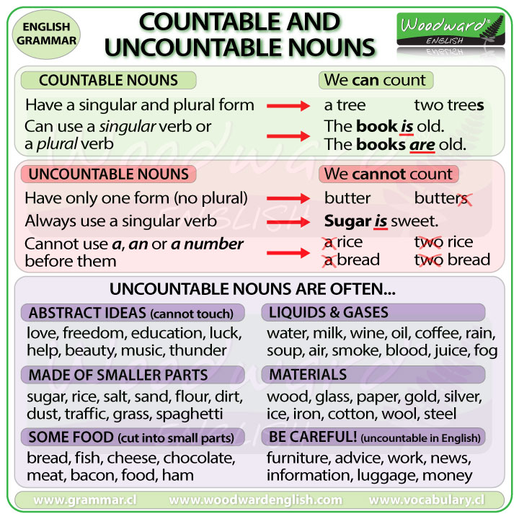



Comparing nouns



1.COUNTABLE NOUNS



If we want to compare between two things

(countable nouns) we use the word many.

1. If they are equal (Equality) we use:

X has as many countable noun + as Y

Example:

Peter has 3 pens.



Mary has 3 pens.



X has as many countable noun + as Y



Peter has as many pens as Mary.



1. If there is a difference (INEQUAL) we use



X V/ not as (many countable noun )+ as Y

Peter has 3 pens.



Mary has 5 pens.



X has/ not as many countable noun + as Y



Peter ________________________________________



Comparing nouns

UNCOUNTABLE NOUNS

If we want to compare between two things

(uncountable nouns) we use the word much.

1. If they are equal (Equality) we use:



X (V) as much uncountable noun + as Y



Example:

Peter spends two dinars daily.



Mary spends two dinars daily.



X (verb)as much uncountable noun + as Y



Peter spends as much mony as Mary.

1. If there is a difference (INEQUAL) we use



X V/ not as (much uncountable noun) + as Y Peter spends two dinars daily.



Mary spends one dinar daily

Peter ________________________________________

1. Adverbs

Comparing adverbs

Adverbs describe verbs, adjectives or other adverbs. They can describe 1. manner (how),2. place (where),



3. frequency (how often), 4. time (when)

*He speaks slowly. (How)

*Your hat is here. (place)



*He will come tomorrow. (Time)

*She seldom visits us. (how often)



Types of adverbs 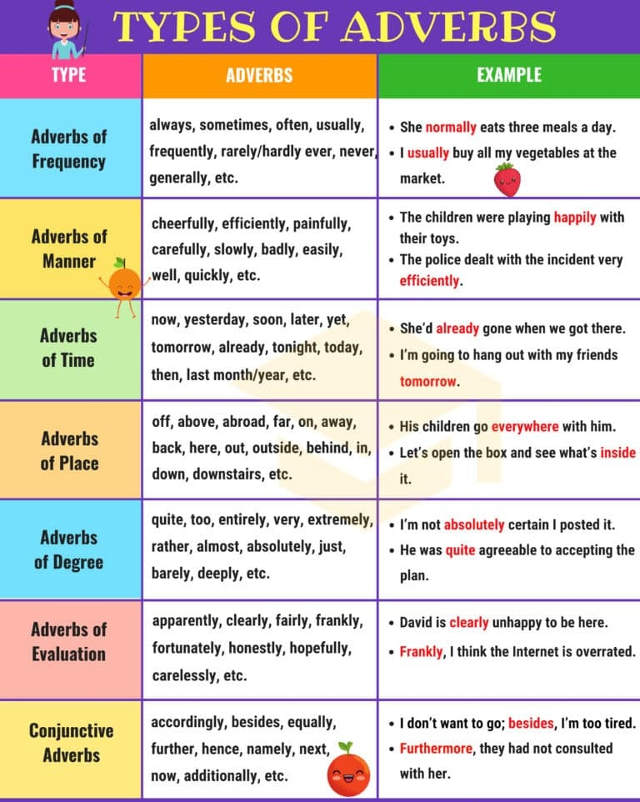



Forming adverbs

***We usually form an adverb of manner by adding -ly to the adjective.

Adj+ ly=adverb of manner



Soft – softly



Irregular adverbs

**Some adverbs have either a totally different form or the same form as the adjective.

|  |  |
| --- | --- |
| Adjective | Adverb |
| good | well |
| fast | fast |
| hard | hard |
| early | early |
| late | late |

**He is a___________(good) student.



He dances___________ .(good)



**He bought a fast car.

He drives ___________



**He is a hard-working student.



She works hard.



1. er + than

More ______________ (not as adj as)



1. X is more beautiful than Y.

Y ___is ____________________________

2. X is not as beautiful as Y.

X _______________________________________

Listening is better than speaking languages.

Speaking languages is not as good as listening.

Listening is better than speaking languages.

1. Neither Noun nor Noun



Neither Ali nor Sami is as intelligent as Peter.



Peter is more intelligent than Ali and Sami.

Neither Ali nor Sami is as smart as Peter.



Peter is smarter than Ali and Sami.

1. Earlier later



Teacher Ali starts lecturing one hour earlier than Khaled.



Khaled starts one hour later than teacher Ali.



Khaled doesn’t start lecturing as early as teacher Ali.



1. Less= not

Less =more



English is less difficult than Physics.

English is not as difficult as Physics.

Physics is more difficult than English.

1. Cheap = expensive



The cheapest house in this area is Ahmad’s.

The least expensive house in this area is Ahmad’s.



1. There is no + NOUN



There is no worker as punctual as Rami.



Rami is the most punctual worker.

There is no student as happy as Mary.

Mary is the happiest student.

Nouns

Uncountable Countable

Less fewer

Not as much as not as many as

Nouns

There are fewer students in my class than in Laith.

There are not as many students in my class as Laith.

There is less oil in Jordan than in Iraq.

There is not as much oil in Jordan as in Iraq.

More = noun

X has more information than Y

Y _doesn’t have as much information as X. (as much )

Running is important. Swimming is more important.

Swimming is more important than running.

Running is not as important as swimming.

Maths is more difficult than English.

English is easier than Maths.