
Conditionals Study Sheet

Name: …………………………… Date: ………………………………..
7 CS/………….
=========================================================

If conditional

Conditional tenses are used to speculate about what could happen, what might have happened, and what we wish would happen.

Conditional sentence type | Usage | If clause verb tense | Main clause verb tense
Type 1 | A possible condition and its probable result | Simple present | Simple future
Type 2 | A hypothetical condition and its probable result | Simple past | Present conditional or Present continuous conditional

Type 1 conditional:
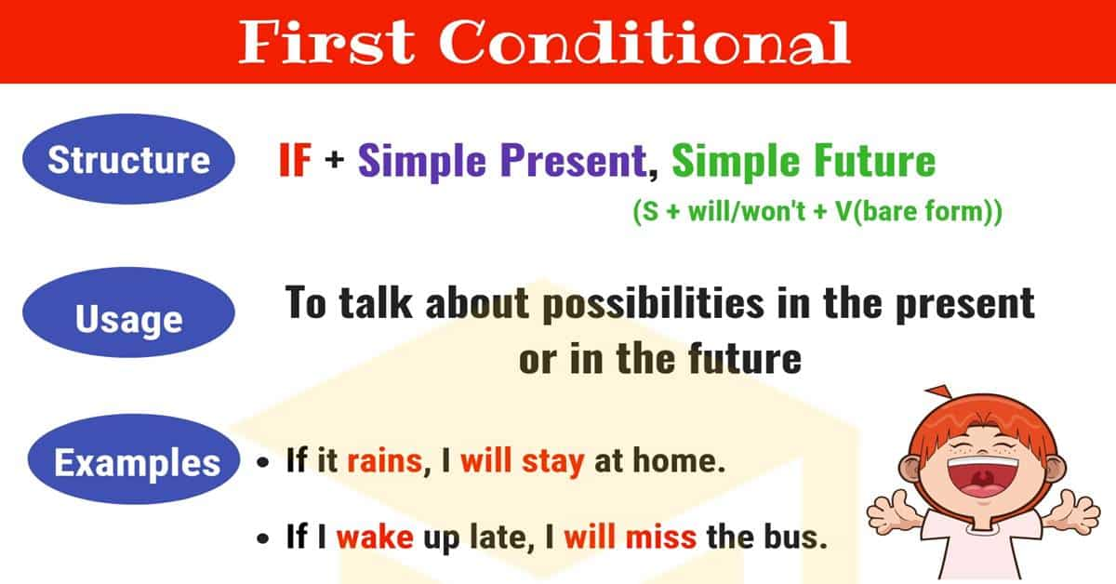

The type 1 conditional is used to refer to the present or future where the situation is real. The type 1 conditional refers to a possible condition and its probable result. In these sentences the if clause is in the simple present, and the main clause is in the simple future.

If clause | Main clause
If + simple present | simple future
If this thing happens | that thing will happen.
If you don't hurry | you will miss the train.
If it rains today | you will get wet.

Type 2 conditional:
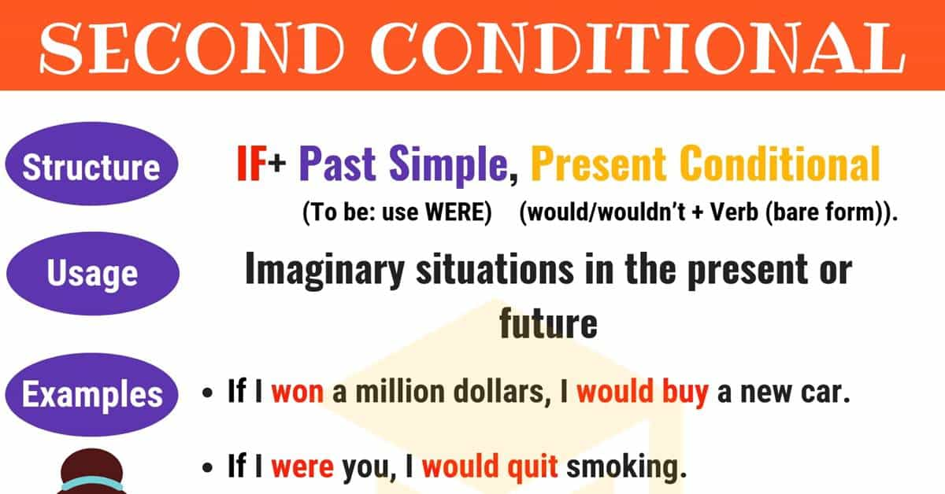

The type 2 conditional is used to refer to a time that is now or any time, and a situation that is unreal. These sentences are not based on fact. The type 2 conditional is used to refer to a hypothetical condition and its probable result. In type 2 conditional sentences, the if clause uses the simple past, and the main clause uses the present conditional.

If clause | Main clause
If + simple past | present conditional or present continuous conditional
If this thing happened | that thing would happen. (but I'm not sure this thing will happen) OR  that thing would be happening.
If you went to bed earlier | you would not be so tired.
If it rained | you would get wet.
If I spoke Italian | I would be working in Italy.

Type 1 examples:
- If you don’t leave, I’ll call the police.
- If you don’t drop the gun, I’ll shoot!
- If you drop that glass, it will break.
- Nobody will notice if you make a mistake.
- If I have time, I’ll finish that letter.

Type 2 examples:
- If it rained, you would get wet.
- You would get wet if it rained.
- If you went to bed earlier you wouldn't be so tired.
- You wouldn't be so tired if you went to bed earlier.
- If the weather wasn't so bad, we would go to the park.
- If you really loved me, you would buy me a diamond ring.
- If I knew where she lived, I would go and see her.

Complete the following sentences with the correct form of the verbs in brackets:
1. If I ___________ (see) her, I ___________ (give) her the news.
2. If Sally _____________ (speak/not) English, she _______________ (not understand) most of her courses.
3. If I ________________ (win) the lottery, I ________________(buy) my dream car.
4. If someone ________________ (ring) the bell at four in the morning, __________________ (You/answer) the door?
5. If my car _________________ (broken), my mechanic _________________ (repair) it.
6. You would feel a lot better, if you ___________________ (not/ smoke) much.
7. If we drink too much coffee tonight, we ________________ (not sleep).
8. If I _________ (be) you, I ______________ (accept) the offer.

