**A visiting student’s blog post (Anita’s blog post)**



Two summers ago, I spent five months studying Arabic at the German-Jordanian University near Madaba. As my father is originally from Jordan, I grew up speaking Arabic as well as German. However, I had never studied Arabic formally, and when the opportunity came up for me to spend a year in Jordan studying Arabic, I didn’t hesitate for one moment.



I have relatives in Jordan and they arranged for me to stay with a wonderful family who live just outside Madaba. I was amazed by the number of international students there, who were not only from Germany, but from all over the world. Most of them had studied Arabic to a high level. I’m very familiar with **colloquial** Arabic, which is what my family speaks and understands. The Arabic class, in Modern Standard Arabic, was challenging, especially the grammar.



Every week, we had to learn a vocabulary list of around 50 words. We covered many topics. Living with a family helped to improve my Arabic-speaking skills because, while all the students

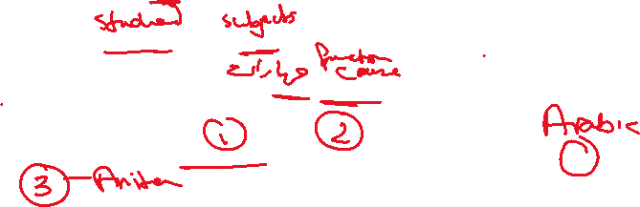

heard Arabic in the classroom and streets, I could also practise it at home. I really **put my back into it**, and I earned an A on the course.



What impressed me most about students in Jordan was their behaviour and their attitude to studying. All the students who I met appreciated the importance of their university education and the opportunities it would give them to contribute to their country’s prosperity. They also showed extremely positive values. Everybody was honest, and people discussed problems rather than getting angry if they disagreed with each other.



As someone who enjoys delicious food, beautiful places and friendly, hospitable people, studying in Jordan was one of the best decisions I have made in my life. I made many new friends. I also improved my Arabic speaking, writing and reading skills. My dream is to be fluent in Arabic one day – and as I intend to return to Jordan as often as I can, I know I’m going to make this dream a reality.

